# About Static Data Maintenance

This chapter describes the static data used by the system and explains how the type of system you run affects what data is provided, how it is provided, and how it is maintained.

1. Your system's security settings may restrict you to working with a sub-set of the static data your bank stores.

## Sources of Static Data Information

The system operates in one or more of the following ways:

* As a standalone system, in which case the system uses static data that is maintained using the facilities described in this guide
* As a system integrated with one or more back office systems where some static data is replicated from the external system. Static data is passed to Trade Innovation where it is held in the database.
* As a system integrated with one or more back office systems using ‘services’ to retrieve some of the static data, such as customers, accounts and settlement instructions, from the back office database. A copy is used by the system and is then updated throughout business hours to keep it in line with the back office database

If ‘services’ become unavailable, the system allows transactions to be continued by allowing you to set the UseLocalData service system option for the following services:

* Customer
* Account
* Standing Settlement

In which case the system’s local copy of the data values are used.

Some other types of static data are specific to trade finance, and so are stored on the database and maintained using Trade Innovation facilities, regardless of whether your system is integrated or standalone.

For some types of data, standard data sets are provided as part of the system release. They can be augmented and maintained using the static data application. These standard data sets provide a consistent set of static data that you can use while familiarising with the system. These can be deleted before your system goes live, but you may want to retain those standard data sets that conform to external standards for live operations.

When you use the static data application to make any changes to the system, before and after images of the affected data are journalled. You can display this information using the Full Journal Report.

The table in Appendix A lists all the static data types that the system uses.

The following sections in this chapter provide a brief description of the static data used by the system explaining what each is used for and how they interrelate, and providing some guidelines on the order in which static data should be set up.

## Overview

Trade Innovation uses static data that is maintained using the facilities described in this guide.

The system allows your bank to define one or more separate banking businesses within a zone so the static data functions are separated into two areas:

* Overall zone level data – relates to common static data that applies to any banking business defined in the zone covering such items as currency, transaction codes and account types
* Branch level data – relates to data that is applicable to a specific part of the bank’s business such as branch definition, base rates, exchange rates, customers, account, nostros and settlement instructions

### Access Restrictions

The security officer or user administrator can restrict users' abilities to access the static data functions by not assigning security capabilities. If your bank runs Trade Innovation integrated with a back office system, you may be prevented by security capabilities from adding, amending or deleting those types of static data provided from the back office.

Additionally, data replicated from a back office system can be flagged as ‘maintained in back office’. This means that data from an external system cannot be changed in the system, however, additional items can be added and maintained in the system.

You will be restricted to working with data for only those customers and branches to which your team assignments allow you access. For more on how teams can be used to limit user access to static data see the Security Guide – Trade Innovation.

### Maker Checker Application

The system can be configured to use the Maker Checker application. This application is used for certain types of zone, customer and branch related static data and means the input or maintenance of an item is only applied to a production system once it has been authorised by one or more people.

The types of data covered includes customer related data such as accounts, addresses and settlement instructions, zone level data such as calendars and internal branch data such as internal accounts or nostro accounts which need to be maintained on a regular basis within a live system.

When Maker Checker is set on, these items in the static data application become view only and can only be maintained in the Maker Checker application.

## Branches and Entity Types

The branch function in the system allows your bank to define the branches that make up your bank’s business hierarchy. These branches are then in turn used to associate system tailoring data and services to control the processing required for different parts of the banking business and to define the teams and users that can enter transactions for those branches:

* **Branches**. Within the system, branches are defined as either ‘business branches’ or as individual ‘branches’. Each discrete legal and/or organisational component of a bank is considered a business branch, and these branches are expected to be arranged into a hierarchy that reflects your bank's structure.

If your bank has several discrete operations, each is handled separately. You can designate certain branches within your hierarchy as banking groups, encompassing other banking businesses, which in turn may cover main banking entities (corresponding to a Back office general ledger) and the associated branches they include. Each main banking entity can have a separate base currency defined against them to reflect the base currency of the associated general ledger.

* **Entity types** (see page 26). Your bank optionally sets up values for these static data types to identify all the different types of banking businesses in your organisations, for example agencies, regional offices, head offices and so on. Entity types can then be selected in the branch browser and your bank can create reports using this value (for example, to report by type of branch).
* **Teams**. Teams are an important element of the system’s security system. Teams provide the mechanism in Trade Innovation’s global processing functionality by which your bank staffs are given roles to determine what transactions they can enter and are linked to the branches on whose transactions they will work. Teams are also a key in the control of workflow.

Team structures may be flat or hierarchical, or a combination of both. Each team is linked to one or more branches in the branch hierarchy. Your bank needs to take into account the inter-relationships. Further details can be found in the Security Guide – Trade Innovation.

## Customer Data

The static data used to define customers consists of the following:

* Basic customer details, including the customer's name, a unique customer number, and a unique customer identifier
* Various customer addresses - a prime postal address; Structured name and address; a SWIFT BIC address; a SWIFT-compatible postal address,if necessary; and associated addresses to allow copies of relevant correspondence to be sent to additional addresses. The prime address indicates the transfer method to be used for communications sent to the customer
* The branch to which mail is to be directed
* Their country of residence, their risk country and the language in which documents are to be sent to the customer, if in a language other than English
* Codes indicating the exchange rates to be used when taking charges or paying principal amounts
* A customer type parameter, which categorises the customer as a bank, a correspondent bank or customer (e.g. individual customer or corporation)
* Settlement instructions. These define standing instructions (different for each currency) that are to be used when settling with a customer. These can be defined for each branch dealing with that customer or for the bank as a whole
* Source banking business – the banking business with which the customer is associated

Customer details may also include:

* A customer group - Customer groups allow you to group together customers for reporting purposes
* A customer charge group parameter, which allows you to group together customers for whom you will use the same charge schedules
* An account officer code. This enables you to identify an individual member of staff or department as responsible for a customer and their accounts
* An analysis code, which can be used to group customers for reporting purposes
* Information used only by the system, including, for example, which corporate access system (if any) is used by the customer

If your bank uses the supply chain finance application you can:

* Assign a customer to one or more buyer centric or seller centric financing programmes (Buyer centric finance, Seller centric finance, and Pool based factoring)
* Enter details of the buyers with whom a seller has a trading relationship
* Enter details of the sellers with whom a buyer has a trading relationship
* Set up limits for each buyer in order to monitor and control your bank's exposure to a particular buyer across one or more sellers
* Set up buyer/seller relationships

The following data can be sent and received following creation, update and deletion via a corporate access system, to synchronise data across both of the systems:

* Programmes
* Programme sub-types
* Buyers
* Sellers
* Buyer/Seller relationship

## Accounts

### Customer Accounts

Customer accounts are defined using the following information:

* The branch to which the account belongs
* The customer's mnemonic, which provides the customer basic number
* The account type
* The currency of the account

|  |
| --- |
| 1. Multiple accounts can be opened for a customer of the same account type and currency. |

### Internal Accounts

Internal accounts are identified using the following information:

* The branch to which the account belongs
* The System parameter - which determines the category code (used for Back office G/L purposes), the account type to be assigned to the account and the transaction codes to be used for postings to the account
* The currency of the account

|  |
| --- |
| 1. Where exchange position accounts are maintained by currency pair using system parameter SP101, then the ‘other’ currency can also be specified.   SP102 is reserved for forward exchange. SP102 is maintained when a currency swap or deal is implemented with a settlement date set out in the future. |

### Charge Income Accounts

Charge income accounts are identified using the following information:

* The branch to which the account belongs
* The charge code parameter or system parameter held against the charge type, - which determines the category code (used for Back office G/L purposes), the account type to be assigned to the account and the transaction codes to be used for postings to the account
* The currency of the account

### Services

If an external Account service is mapped to a branch, the following interface services are used:

* The AccountSearch service is used to retrieve a list of accounts from the back office. The account browser allows you to search on Customer, Charge (SK), or Internal (SP) accounts
* The AccountDetails service is used to retrieve the account details for a specific account from the back office.
* The AccountOpen service is used to send an open account request to the back office to open a new account.

The account service can only be defined at the main banking entity level. All accounts for that particular banking entity are associated with a single General Ledger.

## Financing and Foreign Exchange Deal Types

The deal types parameter enables you to define how different types of deal are to be processed. Each deal type (see page 80) specifies:

* Whether the deal type applies to foreign exchange deals or to financing deals
* For financing deals, the interest characteristics of the deal, for example whether the deal is discounted or has interest payable at maturity

When setting product options using the system tailoring application a deal type parameter is assigned to each possible deal type that can be generated for each product.

For more information on setting product options see the System Tailoring User Guide – Trade Innovation.

## Nostros, Vostros, Clearing Systems and Correspondents

You can enter details of relationships with other banks by defining:

* Nostros, which are our accounts held at another bank
* Vostros, which are other banks' accounts held in our books
* Clearing systems, which reference accounts to control settlements through clearing system
* Correspondents, which are banks that you will use to advise letters of credits

### Nostros

The accounts used to record nostro postings are set up first as normal customer accounts. The account is then assigned:

* A main banking entity
* A unique nostro mnemonic
* The currency that is settled via the nostro
* Transfer methods to be used to advise the nostro of payment or receipt of funds

Default nostros can be set up for individual branches. These are then used for the settlement of transactions belonging to those branches, in conjunction with any standing settlement instructions held. A default nostro is created by specifying:

* A main banking entity
* A branch code, to indicate the branch for which it will be the default
* The currency that is to be settled via the nostro for that branch
* An instruction group code indicating which types of product are to be settled through the nostro
* The nostro to be used for that branch, currency and instruction group

You can set up a single default nostro for each currency for each branch; or you can set up separate nostros for individual instruction groups.

### Vostros

When instructing another bank to pay funds to a beneficiary, you may credit their account in your books rather than instructing one of your nostros to settle the funds. A vostro account is simply an account in your books that is identified as a vostro account by specifying its account type against the system option VostroAccTyp. When you settle via a vostro, the system allows details of the account to be credited in our books to be entered together with instructions for the receiving bank on how to transfer funds to the beneficiary.

### Clearing Systems

The system allows you to define the Clearing systems that are to be used as part of settlement processing. This allows payment instructions to be sent to the paying bank with funds being transferred through a clearing system. The account associated with the clearing system is used to record settlements made through that system.

### Correspondents

The system allows you to set up correspondent banks and to define whether for each country:

* You will always use the same bank
* You will distribute business between a number of banks on a 'round robin' basis. If you select this option, then during processing the system will select the next bank to be used, but the input clerk will be able to override this to select another bank

## Instruction Groups

Instruction groups are used to group together products that share the same settlement accounts. When setting product options using the system tailoring application, an instruction group is assigned to each product type. During transaction processing, the instruction group for the product indicates which customer settlement instructions and/or default nostros for branches are to be used when settling a transaction.

For more information on setting product options see the System Tailoring User Guide – Trade Innovation.

## Transfer Methods

Transfer methods are used throughout the system to determine how correspondence should be sent to parties. Each transfer method has an associated transmission method that determines the physical means by which correspondence is to be sent.

## Currencies, Exchange rates, FX Rate Codes, Calendars, Base Rate Codes, Base Rates and Differential Rates

The basic details of each currency are defined at the overall zone level, allowing your bank to define details such as name and major and minor currency units.

A separate base currency can be specified for each main banking entity defined for your bank, this allows exchange rates to be held and maintained separately for the different parts of the bank’s business.

FX rate codes allow you to set up a number of different exchange rates (see page 94) for each currency to allow you to apply different exchange rates in different situations, depending on, for example, the customer, product, type of charge or foreign exchange deal. Foreign exchange rates codes are defined first as generic types, for example 'CORP - Corporate Rate', using a code and a description. Exchange rates can then be set up for each generic type for each currency for buying and selling in that currency within each main banking entity.

For each currency on your system you can create a calendar defining which days are business days, and which non-working days, in the country of that currency in any given year. When processing euro settlements, you can also set up calendars for each euro-participating country, in order to define which are valid business days for settlement in that country.

The base rate codes used by your bank are defined at zone level, with the actual underlying base interest rates definable at main banking entity level or above, allowing separate rates to be maintained for different parts of your bank’s business.

Differential rate codes and their associated rates are defined at zone level. Differential rate parameters are used in conjunction with base rate parameters to allow the required interest rate to be obtained. The system maintains a record of historical rates, recording against each rate the date at which it ceased to be used.

For financing transactions base rates can be retrieved during transaction processing from the back office, rather than from the database. (This is controlled by the system option InterestBaseRatesRetrievalViaAPI.)

Base rate groups (see page 95) are used to group base rates together. During transaction processing the user can enter a rate group identifier rather than an individual base rate, in which case the system will retrieve the highest rate within that group and apply it to the transaction.

For more information on setting up charges and interest schedules see the System Tailoring User Guide *– Trade Innovation*.

## Trade-related Parameters

The system supports the use of parameters for:

* Goods (see page 109)
* Incoterms (see page 110)
* Types of documents (see page 109)
* Types of collateral (see page 111)
* Documents of title (see page 112)
* Codes for use in statutory reporting (see page 113)
* Note types (see page 114)

Each of these parameters is set up as a code and a description. During transaction processing, the input clerk can use a browser to select from a list of valid values.

## Static Data Downloads to Corporate Access System

If you use corporate access system facilities, the system is delivered with a standard set of static data messages to permit you to download the following types of data to the relevant server for use by the corporate access system:

* Account officer
* Account type
* Reference block
* Account
* Country
* Currency
* Rate definition
* Customer
* Customer address
* Customer type
* Code description
* Supply chain finance programme sub-type
* Supply chain finance programme
* Supply chain finance buyer or seller
* Supply chain finance buyer / seller relationship

You can use the static data application to tailor the mappings of these messages.

# Logging On to Trade Innovation

This chapter explains how to log on to the system and lists the static data application's menu options.

## Logging On for the First Time

Access to the system is controlled by user ID and password. Each user is provided with one or more unique user IDs that control what applications they can access and what functionality they can use within those applications.

Before you can access the system your security officer or user administrator must have set up at least one user profile for you to use, consisting of (among other things) a unique user ID and a password. Your security officer will tell you your user ID and password the first time you log on.

## Logging On

Your bank can define whether you are allowed to have more than one concurrent session open and, if so, how many.

If your bank does not allow users to have more than one session open at a time, then, if you attempt to open a second session, you will be given the choice of logging off from the session you currently have open.

If your bank does allow users to have more than one concurrent session open, a message will be displayed if you attempt to open more sessions than are allowed.

When you start the system a log-in window is displayed.

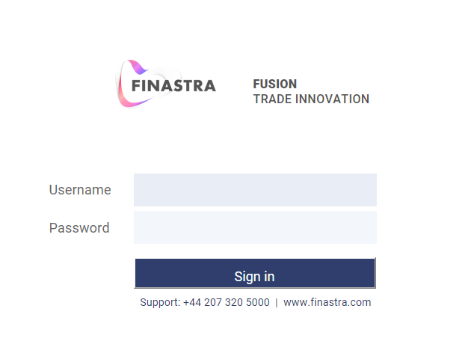

Enter your user ID and password and click **Sign in**.

Provided you have entered these values correctly, the system displays a window that lists all the zones available to you.

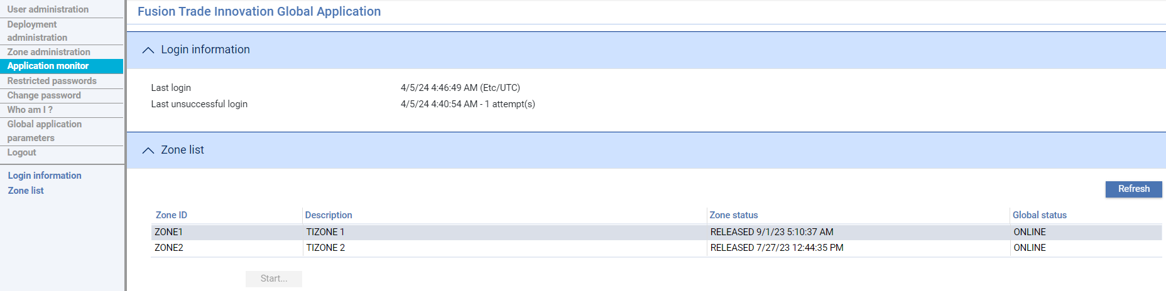

Select the zone in which you wish to work and click **Start**. The system displays a list of all the applications available in that zone to which you have access.

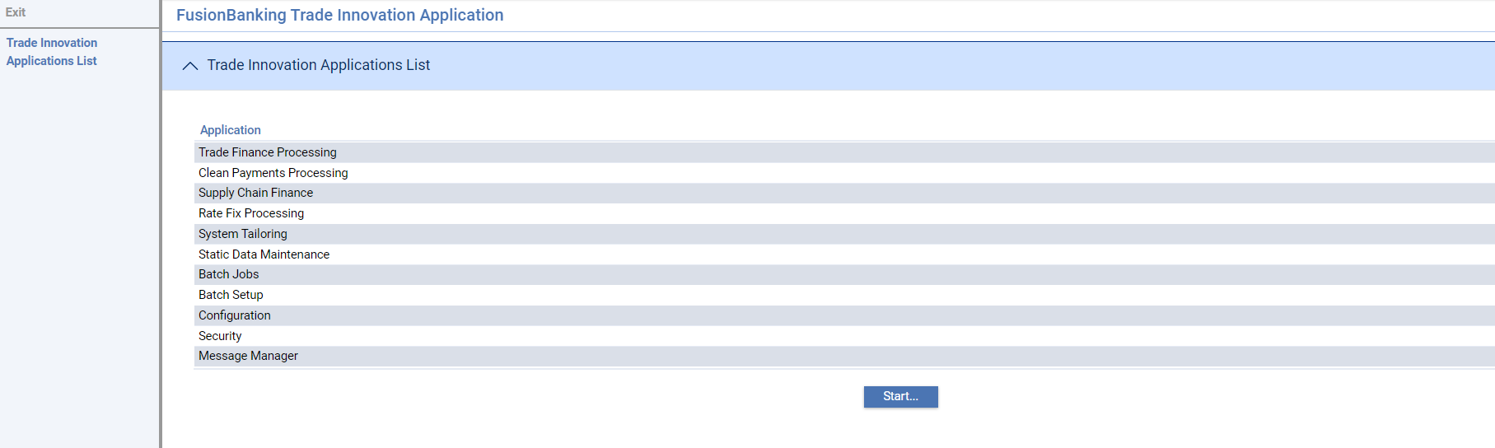

The application names displayed in this window may be modified by your bank, and thus may differ from the ones delivered.

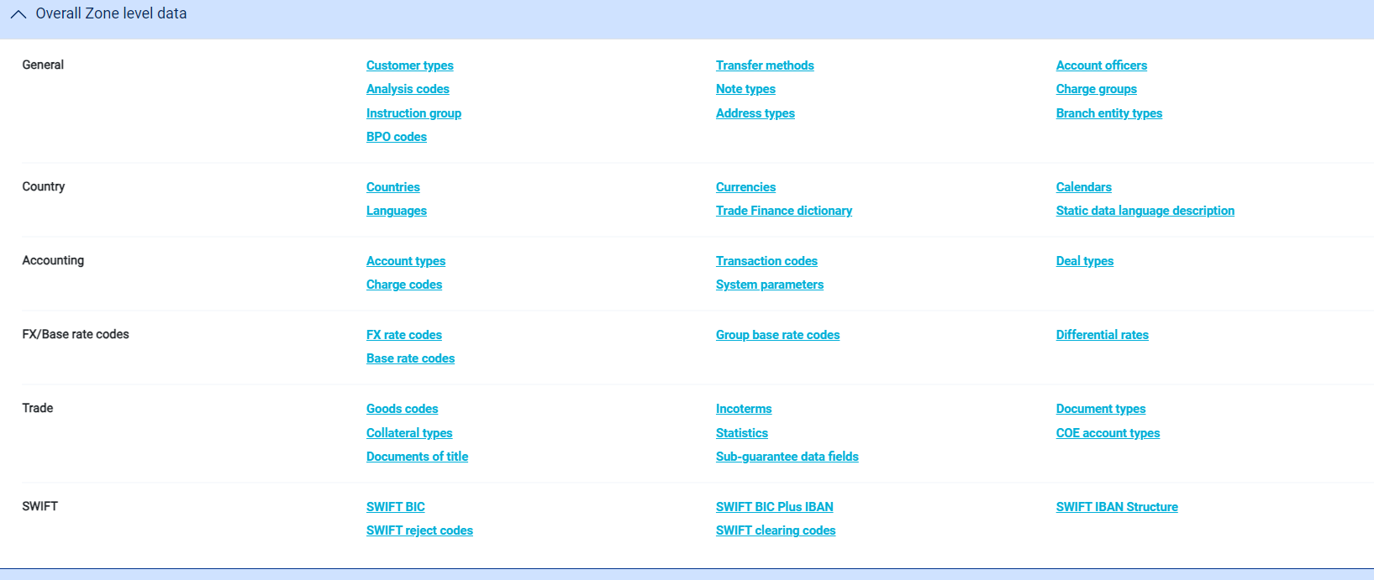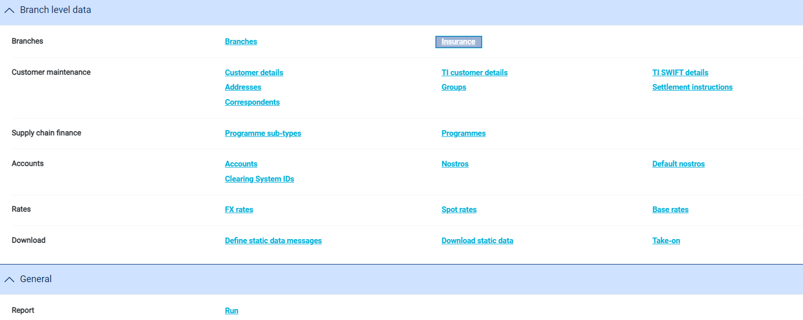

The following table lists the menu options in the static data application and indicates where they are documented in this Guide:

| Option | Sub-option | What it Does |
| --- | --- | --- |
| Zone level data |  |  |
| General | Customer Types | Accesses customer types (see page 70). |
|  | Transfer Methods | Accesses the methods used to communicate with customers and other banks. |
|  | Account Officers | Accesses account officers (see page 65). |
|  | Analysis Codes | Accesses analysis codes used for categorising customers for reporting (see page 65). |
|  | Note Types | Accesses note types used to categorise narrative text entered by the input clerk (see page 114). |
|  | Charge Groups | Accesses customer charge groups (see page 68). |
|  | Instruction Group | Accesses information on the instruction groups used to determine which accounts are to be used for settlement of transactions for individual product types. |
|  | Address Types | Accesses the customer address types hierarchy (see page 45). |
|  | Branch entity Types | Accesses entity types used to categorise branches according to the type of banking entity (see page 2). |
| Country | Countries | Accesses details of countries (see page 100). |
|  | Currencies | Accesses the currencies set up on your system. |
|  | Calendars | Accesses the calendars used to define working and non-working days for the currencies on your system. |
|  | Languages | Accesses details of languages (see page 102). |
|  | Trade Finance Dictionary | Accesses the trade finance dictionary delivered with the system. |
|  | Static Data Language Description | Allows you to translate descriptions of some of the static data items into languages other than the default language. |
| Accounting | Account Types | Accesses account types. |
|  | Transaction Codes | Accesses the transaction codes used with postings (see page 76). |
|  | Deal Types | Accesses deal types, used to govern the characteristics of financing and foreign exchange deals (see page 80). |
|  | Charge Codes | Accesses the charge code parameters used with charge accounts (see page 77). |
|  | System Parameters | Accesses the system parameters used with internal accounts. |
| FX/Base rate codes | FX Rate Codes | Accesses foreign exchange rate codes (see page 93). |
|  | Base Rate codes | Accesses the base rate codes set up on your system. |
|  | Group Base Rates | Accesses the base rate groups set up on your system (see page 95). |
|  | Differential Rates | Accesses the differential rates set up on your system. |
| Trade | Goods Codes | Accesses goods codes (see page 109). |
|  | Incoterms | Accesses details of incoterms (see page 110). |
|  | Document Types | Accesses details of the document types used when processing transactions (see page 109). |
|  | Collateral Types | Accesses details of the collateral types used when processing transactions (see page 111). |
|  | Statistics | Accesses details of the codes used to categorise payments for statutory reporting (see page 113). |
|  | COE Account Types | Accesses the codes used for statutory reporting (see page 114). |
|  | Documents of Title | Permits you to define documents of title for use with shipping guarantees (see page 112). |
|  | Sub-guarantee data fields | Sub guarantees data are not part of standard Undertakings. During the migration process to convert Guarantees to Undertakings, any non-standard data is made available under the additional details menu. |
| SWIFT | SWIFT BIC | Accesses addresses in SWIFT BIC format (see page 116). |
|  | SWIFT IBAN Structures | (reserved for future use) |
|  | SWIFT BICPlusIBAN | (reserved for future use) |
|  | SWIFT reject codes | Allows you to set up reject codes used on SWIFT messages relating to rejected payments. |
|  | SWIFT clearing codes | Allows you to maintain a list of valid national clearing system codes for use on SWIFT messages. |
| Branch level data |  |  |
| Branches | Branches | Accesses branch information. |
|  | Insurance | Allows you to maintain insurance policy details |
| Customer Maintenance | Customer Details | Accesses customer details. |
|  | TI Customer Details | Allows you to enter additional customer information required by the system (see page 33). |
|  | TI SWIFT Details | Accesses additional information entered by your bank against SWIFT BIC addresses (see page 117). |
|  | Addresses | Accesses customer prime and SWIFT-compatible addresses (see page 42). |
|  | Groups | Accesses customer groups (see page 69). |
|  | Settlement Instructions | Accesses customer settlement instructions (see page 45). |
|  | Correspondents | Accesses details of the correspondent banks your bank uses. |
| Supply chain finance | Programme sub-types | Accesses details of programme sub-types that categorizes a programmes on a more specific level (i.e. dealer financing, multiple financing, pool-based factoring) |
|  | Programmes | Accesses details of customers set up for financing under buyer centric or seller centric programmes (see page 50). |
| Accounts | Accounts | Accesses details of customer, internal and charge account. |
|  | Nostros | Accesses details of nostros. |
|  | Default Nostros | Accesses details of default nostros for individual branches (see page 84). |
|  | Clearing System IDs | Accesses details of the clearing systems your bank uses (see page 85). |
| Rates | FX Rates | Accesses foreign exchange rates. |
|  | Spot Rates | Accesses spot rates (see page 90). |
|  | Base Rates | Accesses the base rates set up on your system. |
| Download | Define Static Data Messages | For systems that use corporate access system functionality, allows you to amend the mappings of the messages used to download data from the database to the relevant server. |
|  | Download Static Data | For systems that use corporate access system functionality, allows you to download data from the database to the relevant server manually.  See the Business Operations Guide – *Trade Innovation.* |
|  | Take-on | Allows you to upload transactions to a Customer Corporate Access System |
| Report | Run | Allows you to run reports. See Reports Guide *– Trade Innovation.* |

## Logging Off

To log off from the system, close any applications using the Exit link. Then click on the Logout link in the Zones List window to close the system.

The system prompts you to confirm log-off.

Logging off closes all your sessions in all zones.

# Using the Static Data Application

This chapter describes the standard functionality used to enter and maintain static data, and explains how to authorise changes made to the data.

## Static Data Maintenance in Trade Innovation

The system uses standard functionality for most static data types. This standard functionality is described in this and the following sections of this Guide. Some types of data use non-standard functionality, and this is described in the relevant sections elsewhere this Guide.

When you select a menu option to begin work with static data of a particular type, the system displays the browser window for that data type.

The illustration below shows the window displayed for incoterms.

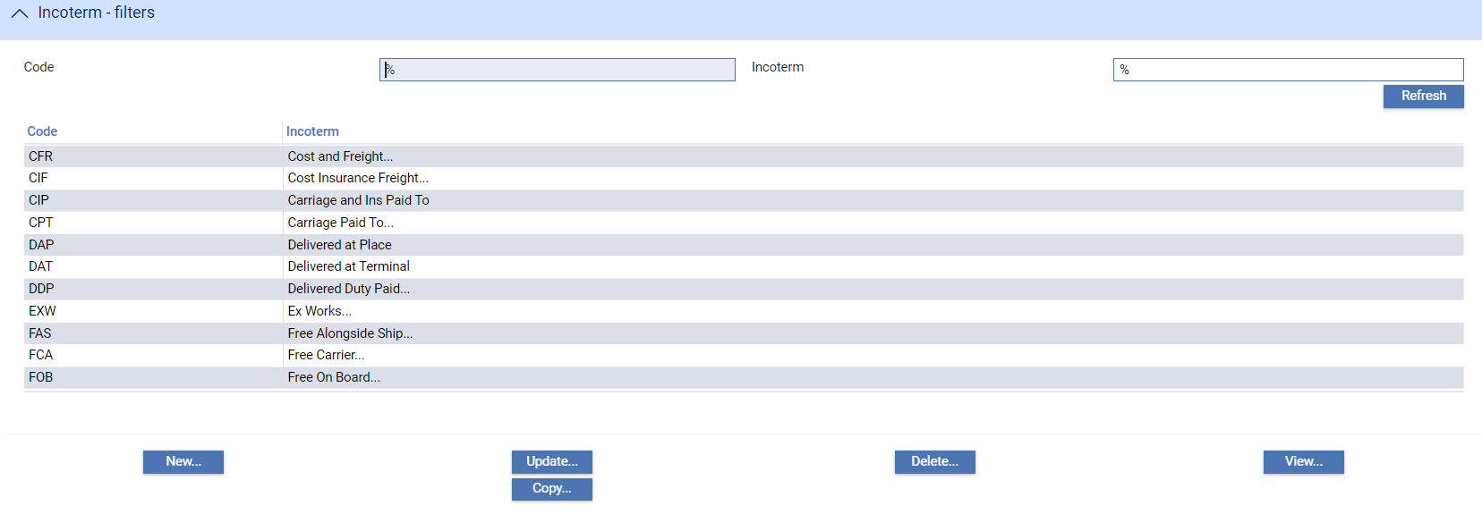

For data types such as incoterms, where it is expected that the system will be able to retrieve all entries without significant delay, the system lists all entries as the window opens. For data types such as customer addresses where there may be a large number of entries on your system, the browser window will be empty when you open it.

The fields above the listed data allow you to set criteria to define which entries are displayed using wildcard characters. Browsers use two wildcard characters:

* One to match any sequence of characters (in the illustration above, the percentage sign '%' is used in this way). This character will always be added at the end of whatever you type into the selection field. For instance, enter 'A%' and click **Refresh** to list all entries beginning with A; enter 'A%S' for all beginning with A, and with S elsewhere in their name (the system converts 'A%S' to 'A%S%')
* Another to match any single character. A question mark is typically used for this purpose. So by typing 'A?S' you can locate all entries beginning with A and having as their third letter S

1. Wildcard characters are used differently in some of the fields on the Master browser used during actual transaction processing.

When you enter any criteria required into the filter fields and then click **Refresh**, the system lists entries that fit your criteria. Note that search criteria are not case-sensitive.

The following buttons at the bottom of the browser window allow you to process static data items:

| Button | Action |
| --- | --- |
| New | allows you to create a new entry (see page 16). |
| Update | allows you to make changes to an existing entry (see page 16). |
| Delete | allows you to delete an entry (see page 17). |
| Copy | allows you to copy an existing entry (see page 17). |
| View | allows you to view an existing entry (see page 17). |

1. If you use any of the buttons listed above to create a new entry or to amend an existing one, when you return to the browser window click **Refresh**. In most cases the system will auto-refresh the display; but for some types of data (where the database table is expected to grow to be large) it does not. So clicking **Refresh** ensures that the information you see is up to date.

The Close link on the left-hand side of the screen closes the browser window and takes you back to the main static data menu.

### Creating a New Entry

To create a new entry, in the browser window click **New**. The system displays the window used to enter the required information.

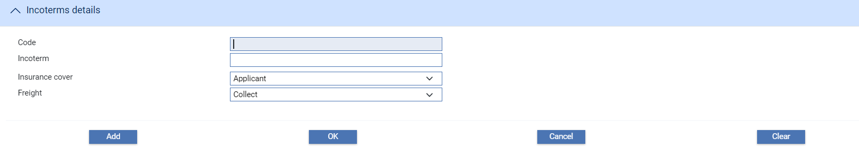

The fields will be blank, ready for you to enter the information to define the new entry. One of the fields will be a key field for the entry - in the illustration above it is the Code field - and the value entered into it must be unique.

When you have finished entering data you can click one of two buttons to save it:

* The **OK** button, which saves the data and closes the window, returning you to the browser window
* The **Add** button, which saves the data but keeps the window open for you to enter another entry. If you use this option, you can then use **Clear** to clear all the fields in the window

Once you close the window, the new entry is included in the list in the browser window.

If your bank is using Trade Innovation integrated with a back office system, a New Local button will be present that allows you to enter data on to the local database.

### Amending an Entry

To amend an entry, select it in the browser window, then click **Update**. The system displays existing information for the entry using a window like the one illustrated below.

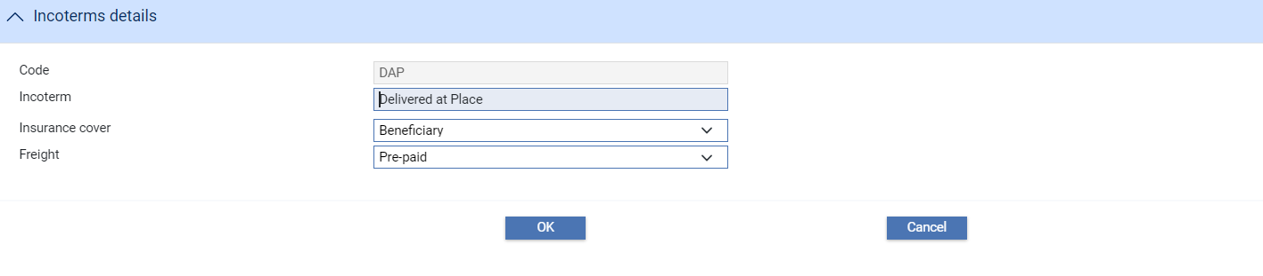

You can overtype any of the values in the window, with the exception of the key field. Click **OK** to save any changes you make and return to the browser window.

For some static data items a **View changes** button appears at the top of the screen

 This allows you to see changes that have been applied to a particular item.

### Deleting an Entry

To delete an entry, select it in the browser window, then click **Delete**. The system displays existing information for the entry.

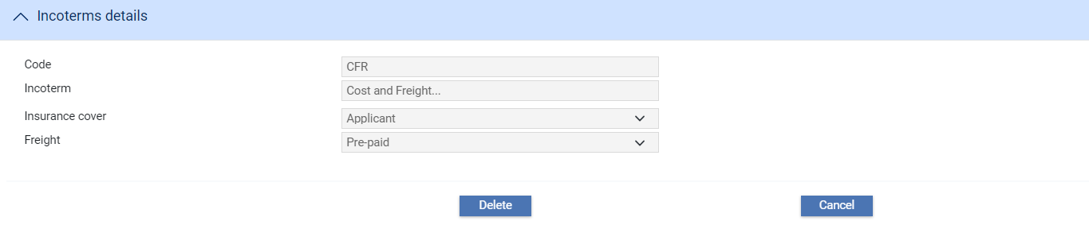

You can then click **Delete** to proceed with the deletion, or the Cancel button to abandon it. If you click **Delete**, the system issues a message requesting confirmation that you wish to proceed with the deletion.

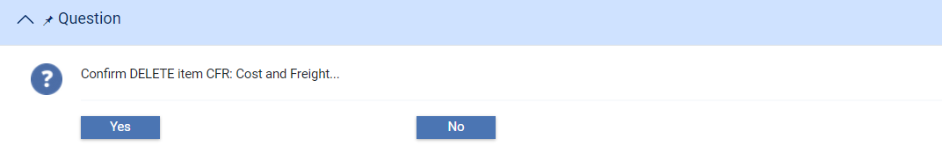

### Copying an Existing Entry

You can use the Copy button in the browser window to create a new entry, basing it on an existing one. To do this, in the browser window, select the entry you want to copy, then click **Copy**. The system opens a window like the one illustrated below.

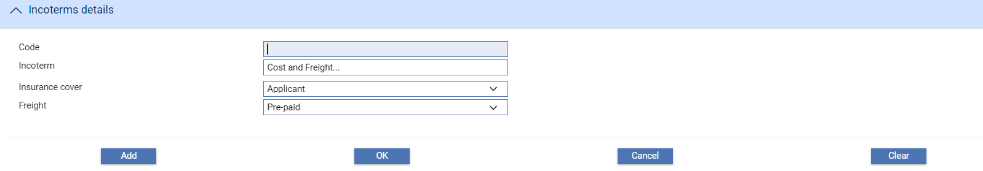

With the exception of the key field, which is blank, the fields contain the same values as for the existing entry, which you can overtype.

Once you have entered a value into the key field, click either **OK** or **Add** to save the new entry. These buttons work in the same way as when creating a new entry, as described in the earlier section (see page 16).

### Viewing an Existing Entry

To view an existing entry, select the entry in the browser window, and click **View**. The system displays existing information for the entry using a window like the one illustrated below.

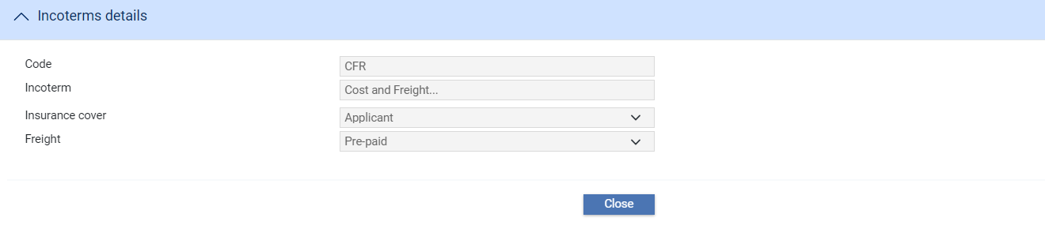

You cannot change anything in this window. Click **Close** to exit it and return to the browser window.

# Branches and Entity Types

This chapter covers business branches, branches and entity types.

## Branches

Within the system, each discrete legal and/or organisational component of a bank is considered a ‘business branch’, and those branches are expected to be arranged into a hierarchy that reflects the bank's structure, encompassing all lower business branches to the lowest ‘branches’ in which transactions are recorded.

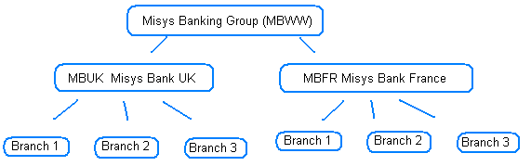

In the above example,

* MBWW – Misys Banking Group is a ‘banking group’, encompassing
* Two further ‘Banking businesses’ –each representing a ‘main banking entity’ (corresponding to a Back office general ledger):
* MBUK – Misys Bank UK
* MBFR – Misys Bank France
* Branches 1- 3 – are the individual transaction ‘branches’ in each main banking entity

Branches can be assigned to parent branches as they are defined or amended at a later date.

Branches can be assigned a time zone and a branch entity type. The time zone allows any one working with a transaction e.g. in a hub team to see transaction times in their own time as well as the branch’s time. The branch opening and closing times are mandatory, either defined for a branch or inherited from the branch hierarchy.

Once set up, branches are assigned parameter sets that allow sets of tailoring data covering items such as charges, postings, documents, interest types, product types, tracers, user defined messages and system option settings to be associated with a particular branch within the bank’s organisation. The relevant set is then used during transaction input according to the behalf of branch being used.

Branches are also assigned to teams. This determines who can enter transactions for the branches through the roles that have been associated with the team and its individual users.

When you select the Branches|Branches menu option the system opens a browser window that allows you to view the branches already set up. If the View by Hierarchy flag is checked the system shows the branches within their hierarchy; otherwise they are shown in alphanumerical order.

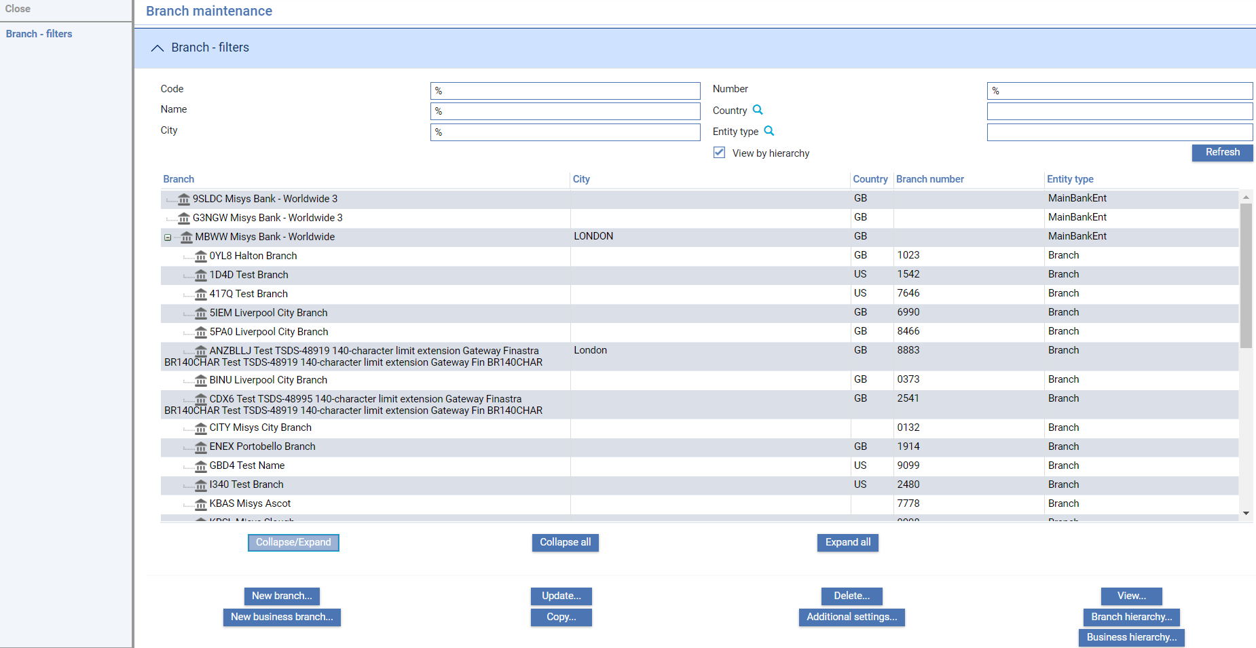

You are able to Add either a:

* New Business branch – this represents a banking business branch within the bank’s business hierarchy and can be defined as a main banking entity or banking group. No transactions can be booked against such a branch
* New branch – this is a transactional branch or non-transactional branch below a main banking entity

### Maintaining a Business Branch

To update/add a new business branch click **Update/New business branch...**.

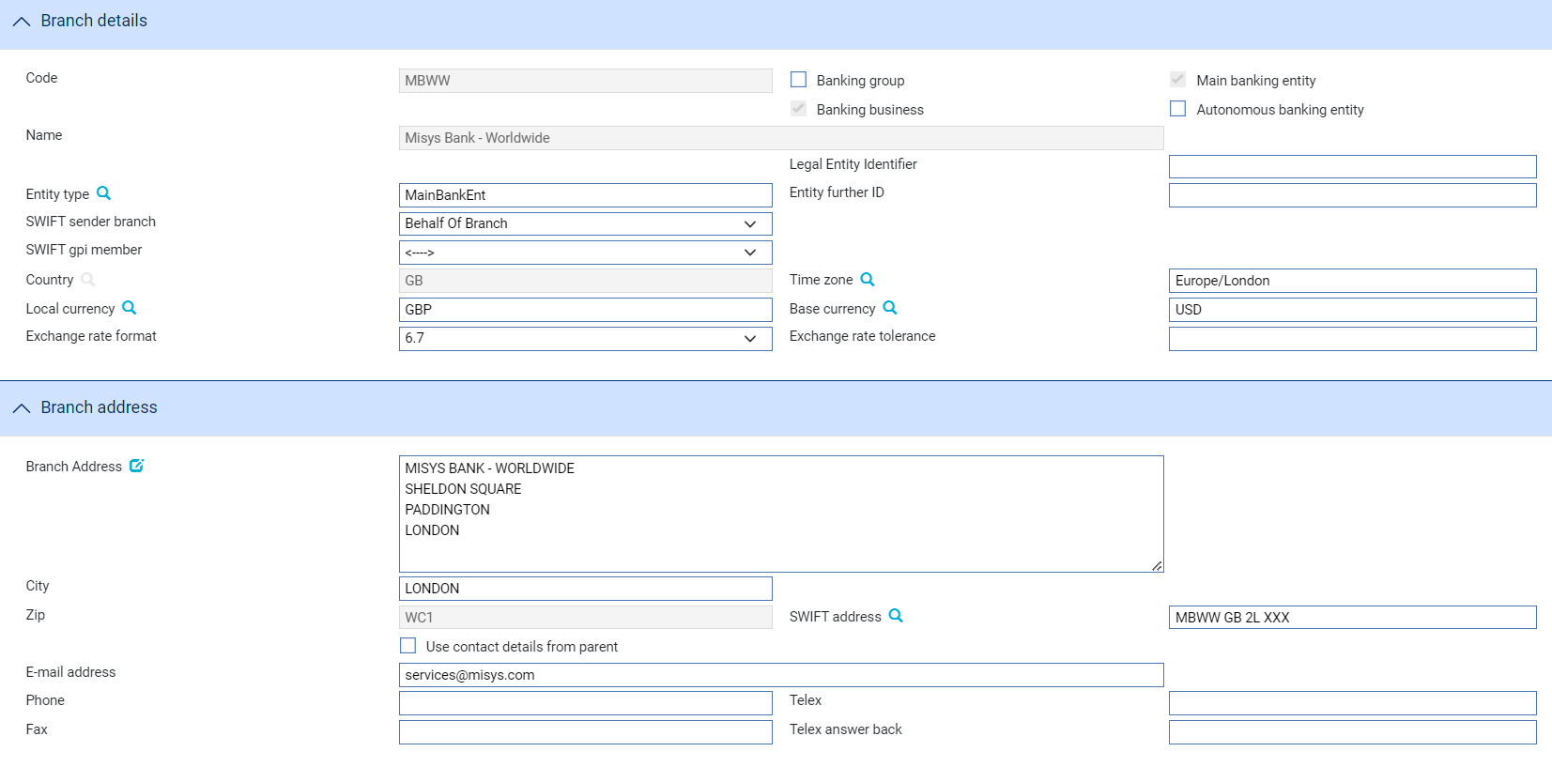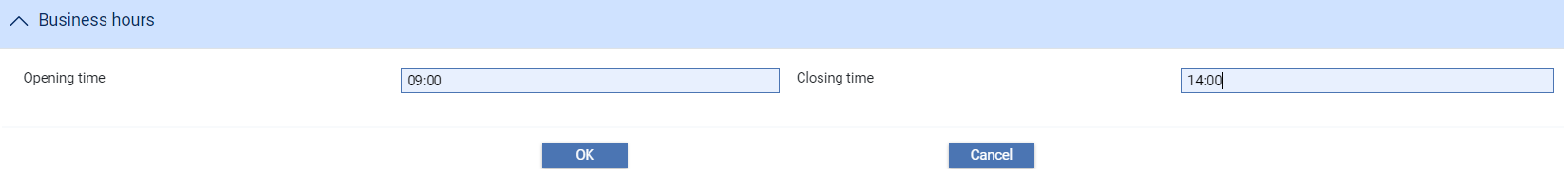

The following table explains what to enter into the fields displayed:

|  | Field | What to Enter |
| --- | --- | --- |
|  | Code | The unique alphanumeric code for the branch. |
|  | Name | The branch name. |
|  | Banking Group | Check this option if the branch you are setting up is a head office, i.e. a banking group covering one or more discrete banking businesses. |
|  | Banking Business | This option is always set for a banking business branch. |
|  | Main Banking Entity | Check this option if the branch you are setting up is a branch that represents a set of transaction branches associated with a single general ledger.  Where the branch is a main banking entity the following details are also required:   * Base currency * Exchange rate format * Exchange rate tolerance |
|  | Autonomous Banking Entity | Check this option if the branch you are setting up is an in-sourced banking unit – a separate autonomous banking business. |
|  | Entity Type | Bank defined banking entity type |
|  | Entity Further ID | Additional details about the branch entity. |
|  | SWIFT Sender Branch | The branch to be used when sending SWIFT messages for this branch. Either Input branch or Behalf of branch. |
|  | SWIFT gpi member | Bank branch is a member of the SWIFT gpi closed user group. Members include SWIFT gpi service type identifier (field 111) in MT 103*, MT 202* and MT 205* payment message headers. |
|  | Country | The branch country. |
|  | Time Zone | The branch time zone. |
|  | Local Currency | The branch local currency. |
|  | Base Currency | The base currency of the main banking entity branch. |
|  | Exchange Rate Format | The exchange rate format of the main banking entity branch, options presented as x.y - where x is the number of digits before the decimal point and y the number of digits after. Formats between 4.9 and 8.5 are available. |
|  | Exchange Rate Tolerance | The exchange rate tolerance of the main banking entity branch, as a percentage of the exchange rate. This is used to check that exchange rates entered are within sensible limits relative to the currency spot rate. |
|  | Branch Address | The branch address. Click on  to update the Structured Name and Address. |
|  | City | The branch city. |
|  | SWIFT Address | The branch SWIFT BIC address. |
|  | Zip | The branch zip code. |
|  | Use Contact Details from parent | If checked, the branch inherits its contact details from its immediate parent or higher levels. |
|  | E-mail Address | The branch e-mail address. |
|  | Phone | The branch telephone number. |
|  | Telex | The branch telex number. |
|  | Fax | The branch fax number. |
|  | Telex Answer Back | The branch telex answerback number at this address. This is a free format field. |
|  | Opening time | The time in 24 hour HH:MM format when the branch opens for business in local time. Field is mandatory in business branch entity at top of branch hierarchy. Lower branches can optionally inherit times from above in the hierarchy. Details shown in branch hierarchy defaults. |
|  | Closing time | The time in 24 hour HH:MM format when the branch closes in local time. Field is mandatory in business branch entity at top of branch hierarchy. Lower branches can optionally inherit times from above in the hierarchy. Details shown in branch hierarchy defaults. |

### Maintaining a Branch

To update/add a new branch, click **Update/New branch....**

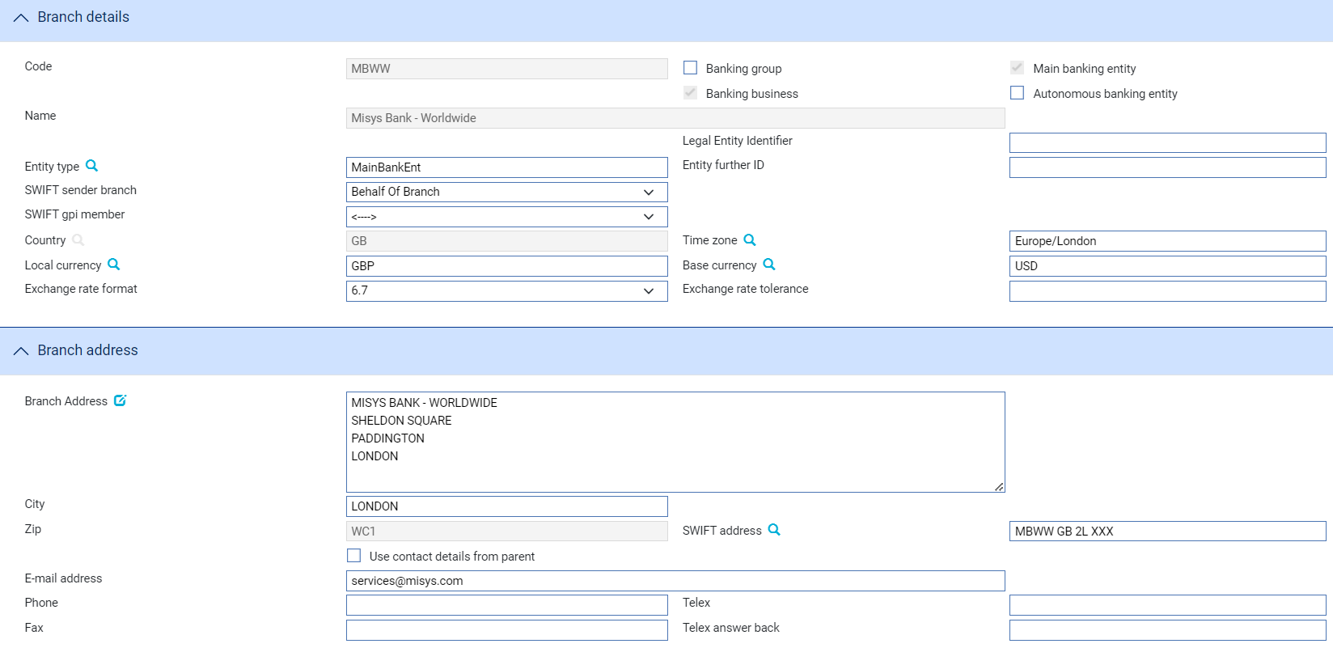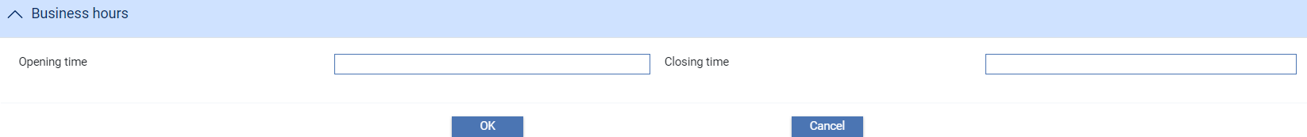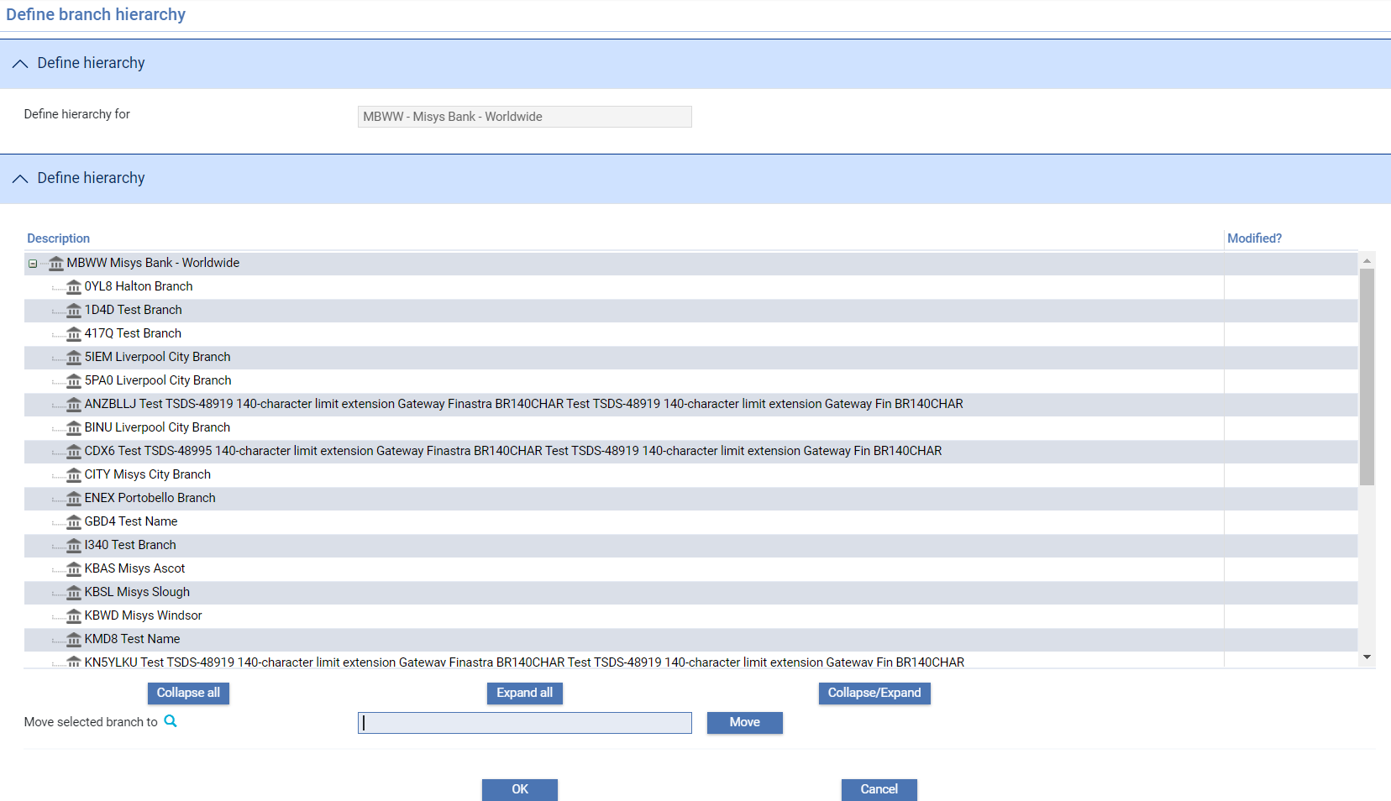

The following table explains what to enter into the fields displayed:

|  | Field | What to Enter |
| --- | --- | --- |
|  | Code | The unique alphanumeric code for the branch. |
|  | Accounting Number | The branch number, up to four digits. This number is used as the first field in account numbers for accounts belonging to this branch. |
|  | Name | The branch name. |
|  | Non-transaction Branch | Check this option if the branch you are setting up is not to permit transactions or accounts to be entered. It acts as a container for other branches, representing a group of branches defined below it in the hierarchy. |
|  | Main banking entity | The Main banking entity to which this branch belongs. |
|  | Entity Type | Bank defined banking entity type. |
|  | Entity Further ID | Additional details about the branch entity. |
|  | SWIFT Sender Branch | The branch to be used when sending SWIFT messages for this branch. Either Input branch or Behalf of branch. |
|  | Branch internal customer | Branch internal customer where contra accounts in this branch are held by internal customer. |
|  | SWIFT gpi member | Bank branch is a member of the SWIFT gpi closed user group. Members include SWIFT gpi service type identifier (field 111) in MT 103*, MT 202* and MT 205* payment message headers. |
|  | Country | The branch country. |
|  | Time Zone | The branch time zone. |
|  | Local Currency | The branch local currency. |
|  | Branch Address | The branch address. Click on  to update the Structured Name and Address. |
|  | City | The branch city. |
|  | SWIFT Address | The branch SWIFT BIC address. |
|  | Zip | The branch zip code. |
|  | Use Contact Details from parent | This field is displayed when you enter the parent branch. Enter the nominated branch to populate its contact details. |
|  | E-mail Address | The branch e-mail address. |
|  | Phone | The branch telephone number. |
|  | Telex | The branch telex number. |
|  | Fax | The branch fax number. |
|  | Telex Answer Back | The branch telex answerback number at this address. This is a free format field. |
|  | Opening time | The time in 24 hour HH:MM format when the branch opens for business in local time. Time can optionally inherit from above in the hierarchy. Details shown in branch hierarchy defaults. |
|  | Closing time | The time in 24 hour HH:MM format when the branch closes in local time. Time can optionally inherit from above in the hierarchy. Details shown in branch hierarchy defaults. |

Inheriting Details from the Branch Hierarchy

The following details may be inherited from either the immediate parent or higher levels within the branch hierarchy to save in duplicate set up. This applies to:

* Accounting number
* SWIFT BIC
* Country
* Time zone
* Business hours opening time
* Business hours closing time
* SWIFT gpi member

The inherited details are displayed in the Branch Hierarchy Defaults pane. Once a value is entered for this branch it is removed from the list of hierarchy defaults.

### Maintaining the Branch Hierarchy

The Branch hierarchy... and the Business hierarchy... buttons allow you to change the bank’s branch hierarchy.

The Branch hierarchy... button allows you to maintain the hierarchy of branches below a selected main banking entity. This would typically be used where you have introduced non-transactional branches and are grouping branches beneath them.

In the following example:

* 1D4D Test Branch

can be moved under:

* KBAS Misys Ascot

By entering KBAS in the Move selected branch to field and highlighting each branch in turn and selecting Move – as follows:

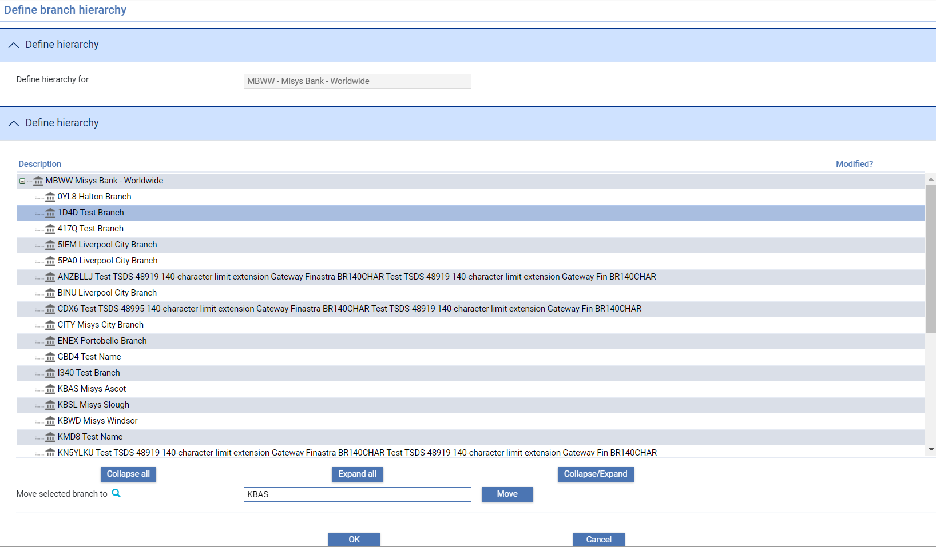

Resulting in the following:

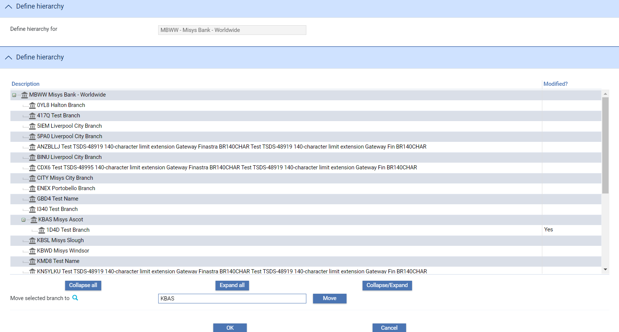

The modified column shows branches that have been moved. The set of changes made are applied when the OK button is selected.

The Business hierarchy... button allows you to similarly maintain banking businesses at main banking entity or above. For example, allowing you to move:

MBWW Misys Bank - Worldwideto be part of the banking business.

9SLDC Misys Bank - Worldwide 3

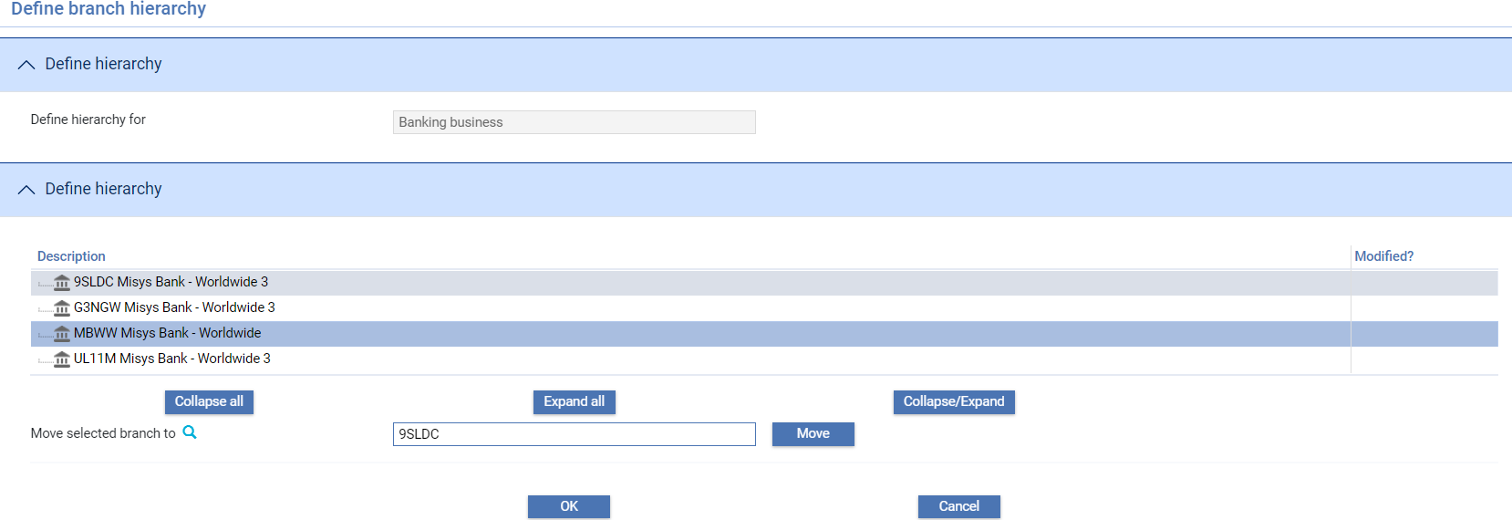

### Special Considerations when Deleting Branches

The system will not allow you to delete a branch that is in use - that is, it is referenced by other static data records, system tailoring information or live transactions.

## Entity Types

Entity types are entered as part of defining your branch details allowing your bank to categorise branches. Your bank sets up its own values for entity types, giving each a unique ID and a description.

Entity types are not mandatory, and the entity type setting is not inherited by child branches. Entity types are not used in the system except as a filter field on the Branch Browser; however your bank can create reports using this value (for example, to report by type of branch).

Entity types are set up using the static data application's General|Branch Entity Types menu option.

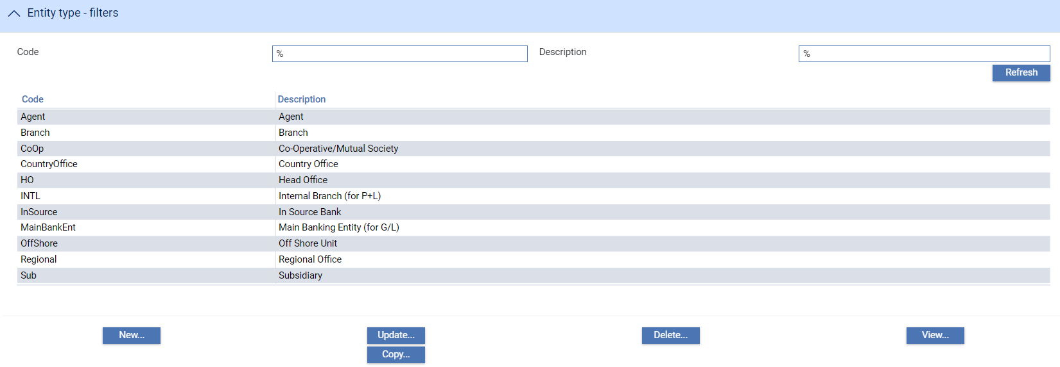

The screen displays a list of all the branch entity types already set up on your system.

To set up a new branch entity, click **New**.

The window used to create a new branch entity type allows you to enter a unique code for the branch entity type and a description. Both fields are mandatory.

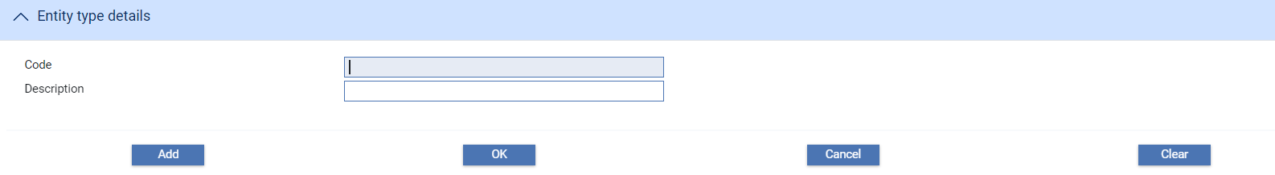

# Customers

This chapter explains how to use the system to enter and maintain customer information. It covers details of the customers, their addresses and settlement instructions, and information specific to the system, such as whether or not they are a corporate access customer. It also covers some of the parameters used when defining customer details, including:

* Customer types
* Customer groups
* Customer charge groups
* Account officers
* Analysis codes

## Customers in Trade Innovation

The system allows your bank’s main customer details to be retrieved from different sources for different parts of the bank’s business. This source is determined by the ‘service’ associated with a main banking entity branch or higher. As a result, customer details are held in the system for each ‘source banking business’ that provides the data and are used by all branches below that business. This can enable a bank to have a central customer information service associated with a banking business or group covering multiple main banking entities. The service definition allows details to be retrieved from either:

* An internal service – where details are added manually in the system or replicated to the system from an external system or
* An external service – where real time requests are made to an external system for customer details

Additionally, local customers can be added for use only in the system. These customers are also associated with the relevant ‘source banking business’. These customers are used to entered details of parties that are regularly used in the system but are not customers of your bank. Entering details in this way means data associated with the customer can be readily retrieved rather than being re-keyed each time the party is used. A local customer cannot have any accounts associated with them. Local customer functionality is controlled by the Customer service system option LocalCustomerAllowed. The customer mnemonic range assigned to local customers is defined using Local Customer definition, for example LCUS-xxxxxxxx, see System Tailoring User Guide – Trade Innovation.

### Customer Addresses and Address Types

The system permits you to set up various addresses for your customers, including:

* A prime postal address (which indicates the transfer method to be used for communications sent to the customer)
* Additional associated addresses of other parties to whom correspondence is to be sent, for example when issuing a letter of credit a copy of the letter of credit may need to be sent to the applicant, plus their head office and corporate lawyer
* A SWIFT BIC address
* A SWIFT- compatible address, if necessary

SWIFT-related addresses are covered in the chapter SWIFT Related Static Data.

### Address Types

Address types are used in the following two ways

* An override address type can be added for Prime and SWIFT address at Product level. This allows different addresses for a customer to be defined by Product.
* Address types which are used to define Additional addressees - i.e. one or more people who should also get a copy of the document sent to the main addressee.

Additional Addressee Address types can be defined in a hierarchy. For example, this allows additional addressees to defined when issuing LCs ( LC01) or Amending (LC011) or Cancelling (LC012) .

When documents are produced, the system will look for addressees at a specific level such as LC011 when generating Amendment advices but if a Customer does not have specific addressees defined for that type, it will search at the next level e.g. LC01 (and so on up the hierarchy until any addressees are found or no further address types in the hierarchy ) and so, in the case, will send documents to the same addressees as when the original issuance was generated.

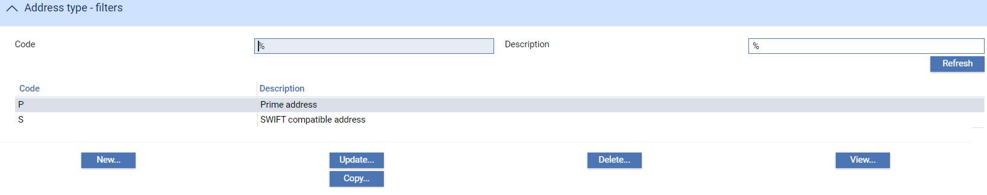

### Product level address types

If a bank wants to define Product specific addresses for a customer, then it is necessary to

* Define the required Address types to be used e.g. ILCP or ILCS as defined by the bank
* Specify the address types against the relevant Product
* Enter specific Product level addresses for each Customer

For example:

Address types ILCP and ILCS are added

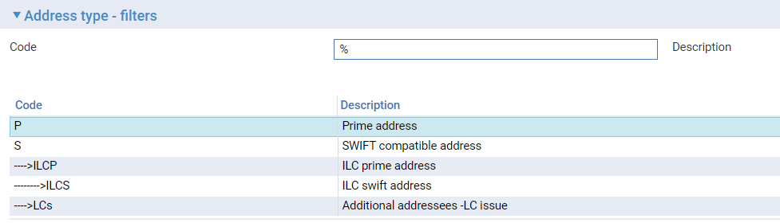

#### Product options

ILCP and ILCS are defined on the Product specifying which address to be used for the Product.

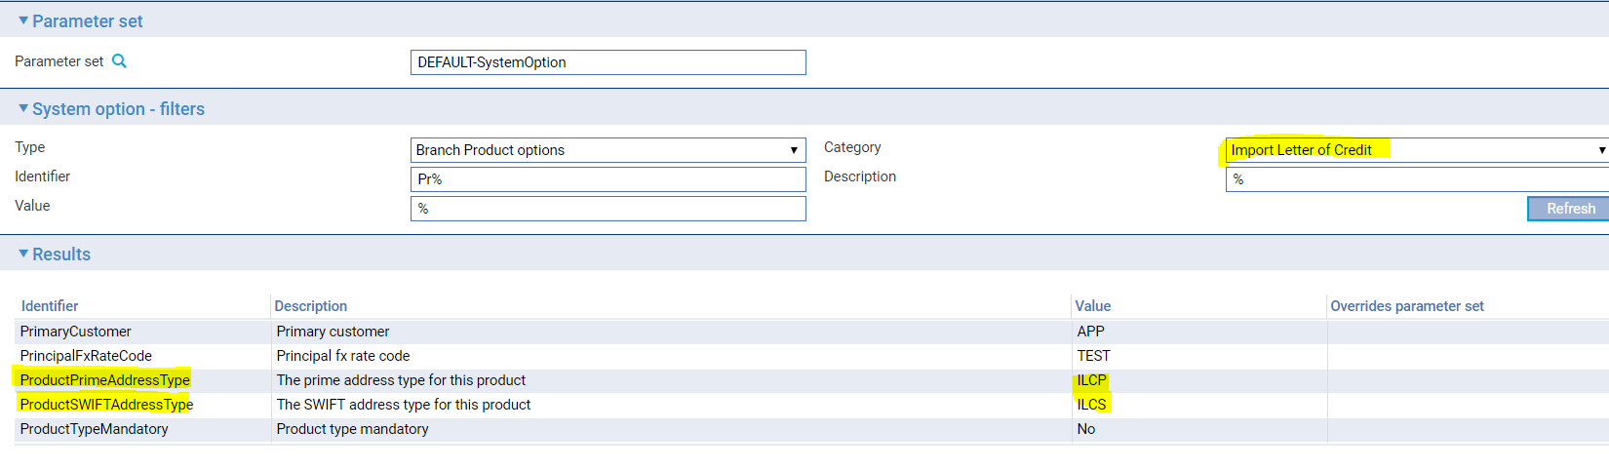

#### Customer addresses

Specific Product level address are defined for the Customer

* GREEN ILCP - Green (LCS) department
* GREEN ILCS - Green LCS department SW

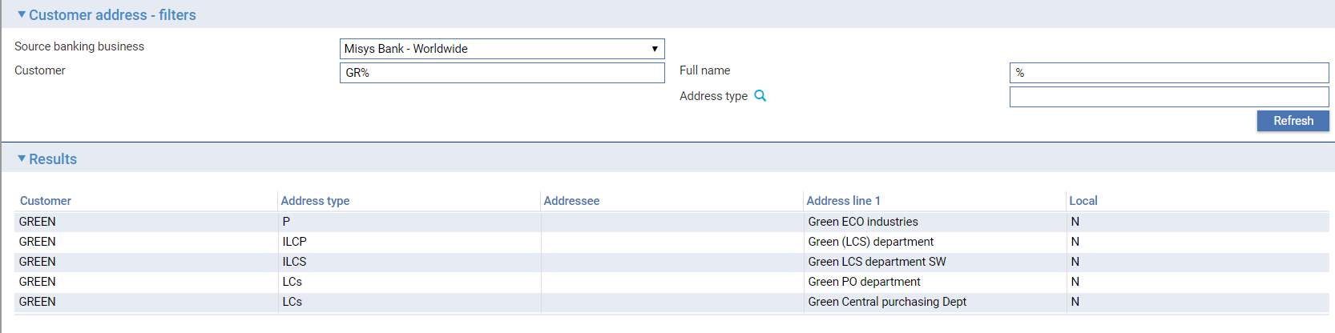

When processing transactions against the Product then the prime documents are generated using the Product specific addresses rather than the P – Prime address type (However, in the absence of a product level address the standard prime and SWIFT address is used as a default)

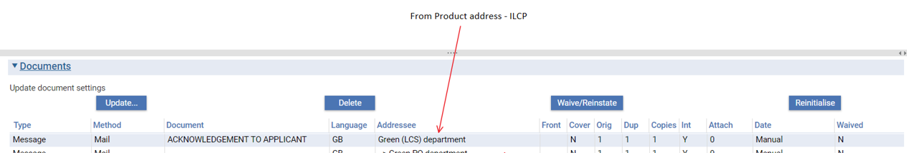

### Address types for Additional Addressees

Address types are used by the system to retrieve any additional addressees when generating documents e.g. an address type of ‘LCs’ that is defined against a document to be produced will result in a copy of the document being sent to all additional addresses of that address type for the recipient customer.

For example

1. Address type **LCs – Additional addressees – LC issuance** is used to denote additional addressees that documents are to be sent to when sending an Acknowledgement to an Applicant
2. Customer GREEN requires documents to be sent to themselves but also sent to the following addressees (as per customer addresses defined above)

**LCs -** Green PO Department

**LCs–** Green Central purchasing department

1. When setting up document types, your bank can also define an address instruction, and this identifies which of the recipient's associated addresses are to be used when generating documents.

During transaction processing, when a customer document is to be produced, the system checks whether the document type has an address type. If it does the system checks whether the recipient has any associated addresses set up for that address type. If so, those addresses is used. If not, the system checks the next level up in the address type hierarchy, and then the next one after that, until it finds one. If none is found, then documents are only produced for the customer's prime address.

Example:

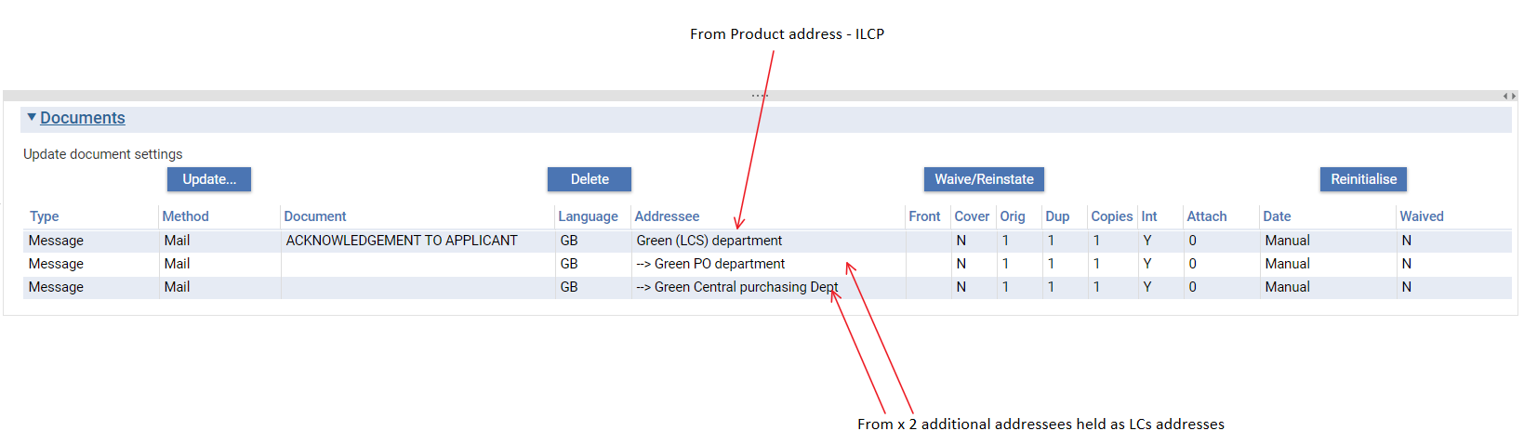

### Sundry Customers

In some cases payments may be made to parties who are not defined as customers of the bank. In such cases, the system posts liability entries to accounts using a general-purpose customer that can be readily identified. The same customer is also used to identify general funds movements arising from trade finance activities.

You will need to set up one or more sundry customers for this purpose. You can use a single sundry customer to identify all trade finance activities, named for example 'Sundry TF', or you can set up separate customers for use with different products, such as letters of credit, collection orders and guarantees.

## Customers

Customer details are entered and maintained using the Customer Maintenance|Customer Details menu option.

If Maker Checker is being used in your system, you will only be allowed to view this function. Any changes will need to be made in the Maker Checker application. See the *Maker Checker User Guide – Trade Innovation* for further details.

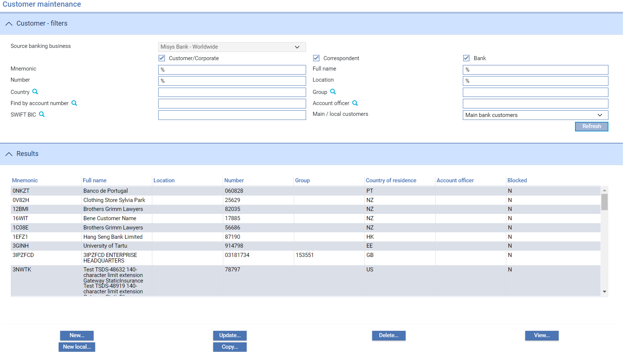

Initially the window is blank. Use the filter fields to select the relevant source banking business and to set other filter criteria, and then click **Refresh**.

The New Local... button will only appear if your bank is using TI local customers (see page 28).

The following table explains what each of the columns in this window shows:

|  |  |
| --- | --- |
| Heading | What it Shows |
| Mnemonic | The customer's unique identifier. |
| Full Name | The customer's full name. |
| Location | The customer’s location. |
| Number | The customer's unique basic number. |
| Country of Residence | An abbreviation indicating the customer's country of residence. |
| Account Officer | If the customer has an account officer, that officer's code is shown here. |
| Blocked | Indicates whether there are any restrictions on deal input for the customer. N indicates no restrictions; Y indicates that deals will not be accepted for this customer. |

Information displayed in this window is ordered alphabetically by customer identifier, however, if the Customer service system option AllowFilterOnLocation is set and a search is entered including full or partial Name  (ABC or  ABC%) or location the details are sorted in Full name, Country and Location  order.

To enter details of a new customer click **New**.

### Entering Details of a New Customer

New customers are defined using the following panes:

* The Customer Details pane
* The Basic Details pane
* The Address Details pane
* The Special Instructions pane (see page 36)
* The Other Details pane

#### The Customer Details Pane

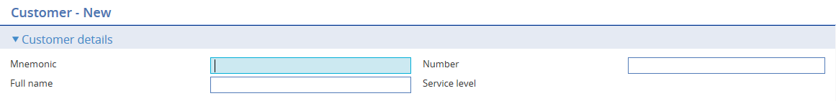

The following table explains what to enter into the fields in the Customer pane:

|  |  |  |
| --- | --- | --- |
|  | Field | What to Enter |
|  | Mnemonic | The unique identifier of the customer for whom you are setting up additional information. |
|  | Full Name | The customer’s full name.  When the system option StructuredNameandAddressAllowed is enabled, this field is updated with the Name from the Structured Name and Address details screen. |
|  | Number | Customer basic number. |
|  | Service Level | Service level of the customer. |

#### The Basic Details Pane

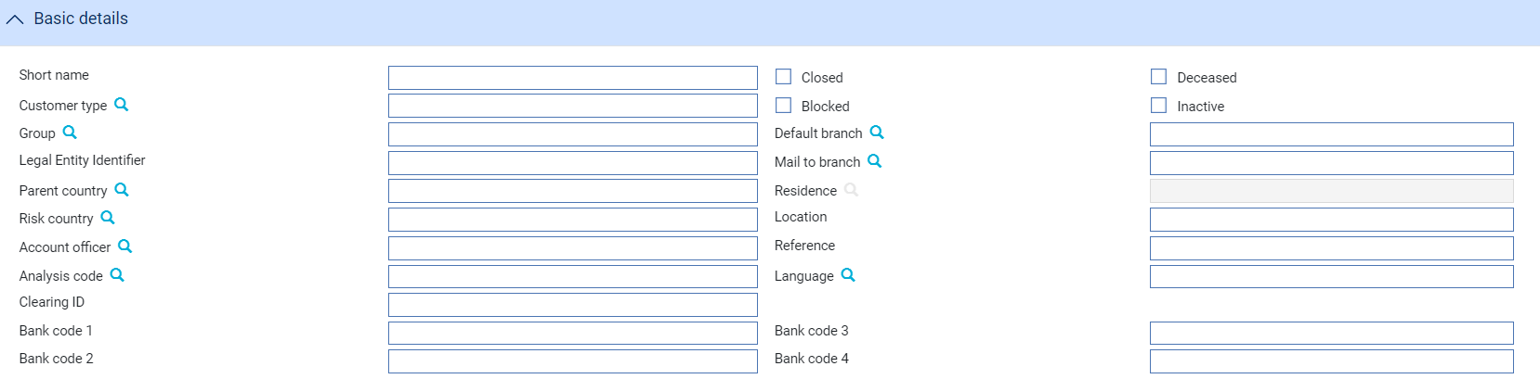

The following table explains what to enter into the fields in the Basic pane:

|  | Field | What to Enter | |
| --- | --- | --- | --- |
|  | Short Name | The customer's short name, used as the default name when opening accounts for that customer. | |
|  | Closed | If checked, this field prevents any new accounts from being opened for the customer. | |
|  | Deceased | If checked, this field indicates that the customer is deceased or in liquidation. | |
|  | Blocked | If checked, this field indicates that deals will not be accepted for this customer. | |
|  | Inactive | If checked, this field indicates that the customer is inactive. | |
|  | Customer Type | Used to categorise the customer in the Customer Browser window. Select from: | |
|  |  | Customer/Corporate | If the customer is a corporation or private individual. |
|  |  | Correspondent | If the customer is a bank that you may use as a correspondent bank. |
|  |  | Bank | If the customer is a bank. |
|  | Group | If relevant, the group to which the customer belongs. | |
|  | Default branch | The Customer’s default branch | |
|  | Legal Entity Identifier | The Customer’s Legal Entity Identifier | |
|  | Mail To Branch | The branch to which trade finance documents are to be sent, if different from the customer's branch. | |
|  | Parent Country | Indicates the customer's parent country. | |
|  | Residence | Indicates the customer's country of residence. Your local country code is used as the default. The country code entered here is attached to accounts opened for this customer. For countries participating in euro, the country code is used to identify a calendar providing valid settlement dates for that country. | |
|  | Risk Country | Indicates the customer's country for risk purposes. | |
|  | Location | The primary location of the customer, such as city, area or region | |
|  | Account Officer | If relevant, the department or account officer responsible for the customer. | |
|  | Reference | The customer's reference. This field can be used to hold, for example, the customer's registration number, social security number or any other such identifier external to the system. | |
|  | Analysis Code | Used for reporting purposes. Your bank will have devised its own values for using this field. | |
|  | Language | If the customer requires documents sent to them in a language other than English, this field shows the code of the language to be used. | |
|  | Clearing ID | For banks and correspondents, their clearing number with the local clearing system. | |
|  | Bank Code 1 – 4 | Codes that can be used for your bank's own purposes. | |

#### The Address Details Pane

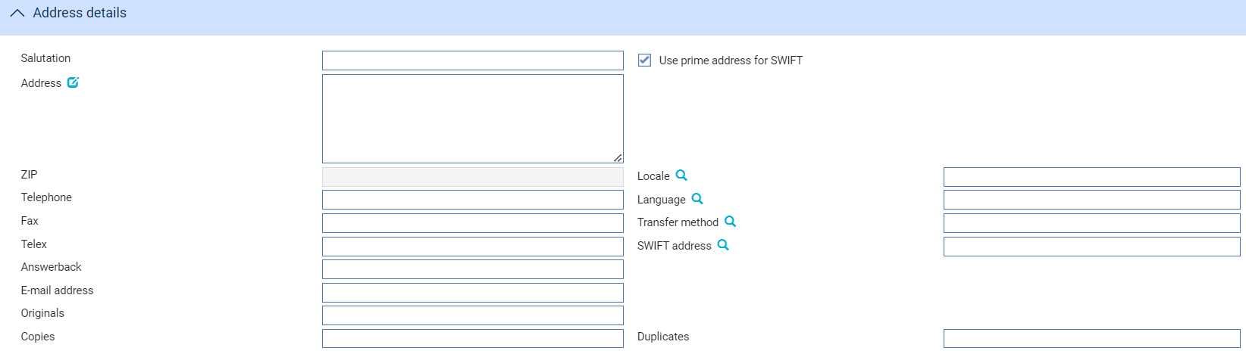

The following table explains what each of the fields in the Address Details pane hold:

| Field | What to Enter |
| --- | --- |
| Salutation | The text to appear at the beginning of correspondence sent to this address. Depending on how document templates to be used for correspondence sent to this address have been set up, you can enter just a salutation, for example 'Dear Sir'; a salutation, such as 'Dear', followed by a name; or, if the salutation has been included in the document template, just a name.  See the System Tailoring User Guide – Trade Innovation for more information on document templates. |
| Address | The customer's prime name and address, up to five lines. This is the customer's main name and address, used for mailing purposes. e.g.  ABC Limited  12 Edgware road  LONDON  WC1 ED1  Enter the name in the form in which it should appear in customer documents. This need not be the same as in the Full Name field: for example, you could enter 'Andrew Graham Jones' in the Full Name field, and 'Mr A G Jones' as the first line of the Address Details field. Documents will then be produced as addressed to Mr A G Jones.  It is important that your bank should be consistent in the way you enter all your customers' names and address details.  Click on  to update the Structured Name and Address. |
| Use Prime Address for SWIFT | Check this field if the customer's prime postal address is to be given as their address in SWIFT messages. Alternatively, in the other field enter an address valid for use by SWIFT. This can be up to four lines and must include only characters that are valid for use via SWIFT. |
| ZIP | The post code or ZIP code. |
| Telephone | The customer's telephone number at this address. This is a free format field. |
| Language | Indicates the language to be used for documents sent to this address. If blank, the language used is English. |
| Fax | The customer's fax number at this address. This is a free format field. |
| Transfer Method | Indicates the transfer method to be used for correspondence with this address. |
| Telex | The customer's telex number at this address. This is a free format field. |
| SWIFT Address | The customer's SWIFT BIC address (see page 116).  If your bank uses a SWIFT BIC file you can use the browser to select an address from that file, although the value you enter here is not required to match with an entry on the SWIFT BIC file.  If your bank sends or receives MT messages using SWIFTNet FIN and participates in the ‘SCORE (Standardised Corporate Environment) service; then the customer SWIFT BIC may be quoted in MT798 messages in lieu of a customer mnemonic.  If a SWIFT BIC is received, the system attempts to identify the customer from that SWIFT BIC address. If the customer can be identified in this way, their customer details are retrieved and mapped to the appropriate fields in the event.  Note that where a mnemonic is not known, it is possible to search, using the SWIFT BIC, for a (principal or non-principal) party to a transaction via the Trade Finance Processing and Clean Payments Processing Master Browsers. A ‘SWIFT BIC’ field is available on the Master Browser which accepts wildcard searches.  Refer to the Common Facilities User Guide – Trade Innovation for more details. |
| Answerback | The customer's answerback number at this address. This is a free format field. |
| E-mail Address | The customer's e-mail address at this address. This is a free format field. |
| Originals | The number of original documents to be sent to the customer or addressee. |
| Copies | The number of copies to be sent to the customer or addressee. |
| Duplicates | The number of duplicates to be sent to the customer or addressee. |

#### The Special Instructions Pane

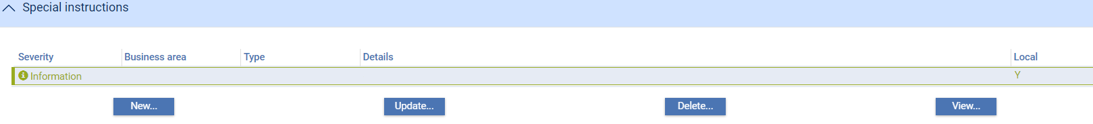

The Special Instructions pane allows you to set up, amend and delete special instructions. When you click **New** a window opens that allows you to define special instructions.

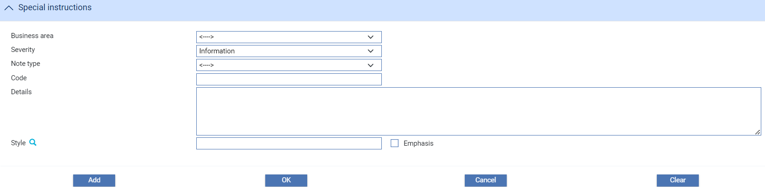

The following table explains what to enter into the fields in this window:

| Field | What to Enter |
| --- | --- |
| Business Area | The business area to which the special instructions pertain. |
| Severity | The severity of the special instructions:   * Error * Warning * Information |
| Note Type | Select the category to which the special instructions are to belong. |
| Code | If your bank runs Trade Innovation integrated with a back office system, then the note may have a related customer information number. If so, enter it here. |
| Details | The actual special instructions. |
| Style | Displayed only for special instructions with a severity level of 'Information'.  Select the style to be used to display the special instructions. If a style has been set up for the note type, that is used as the default style. The style selected here determines the text and background colours used to display the special instructions. |
| Emphasis | Check this field if you want the special instructions to be displayed bold, rather than normal weight. |

#### The TI customer Details Pane

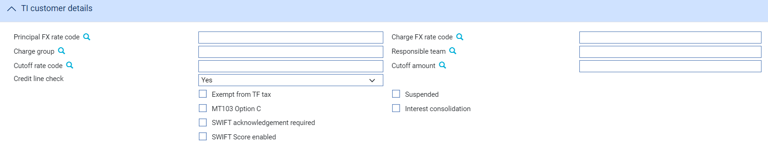

The TI Customer Details pane allows you to enter information that is used only by Trade Innovation, and not by any back-office system it may be integrated with. The following table explains what to enter into the fields in the TI Customer Details pane:

| Field | What to Enter |
| --- | --- |
| Principal FX Rate | The exchange rate to be used when converting principal amounts to another currency for this customer. |
| Charge FX Rate | The exchange rate to be used when converting charge amounts to another currency for this customer. |
| Charge Group | To include the customer in a particular customer charge group select the customer charge group code (see page 68) here. |
| Responsible Team | The responsible team associated with the customer. |
| Cutoff rate Code / Cutoff Amount | Use the first field to enter an amount for foreign exchange deals, above which a different rate code - defined using the second field - is to be used for this customer. The amount is entered in base currency. You can leave either, or both, of these fields blank.  Cutoff amounts and rate codes can also be entered at product and system level. During transaction processing, the system will look for values entered against the customer first, then against the product. If it fails to find values at customer or product level it will use the values entered at system level instead. The system thereby permits you to enter different cutoff amounts (or rates) for different customers, while using the same cutoff rate (or amount) at product- or system-level. |
| Suspended | The Suspended flag is present only if the AllowCustomerSuspensionInput system option is set, and allows the customer to be flagged as suspended. |
| Exempt from TF Tax | If checked, this field indicates that the customer is exempt from trade finance tax. |
| MT103 Option C | Check this field if this customer accepts SWIFT MT103 Customer Transfer messages in format C. |
| Interest Consolidation | Displayed only if you have the system 's consolidated interest functionality implemented. (This is controlled by the AllowAutoMonthlyInterest system option.) If you check this field, for selected customers then the interest accrued to date on transactions belonging to product types that are also flagged as supporting interest consolidation will be included in monthly interest consolidation and debited automatically. |
| SWIFT Acknowledgement Required | This field is displayed if the SWIFTProcessAcknowledgements system option is set to Yes. This means that your system supports automatically generated correspondence messages providing SWIFT acknowledgement information. If this customer requires acknowledgement of SWIFT messages, check this box.  During transaction processing, the system will automatically acknowledge SWIFT messages for outward SWIFT messages for transactions where:   * The primary customer has the SWIFT Acknowledgement Required field checked. * The outward SWIFT message has also been identified as requiring acknowledgement messages to be produced for that product (as described in the System Tailoring User Guide – Trade Innovation).   See the Common Facilities User Guide – Trade Innovation for more information on the automatic handling of SWIFT acknowledgements. |
| SWIFT Score enabled | Check this field if the Customer has opted for SWIFT Score messages. |
| Credit Line Check | If CheckCL system option is set to Yes, credit line checks are to be carried out for this customer. For more information on setting product options see the System Tailoring User Guide – Trade Innovation. |

#### Mapped corporate access systems pane

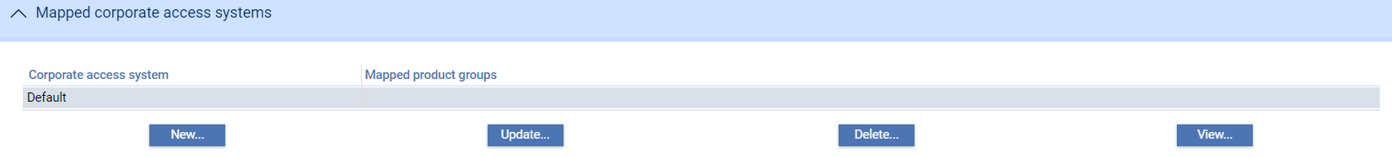

The mapped corporate access systems pane allows you to link Corporate access systems which the Customer is using. The Bank maintains the Corporate access systems in System tailoring|Corporate access systems screen.

#### Maintenance Considerations

With the exception of the customer's basic number and unique identifier, all other details held for a customer can be amended (where a customer details are maintained in the system via internal service).

If you change a customer's team, you can ensure that the team on outstanding transactions is also updated. You can do this by including the Auto-update Team action in an overnight batch processing phase, as described in the Business Operations Guide *– Trade Innovation*. To remove a customer from the system, set the Status field for the customer to ‘Closed’. You can do this in one of two ways:

* By selecting the customer in the Customer browser window and clicking **Delete**. The following message is displayed.

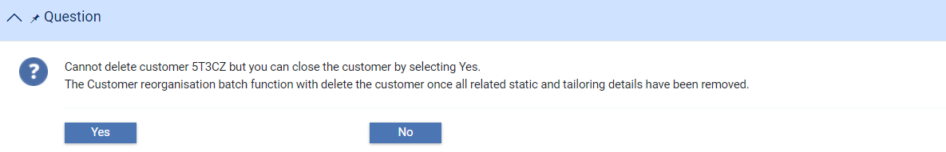

* By selecting the customer in the Customer browser window, clicking **Update**, and then checking the Closed box in the Status pane.

When a customer's status is set to 'Closed', the system prevents any new accounts from being created for that customer.

Once a customer has been flagged for removal, the customer details are retained by the system until overnight processing deletes them. In the meantime, you can reactivate the customer by unchecking the Closed box. The system deletes the customer as part of Batch processing when there are no associated accounts, standing settlement instructions, billing details and Supply Chain Finance programmes held for the customer.

#### Customer mnemonic maintenance

The system allows external systems to pass details of customer mnemonic changes that are required, allowing your bank to amend customers' unique IDs. Any requested changes to a customer's mnemonics are stored and applied to the database during the next overnight processing, see the Business Operations Guide – Trade Innovation.

For each customer whose details are changed an entry is written in the journal file, showing values for the old and the new customer mnemonic.

These changes are made to the key fields in the database, but are not applied to any rules or customised fields you have set up. Therefore, if you have rules set up based on customer mnemonic or customised fields which hold this data you must change these manually the day after the customer mnemonic was changed before users log on to the system.

In the event that overnight processing of this update function fails, you will need to perform the update manually, using the system’s configuration application. This application includes the Special|Repair Customer Mnemonic menu option, which permits you to enter an old customer mnemonic and then apply it to the system’s database.

## Additional Customer Details

The Customer Maintenance|TI Customer Details menu option allows you to access these details for amendment. When you select this menu option the system lists all customers for the selected source banking business for whom additional information has been set up.

If Maker Checker is being used in your system, you will only be allowed to view this function. Any changes will need to be made in the Maker Checker application. See the *Maker Checker User Guide – Trade Innovation* for further details.

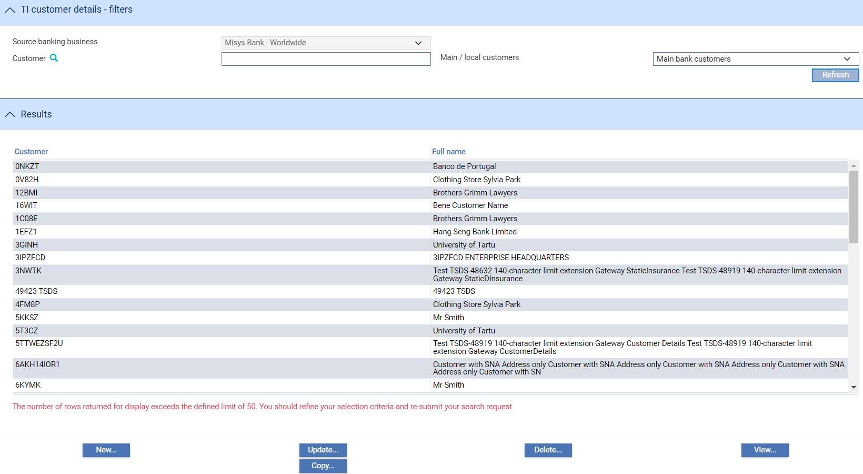

To enter additional information for a customer click **New**.

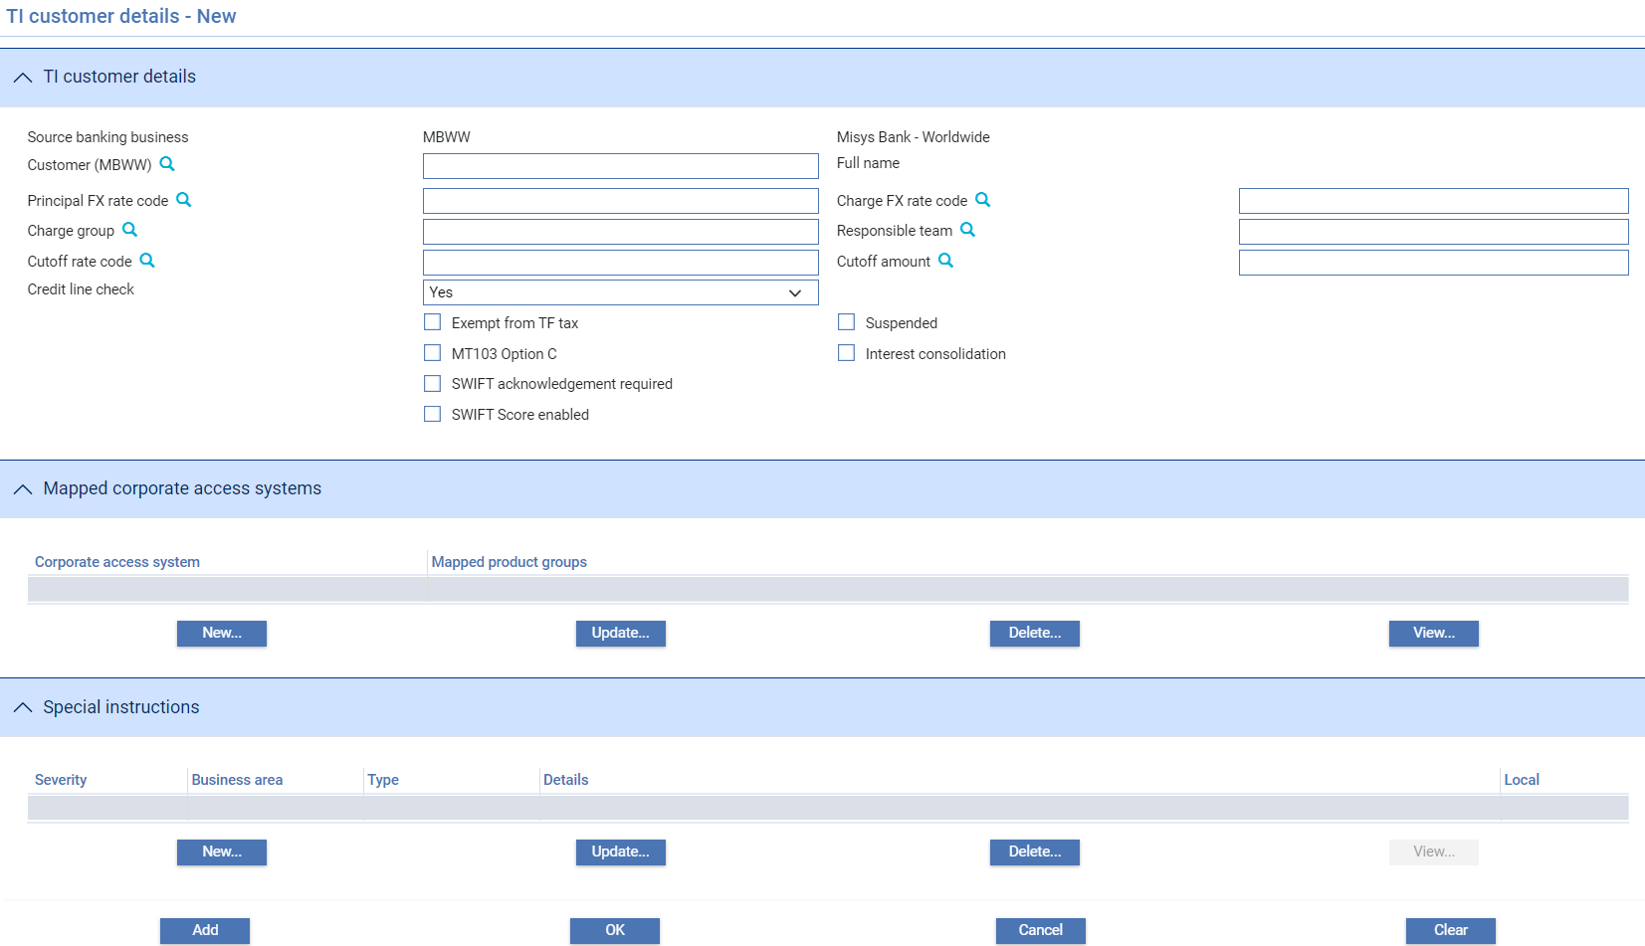

The following table explains what to enter into the fields in this window:

| Field | What to Enter |
| --- | --- |
| Mnemonic | The unique identifier of the customer for whom you are setting up additional information. |
| Full Name | The customer's full name. |
| Principal FX Rate | The exchange rate to be used when converting principal amounts to another currency for this customer. |
| Charge FX Rate | The exchange rate to be used when converting charge amounts to another currency for this customer. |
| Charge Group | To include the customer in a particular customer charge group select the customer charge group code (see page 68) here. |
| Responsible Team | The responsible team associated with the customer |
| Cutoff rate Code / Cutoff Amount | Use the first field to enter an amount for foreign exchange deals, above which a different rate code - defined using the second field - is to be used for this customer. The amount is entered in base currency. You can leave either, or both, of these fields blank.  Cutoff amounts and rate codes can also be entered at product and system level. During transaction processing, the system will look for values entered against the customer first, then against the product. If it fails to find values at customer or product level it will use the values entered at system level instead. The system thereby permits you to enter different cutoff amounts (or rates) for different customers, while using the same cutoff rate (or amount) at product- or system-level. |
| MT103 Option C | Check this field if this customer accepts SWIFT MT103 Customer Transfer messages in format C. |
| Exempt from TF Tax | If checked, this field indicates that the customer is exempt from trade finance tax. |
| Suspended | The Suspended flag is present only if the AllowCustomerSuspensionInputsystem option is set, and allows the customer to be flagged as suspended. |
| SWIFT Acknowledgement Required | This field is displayed if the SWIFTProcessAcknowledgements system option is set to Yes. This means that your system supports automatically generated Correspondence messages providing SWIFT acknowledgement information. If this customer requires acknowledgement of SWIFT messages, check this box.  During transaction processing, the system will enable automatic SWIFT acknowledgement processing for outward SWIFT messages for transactions where:   * The primary customer has the SWIFT Acknowledgement Required field checked * The outward SWIFT message has also been identified as requiring acknowledgement messages to be produced for that product (as described in the System Tailoring User Guide – Trade Innovation).   See the Common Facilities User Guide – Trade Innovation for more information on the automatic handling of SWIFT acknowledgements. |
| Interest Consolidation | Displayed only if you have the system 's consolidated interest functionality implemented. (This is controlled by the AllowAutoMonthlyInterest system option.) If you check this field, for selected customers then the interest accrued to date on transactions belonging to product types that are also flagged as supporting interest consolidation will be included in monthly interest consolidation and debited automatically. |
| Credit Line Check | If CheckCL system option is set to ‘Yes’, credit line checks are to be carried out for this customer. For more information on setting product options see the *S*ystem Tailoring User Guide – Trade Innovation. |

## Mapped Corporated access system pane

Corporate access systems are a special type of external system used by banks to allow their customers to communicate with the system. Click on the New button to add a Corporate Access System. The existing details can be Updated/Deleted/Viewed.

## Special Instructions pane

Special Instructions for the Customer can be maintained by clicking on the New button. See *Special Instructions details* section in this document for more details.

## Local Customers

The system enables you to set up and maintain customers local to the system, that is they are not linked to a customer in any of the bank’s other systems.

If your bank is using local customers for a source banking business (the Customer service option LocalCustomersAllowed is set), a New Local button is present that allows you to enter data on to the local database. This is the same as adding a standard customer except that the mnemonic is initialised to the local customer definition prefix plus next available sequence number e.g. LCUS-xxxxxxxx or 999-xxxxxxxx

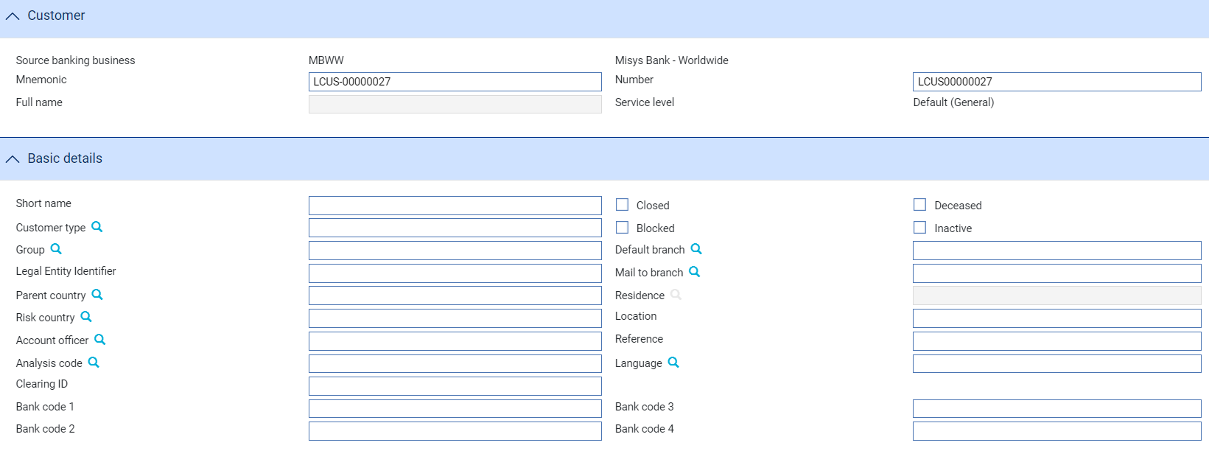

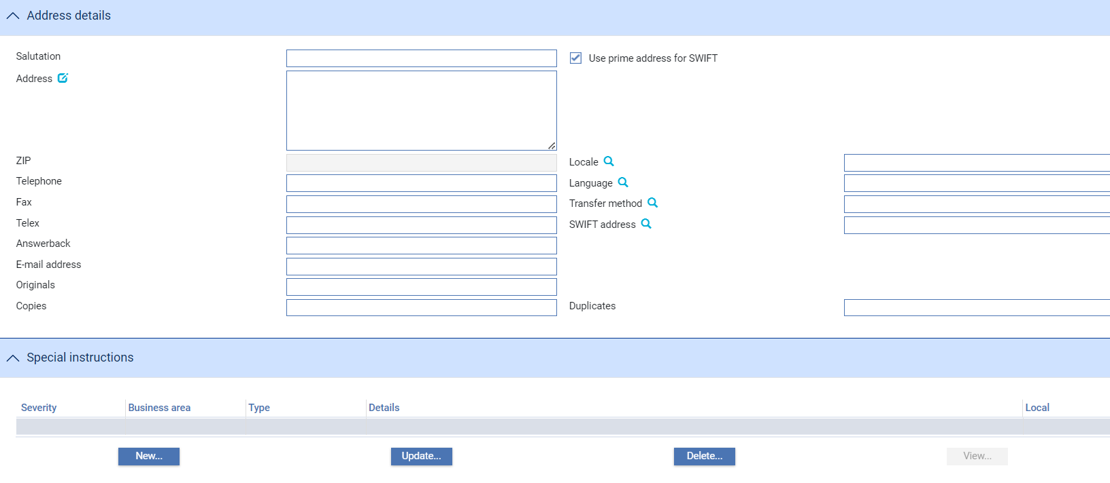 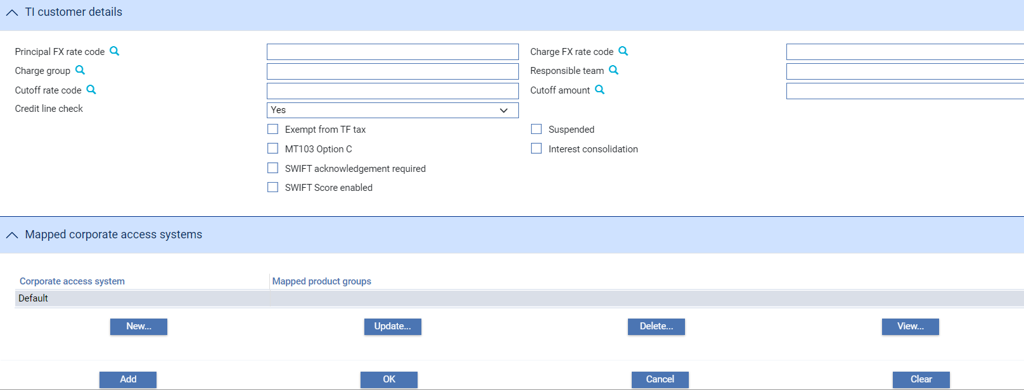

When local customers are added (i.e. customers that are defined in the system itself - only for use in the system), they are associated with the source banking entity where they were added.

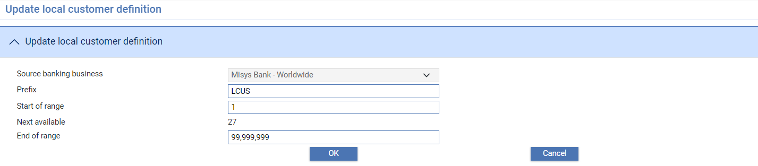

When searching for local customers, the Customer search type should be set to ‘Local customers’. The system then retrieves the local customers from the database for the relevant source banking entity.

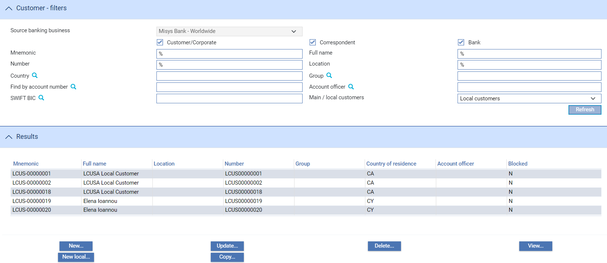

## Customer Addresses

Customer addresses are accessed using the Customer Maintenance|Addresses menu option. Initially the window is blank. Use the filter fields to set criteria for the customer addresses you want to see for the selected source banking business and click **Refresh**.

If Maker Checker is being used in your system, you will only be allowed to view this function. Any changes will need to be made in the Maker Checker application. See the *Maker Checker User Guide – Trade Innovation* for further details.

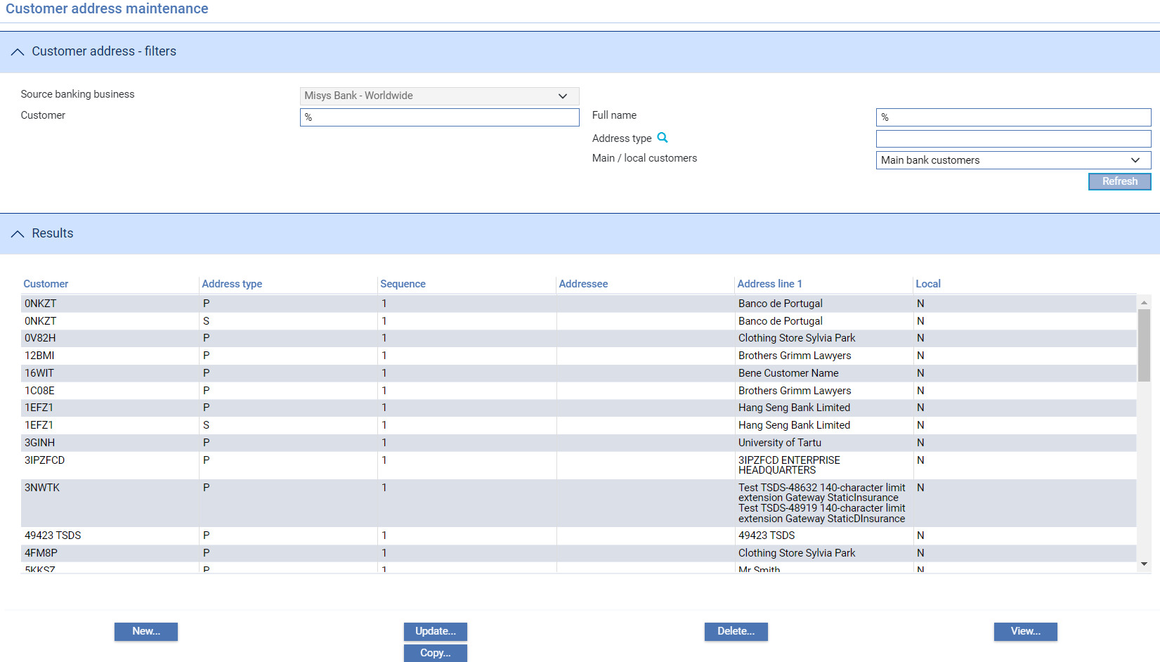

For each customer the system displays the customer's unique identifier and prime address, followed by any associated addresses set up for them. The level of indentation shown in the display indicates the relationship of associated addresses to each other in the address type hierarchy.

The display shows:

* The unique identifier of the customer
* The full name of the customer
* Address type against which the address is held

To enter details of a new customer address click **New**.

Select the customer for whom you are entering address details.

Use the Address Type field to indicate the type of address you are entering:

* The prime address
* The SWIFT-compatible address
* An associated address

If you select the Prime address type, the following details can be entered:

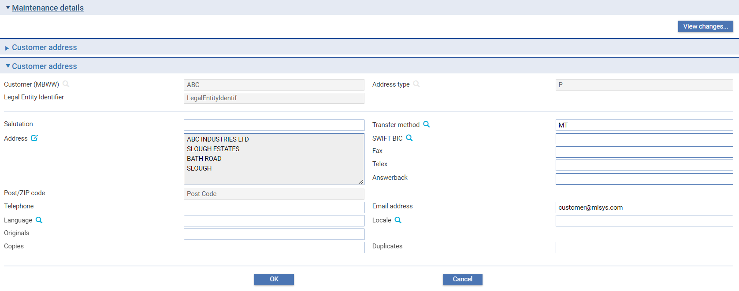

If you select SWIFT compatible address, the following details can be entered:

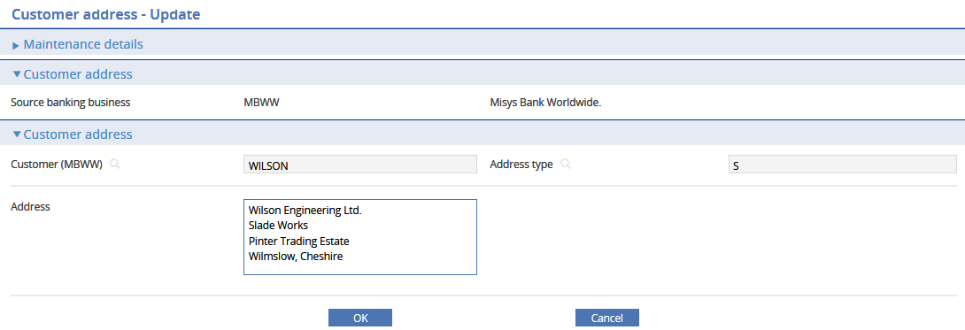

If you select an address type, other than the one identified as Prime or SWIFT compatible, the following details can be entered:

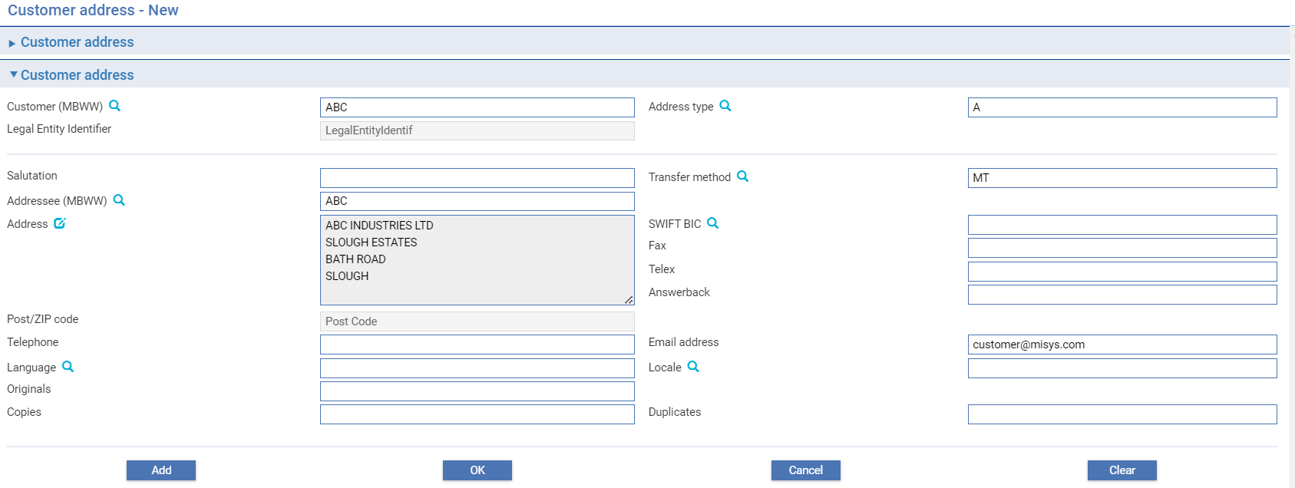

The following table explains what to enter into the fields displayed in this window:

| Field | What to Enter |
| --- | --- |
| Salutation | The text to appear at the beginning of correspondence sent to this address. Depending on how document templates to be used for correspondence sent to this address have been set up, this can be just a salutation, for example 'Dear Sir'; a salutation, such as 'Dear', followed by a name; or, if the salutation has been included in the document template, just a name.  See the System Tailoring User Guide – Trade Innovation for more information on document templates. |
| Transfer Method | The transfer method to be used for correspondence for this address. |
| Addressee | This is used for additional address instructions only and allows your bank to route documents to additional parties, such as a head office (see page 45). |
| Address | The address. You must enter at least one line of the address, and for a SWIFT-compatible address all characters must be valid for use in SWIFT. Click on  to update the Structured Name and Address. |
| SWIFT BIC | The customer's SWIFT BIC address. |
| Fax | The customer's fax number at this address. This is a free format field. |
| Telex | The customer's telex number at this address. This is a free format field. |
| Answerback | The customer's answerback number at this address. This is a free format field. |
| Post/ZIP Code | The post code or ZIP code. This is a free format field. |
| Telephone | The customer's telephone number at this address. This is a free format field. |
| E-mail Address | The customer's e-mail address at this address. This is a free format field. |
| Language | The language in which documents for this address are to be produced. If blank, the language used is English. |
| Originals | The number of original documents to be sent to the customer or addressee. |
| Copies | The number of copies to be sent to the customer or addressee. |
| Duplicates | The number of duplicates to be sent to the customer or addressee. |

## Address Types

The address types hierarchy is set up using the General|Address Types menu option.

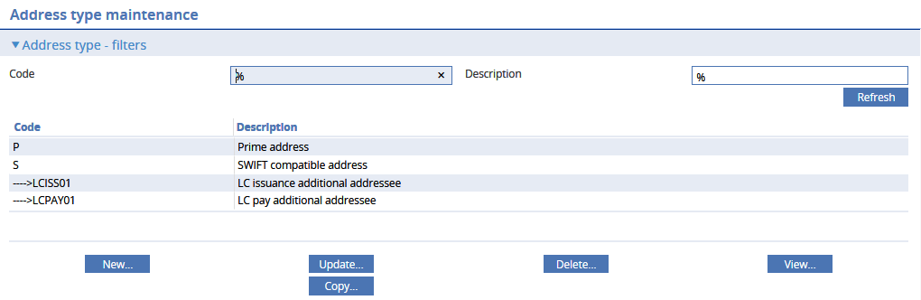

The system lists existing address types, showing their address type code and description. The level of indentation shown in the display indicates the relationship of entries in that hierarchy relative to each other.

You can amend and delete entries in the usual way, except for the root prime address type and the SWIFT address type, which are provided with the system and cannot be deleted. In addition, the system will not let you delete an address type that has any address types below it in the hierarchy.

To enter a new address type click **New**.

### Entering a New Address Type

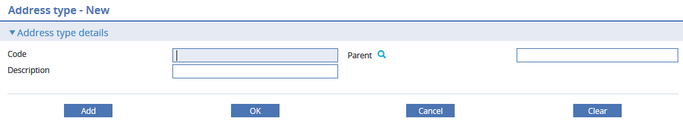

Use the Code field to enter a unique code for the address type.

Use the Description field to enter a meaningful description of the address type.

Use the Parent field to select the address type below which this one will sit in the hierarchy.

## Settlement Instructions

1. See the Common Facilities User Guide – Trade Innovation for information on how the system retrieves settlement instructions.

The system holds standing settlement instructions (SSIs) for customers as part of its static data. These standing settlement instructions are used by default when a transaction is settled. These can be defined at main banking entity level, so that the same customer instructions are used by all branches, or at branch level within the main banking entity, so that different branches can use different settlement accounts for the same customer. This is controlled by the Standing settlement service system option BranchSSI. If BranchSSI is set to ‘Yes’, the branch-level instructions are used for the customer and any bank-level instructions are ignored (and vice versa). The system also permits you to set up master level settlement instructions, which are used instead of standing settlement instructions for that transaction.

When entering Customer standing settlement instructions, the main banking entity for which the Customer SSIs are being defined (when working across multiple banking entities) must be specified. The SSIs contain account information for the banking entity and are tied to that particular General Ledger.

Nostros, Clearing Systems and Customer SSIs are held at main banking entity level, as settlement instructions refer to account details within the main banking entity.

In the following example accounts are defined at MBUK – Misys banking UK with the relevant Nostros (and default Nostros) and Clearing systems referencing those accounts:

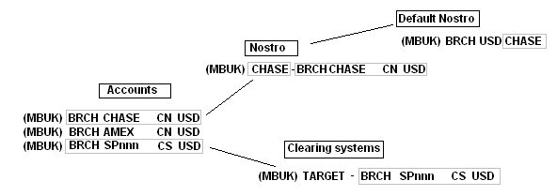

You can set up different settlement instructions for the same customer to be used for settlements in different currencies or involving different types of product. You can define settlement instructions to settle payment or receipt of a transaction currency amount in a different currency. During transaction processing the system automatically creates the foreign exchange deal required to convert the transaction currency funds to the required settlement currency.

You can set up settlement instructions in one currency but allow settlement in another currency when the main banking entity system option SettleInstructionAlternateCcy is set to ‘Yes’. This functionality can be used to allow a transaction denominated in one currency to settle in another currency. During transaction processing, the system creates a foreign exchange deal on the transaction date using the FX rate code defined by the main banking entity system option FXRateCodeAutoDefinition (see the see the System Tailoring User Guide – Trade Innovation for further information).

1. To support euro processing, if the system option SettleInstructionAlternateCcy is set to ‘No’, the system still permits you to define settlement instructions in one member currency, but to allow settlement in another, when the currencies involved are euro or a euro-member currency. This functionality can be used to allow a transaction denominated in the euro to settle in a euro-member currency, or vice versa. If the settlement currency is euro and you try to amend the pay/receive currencies to a non-euro currency, a warning message will be displayed stating that this functionality only supports transactions denominated in euro. During transaction processing, it results in the automatic creation of a foreign exchange deal on the transaction date, using a fixed exchange rate taken from the static data. This functionality is supported only for transactions denominated in a euro-member currency or the euro, to allow the currency to be changed from the euro to euro-member currency (or vice versa) for settlement.

When you select the CustomerMaintenance|Settlement Instructions menu option, the system displays the SSI Maintenance window.

This window can be used to list standing settlement instructions already set up for customers, alphabetically by customer identifier for the selected source banking business.

If Maker Checker is being used in your system, you will only be allowed to view this function. Any changes will need to be made in the Maker Checker application. See the *Maker Checker User Guide – Trade Innovation* for further details.

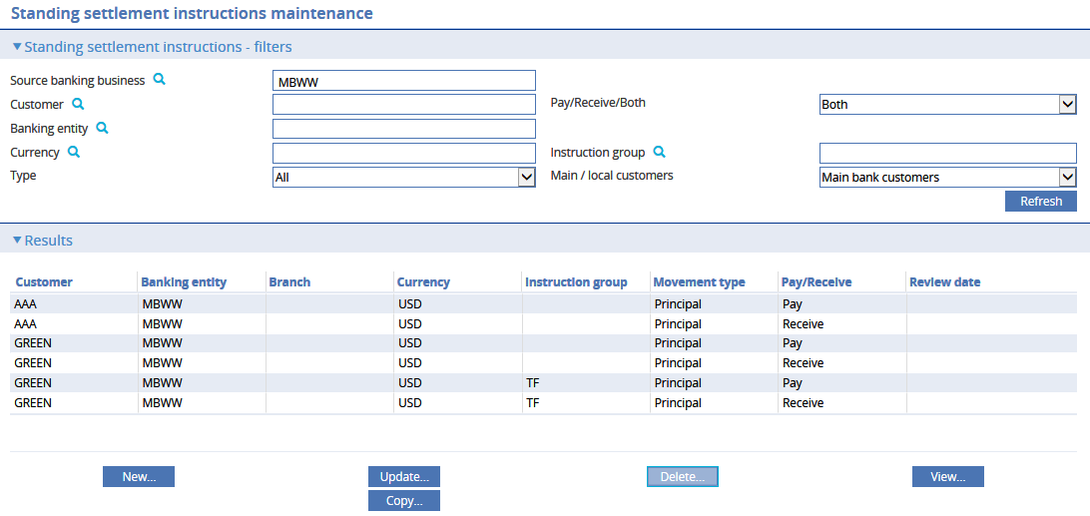

The following table explains what each of the columns in this window shows:

| Heading | What it Shows |
| --- | --- |
| Customer | The unique customer identifier. |
| Banking entity | The main banking entity for which these settlement instructions will be used. It allows the settlement instructions held for the customer in different main banking entities be reviewed. |
| Branch | If you have the system option BranchSSI set on, the Branch field is displayed. It allows the settlement instructions held for the customer at the different branches to be reviewed.  When you first open the window, your branch is displayed as the default in the field. |
| Currency | The currency for which the settlement instructions are to be used |
| Instruction Group | The instruction group for which the settlement instructions are to be used |
| Movement Type | Indicates the type of movement for which the settlement instructions are to be used, which will be one of the following:   * Charge * Interest * Principal |
| Pay/Receive | Whether the instructions are for payment or receipt of funds. |
| Review Date | The date on which the settlement instructions are to be reviewed. |

When updating or deleting settlement instructions select either the pay or receive details line in the browser will allow both sets of instructions to be maintained in a single screen.

To enter a new set of settlement instructions click **New**.

The initial fields allow the details of the customer for which settlement instructions are to be entered to be defined.

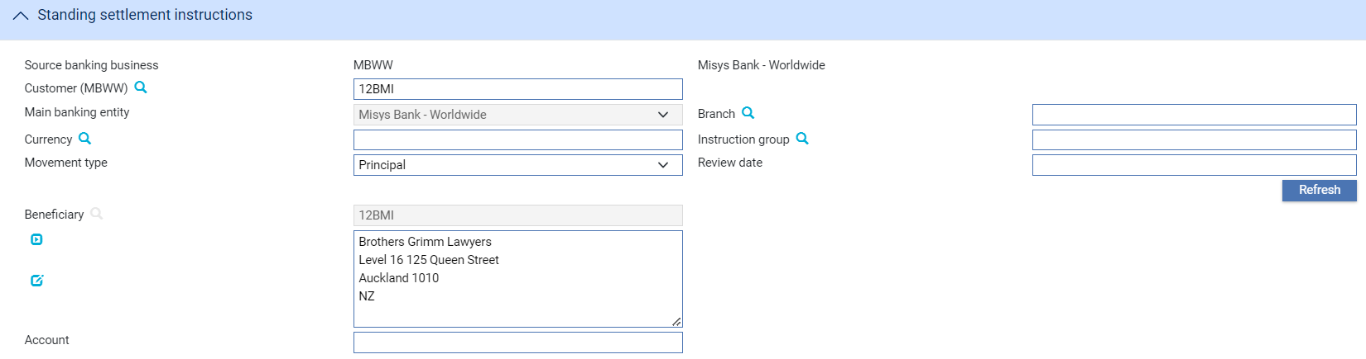

The following table lists the fields used to hold basic information for the settlement instructions and explains what to enter into each of them:

|  | Field | What to Enter |
| --- | --- | --- |
|  | Customer | The unique customer identifier. |
|  | Banking entity | The main banking entity for which these settlement instructions will be used. It allows the settlement instructions held for the customer in different main banking entities be reviewed. |
|  | Branch | The branch to which the settlement instructions apply. If you have the system option BranchSSI set on .This defaults to your branch but can be changed if necessary. |
|  | Currency | The settlement instructions currency. |
|  | Instruction Group | The instruction group for which the settlement instructions are being set up. If you enter a value here, then only those products whose instruction group matches it will use these settlement instructions.  If you leave this field blank, the settlement instructions can be used for all products. |
|  | Movement Type | Use this field to specify which type of movement the settlement instructions can be used for. Select from one of the following:   * Charge * Interest * Principal |
|  | Review Date | The date on which the settlement instructions are to be reviewed. |

The remaining settlement instruction fields that appear vary, depending on whether your bank is paying or receiving funds via account in your bank's own books, through a nostro, clearing system, vostro and whether cover payment instructions are required.

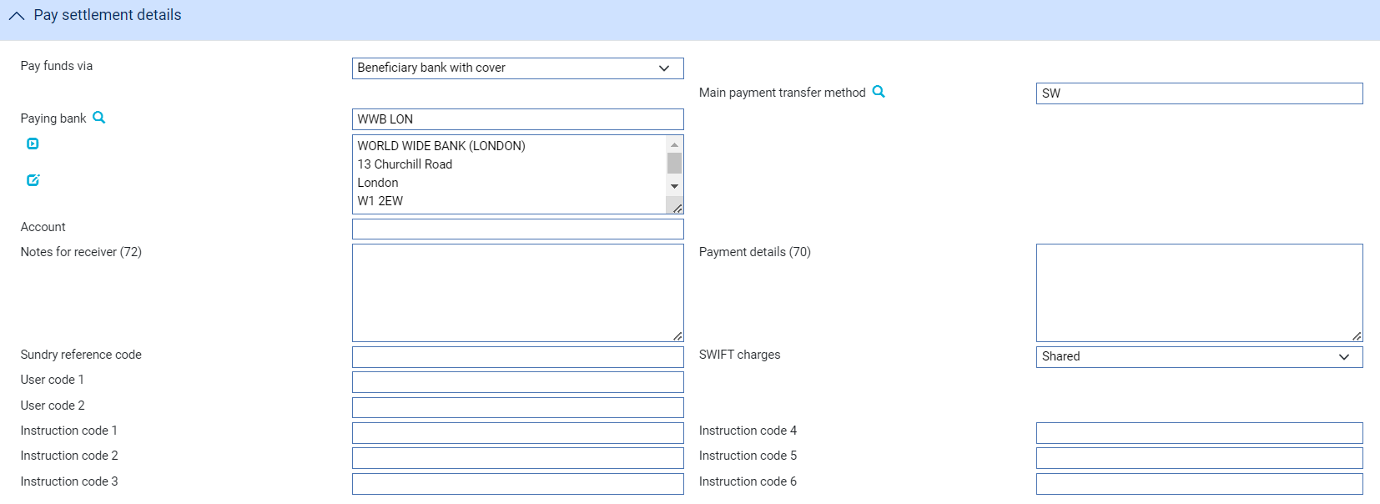

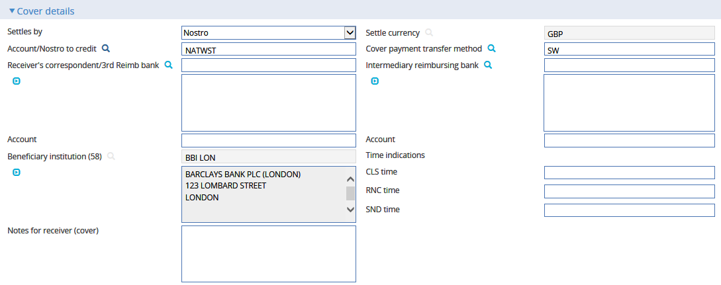

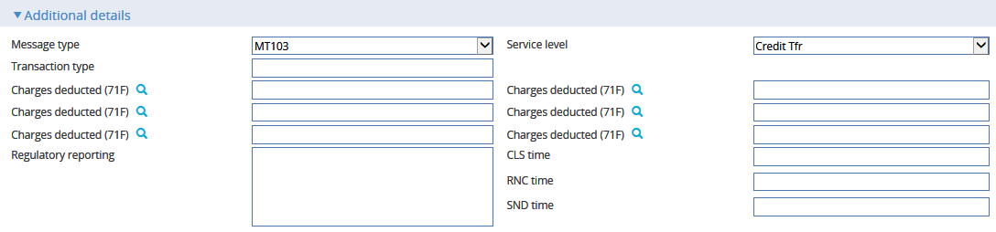

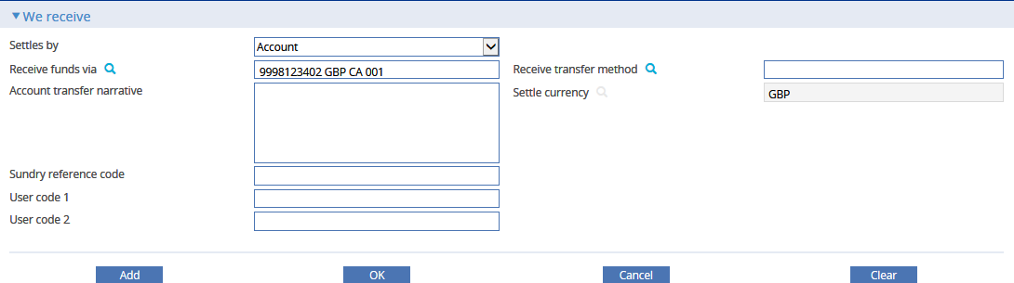

When you add, update or delete an existing set of settlement instructions, click **Refresh** when you return to the browser window to update the information displayed.

## Supply Chain Finance Details

To assign a customer to a buyer centric and/or a seller centric programme, select the Supply Chain Finance|Programmes menu option.

The window that appears can be used to display details of customers that have already been defined as using a buyer centric and/or seller centric programme and also the related Programme sub-types which may be set up by your bank, specifically for each customer, to identify whether the programme is buyer, or seller centric.

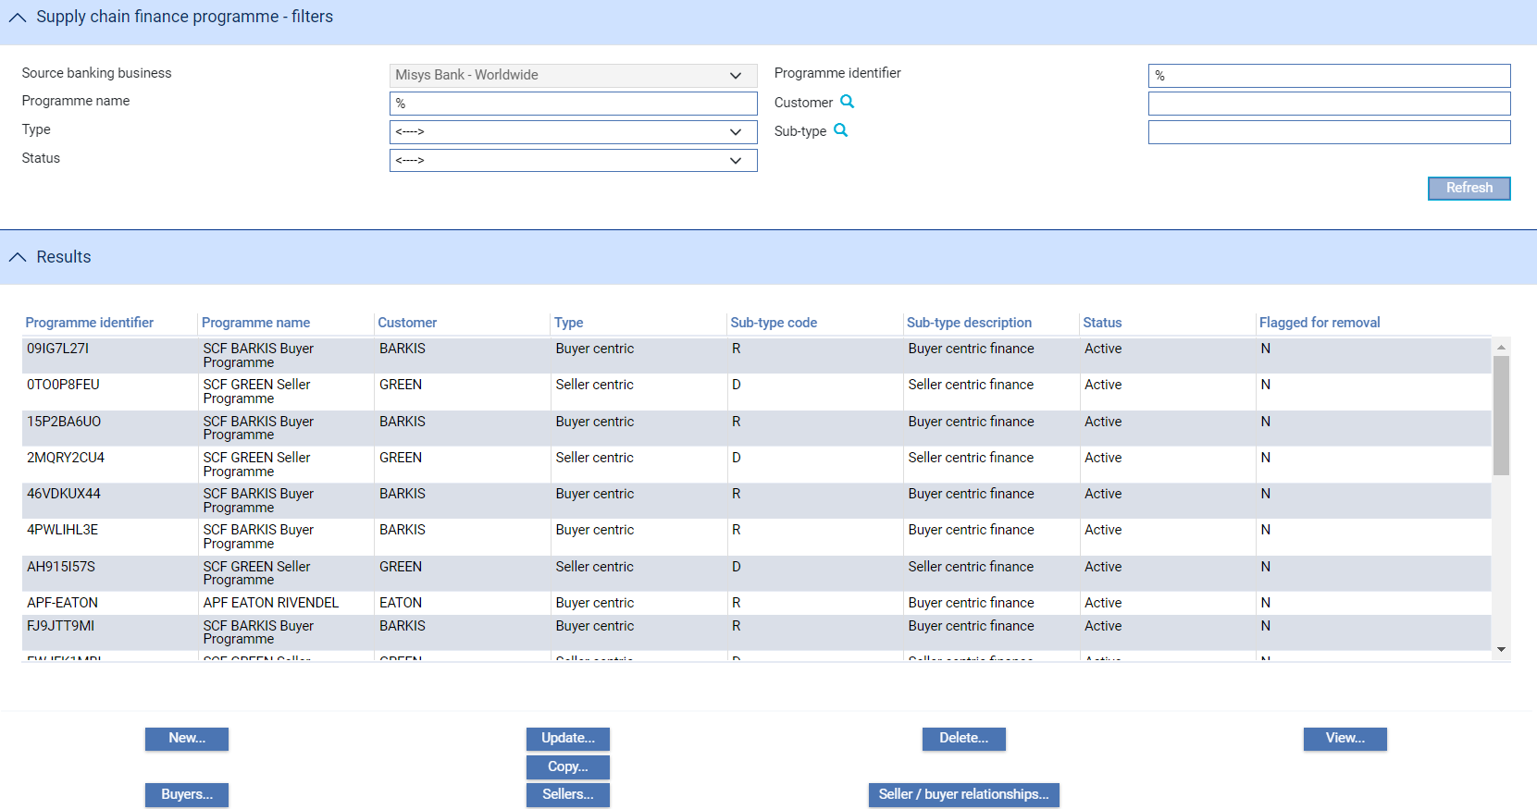

Use the filter fields in the usual way to limit the display.

The following table explains what each of the columns in this window shows:

|  |  |
| --- | --- |
| Heading | What it Shows |
| Programme Identifier | The unique identifier for the SCF programme, allocated when the agreement is set up between bank and customer. |
| Programme Name | The name of the programme. |
| Customer | The customer/programme owner mnemonic. |
| Type | The programme type (seller centric or buyer centric). |
| Sub-type code | The programme sub-type (Buyer centric finance, Seller centric finance, or Pool based factoring). |
| Status | The programme status (whether currently Active, Referred, Inactive or Blocked) |
| Flagged for removal | If set to Y, the programme has been flagged to be removed during overnight processing. |

You can use this window to create, amend, copy, and delete details in the usual way.

You cannot delete a Programme if buyer/seller relationships still exist for that programme. The seller buyer relationship must be deleted first. However, you cannot delete a relationship if invoice transactions are still active for the buyer/seller combination.

When you do delete information, the details are not immediately removed from the system, but are flagged for removal during overnight processing (the 'N' in the Flagged for Removal column changes to a 'Y'). This means that the programme can be reactivated if necessary before overnight processing begins.

Prior to creating a Programme, your bank can create specific Programme sub-types to apply to each of your customers. Each sub-type can be tailored with its own unique Code and Description.

If Maker Checker is being used in your system, you will only be allowed to view this function. Any changes will need to be made in the Maker Checker application. See the *Maker Checker User Guide – Trade Innovation* for further details.

### Creating a Programme Sub-type

Supply chain finance, Programme sub-types are created for customers of your bank. They are derived from Programme types and may be either Buyer centric or Seller centric, or they may relate to (seller centric) Pool based factoring. To create a Programme sub-type, select the Supply chain finance|Programme sub-types menu option. The window that appears can be used to display details of existing sub-types.

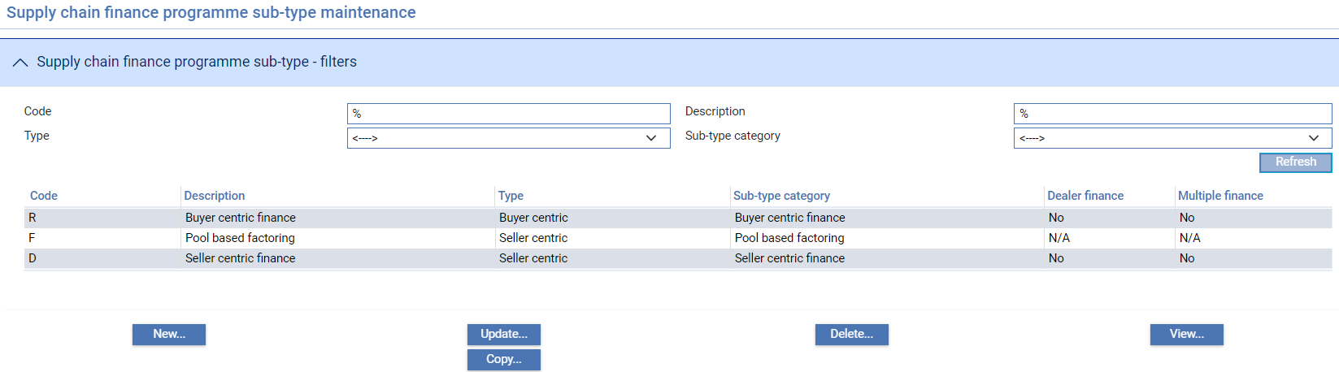

Click **New** to create a Supply chain finance programme sub-type:

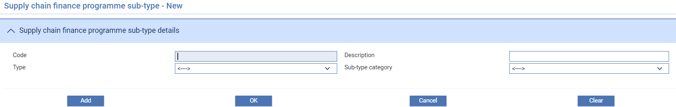

The following table lists the fields used in this window to create the programme sub-type:

|  |  |  |
| --- | --- | --- |
|  | Field | What to Enter |
|  | Code | The unique code used to identify the sub-type |
|  | Description | The sub-type description |
|  | Type | The programme type (either buyer centric or seller centric) |
|  | Sub-type category | The sub-type category (either buyer centric related, or seller centric / pool based factoring related) |

When **Type** and **Sub-type** has been selected, two additional fields will be displayed. Note that these fields are not available if sub-type is ‘Pool based factoring’.

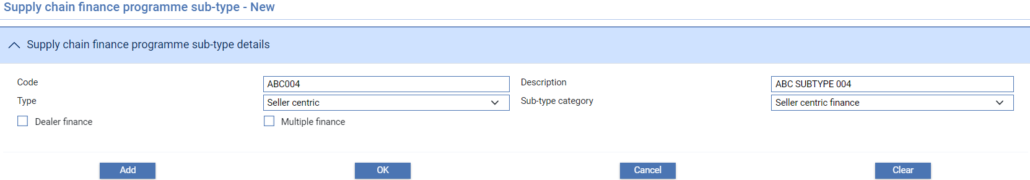

|  |  |  |
| --- | --- | --- |
|  | Field | What to Enter |
|  | Dealer Finance | If this box is unticked, the options for setting up Dealer Financing as a programme does not arise in the system. |
|  | Multiple Finance | If the box is unticked, the transactions under the programme being created will not have the option to request for financing of the same invoice multiple times. |



Click **Add** or **OK** to save your input.

You can also use the Copy button in the SCF programme sub-type – filters screen to copy the details of an existing sub-type. Note that the new sub-type must have its own unique identifier.

#### Amending a Programme Sub-type

You can amend the programme sub-type description by selecting the sub-type from the Supply chain finance programme sub-type list and clicking the Update button. Note that other details cannot be updated.

#### Deleting a Programme Sub-type

You can delete a programme sub-type by selecting the sub-type from the Supply chain finance programme sub-type list and clicking the Delete button. The programme will be deleted after overnight processing.

### Creating a Programme

Supply chain finance Programmes are created for customers of the bank. They may be either Buyer centric, or Seller centric. They enable the creation in the system of either buyer or seller centric invoice finance deals, or drawdowns under pool based factoring facilities.

It is necessary to create and/or assign counterparties to programmes and also to set up the necessary seller/buyers relationships. Counterparties may be either the buyer or seller in a programme (depending on whether the programme is buyer or seller centric) and may or may not be customers of your bank.

Click **New** to create a Supply chain finance programme for your customer.

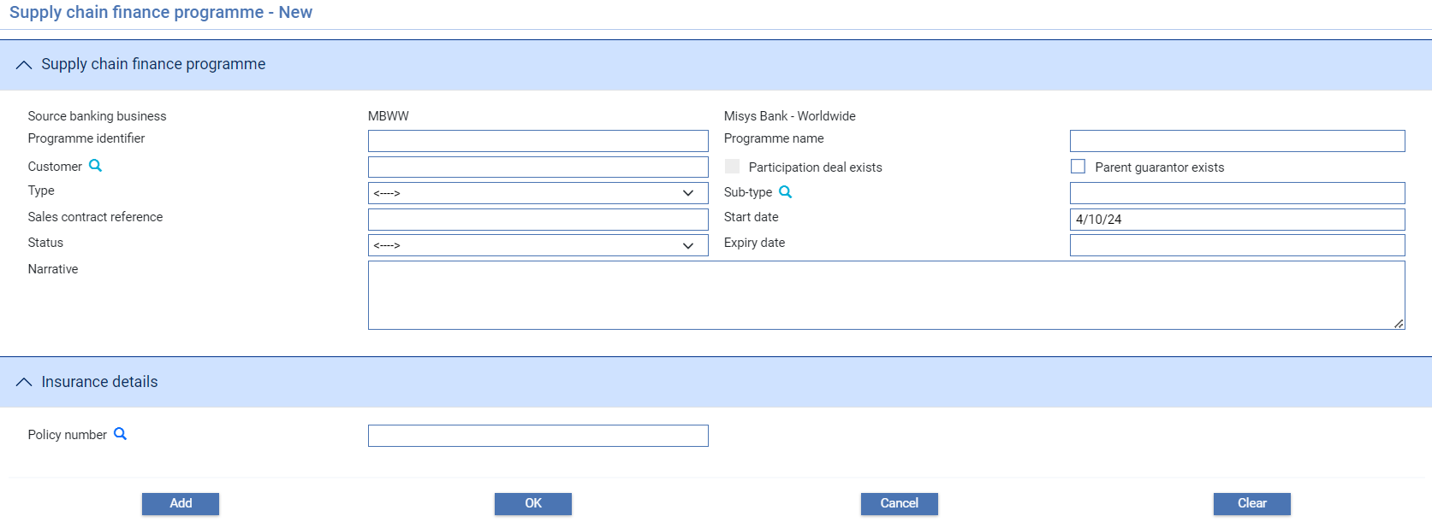

The following table lists the fields used in this window to create the programme:

|  | Field | What to Enter |
| --- | --- | --- |
|  | Programme Identifier | The unique identifier for the SCF programme, allocated when the agreement is set up between bank and customer. |
|  | Programme Name | The name of the programme. |
|  | Customer | The customer/programme owner mnemonic (the programme owner is also referred to as the ‘Anchor party’ for the programme). |
|  | Participation deal exists | This field is automatically checked when a participation deal is linked to the programme. |
|  | Type | The programme type (either seller or buyer centric). |
|  | Sub-type | The programme sub-type (either buyer centric finance, Seller centric finance or pool based factoring). |
|  | Sales contract reference | The reference of the underlying sales contract. |
|  | Start date | The date that the programme is effective from. |
|  | Status | The current status of the programme. May be set to one of the following:   * Blocked (the customer is financially or commercially in difficulty. This prevents loading of invoices or processing of finance deals) * Referred (the Programme is operative but there are doubts as to a customer’s commercial trading viability. This prompts a warning during loading of invoices or processing of finance deals). * Active (the Programme is operative and ready for recording related invoices and finance deals). * Inactive (default status – programme is not operative) |
|  | Expiry date | The date that the programme expires. |
|  | Narrative | General text narrative field. |
|  | Policy Number | The insurance policy number that may be linked to the Programme |

After entering the details and selecting a **Customer**, two additional fields are displayed.

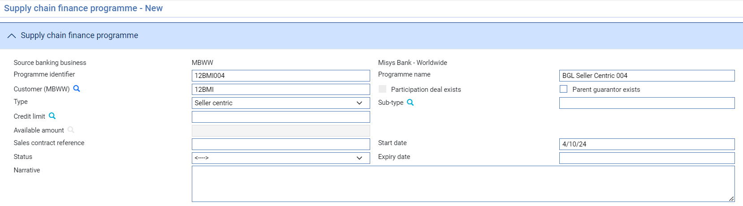

|  |  |  |
| --- | --- | --- |
|  | Field | What to Enter |
|  | Credit Limit | The maximum credit limit applicable to the programme. Invoices may be recorded and financed up to this limit. |
|  | Available Amount | The amount of the credit limit currently available |

When **Type** and **Sub-type** has been selected, the following additional fields are displayed. Note that these fields are not available if sub-type is ‘Pool based factoring’.

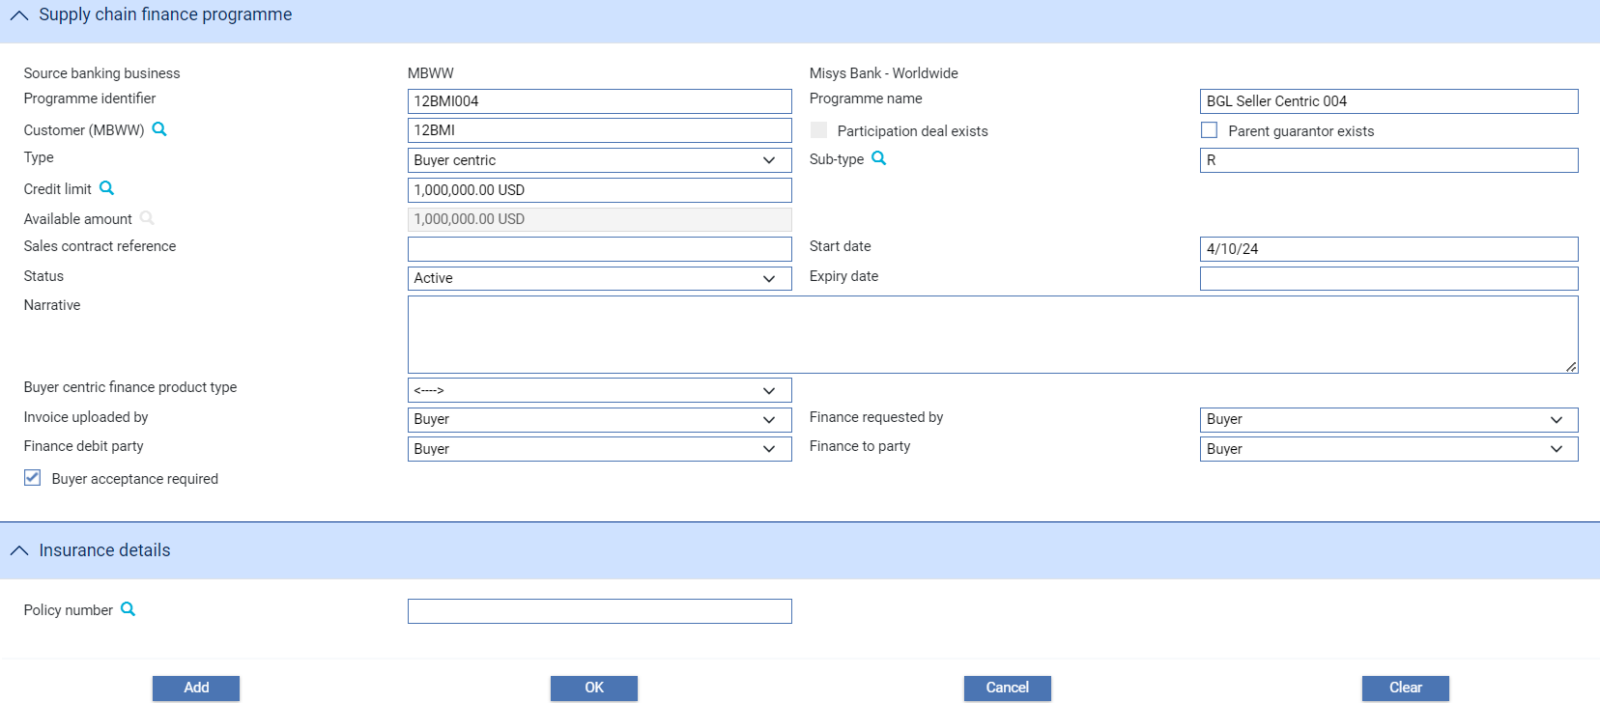

|  | Field | What to Enter |
| --- | --- | --- |
|  | Buyer Centric Finance Product type | The product type to be used for the specific programme.  The selected product type will determine the default values for specific fields in the finance transaction. |
|  | Invoice uploaded by | The party who will be able to upload the invoice for a specific programme.  For transactions requested from a corporate access system. Field is view only. |
|  | Finance requested by | The party who will be able to request financing of the invoice for a specific programme.  For transactions requested from a corporate access system. Field is view only. |
|  | Finance debit party | The debit party of the financing transaction. Value for this field will be used in financing transactions.  Finance debut party is defaulted from the programme type and subtype. |
|  | Finance to party | The party who the requested financing will be credited to. This party is used in financing transactions. |
|  | Buyer acceptance required | For transactions requested from a corporate access system. Field is view only. |

Click **Add** and then **OK**.

You can also use the Copy button in the SCF programme – filters screen to copy the details of an existing programme for a customer. Note that the new programme must have its own unique identifier.

### Amending a Programme

You can amend the details of a programme by selecting a programme from the Supply chain finance programme list and clicking the Update button.

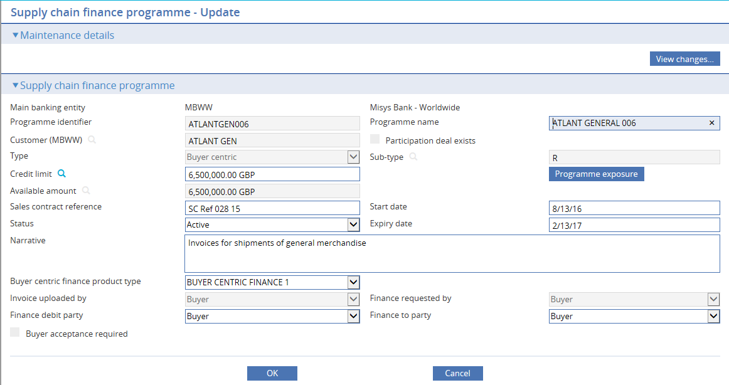

Click **OK** to save the changes.

#### Deleting a Programme

You can delete a programme by selecting a programme from the Supply chain finance programme list and clicking the Delete button. The programme will be deleted after overnight processing.

### Viewing a Programme’s Exposure

Clicking **Programme Exposure** displays the Programme Exposure Breakdown window. This window shows the programme’s current exposure.

Beyond that, different information is shown depending on whether the programme relates to buyer or seller centric finance, or pool based factoring.

For a pool based factoring programme, selecting the Show Exposure Details field, lists all the exposure entries relating to drawdowns and settlements recorded against the programme.

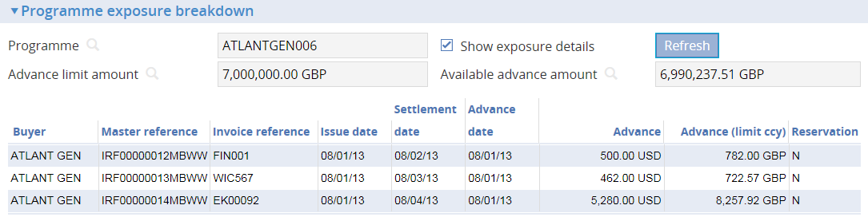

The exposure value of each invoice is shown in the drawdown currency or invoice settlement currency, and also in the limit currency, calculated using current spot exchange rates.

For a buyer or seller centric programme, selecting the Show Exposure Details field lists all the exposure entries relating to financed invoices recorded against the programme.

The value of each advance is shown in the currency of the advance, and also in the limit currency, calculated using current spot exchange rate.

The values shown in these windows are recalculated during overnight processing using the latest spot exchange rates. The Reservation column indicates whether an exposure entry represents actual exposure (Y) or just a reservation (N).

### Buyers

The system permits you to set up buyers for use in both buyer and seller centric finance programmes. Under a buyer centric programme, the buyer is typically a customer of your bank with whom you have established credit lines. For seller centric finance, the buyer may, or may not be a customer of your bank, but they will have a relationship with the programme seller.

Under a buyer centric programme, you can assign a single buyer via the Buyers button. You can search for and select the buyer using the ‘Customers’ filter.

A seller centric programme will have a single seller but one or more buyers, depending on the seller’s trading relationships. Buyers are added to a seller centric programme in the same way as a buyer centric one. They may, or may not be customers of your bank.

Select the Supply chain finance|Programmes menu option.

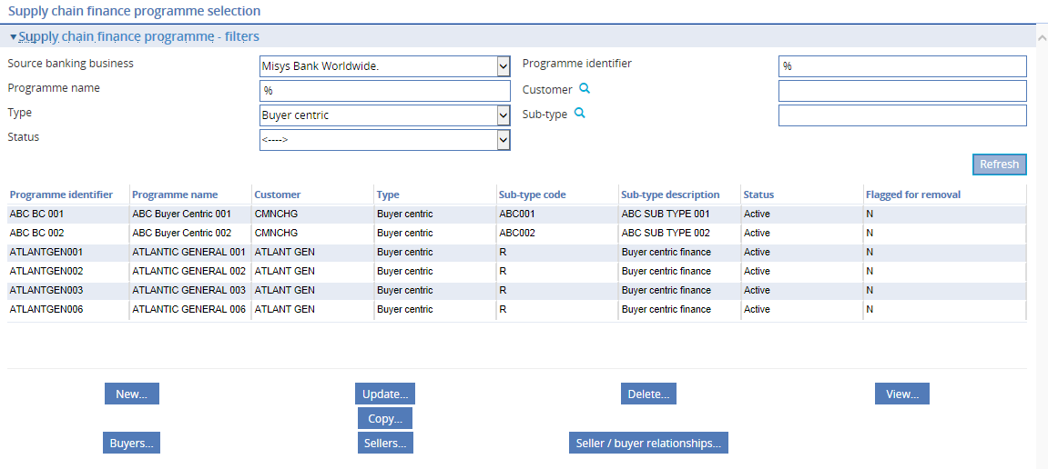

On the screen that appears, select a buyer centric programme then click **Buyers**.

Use the filter fields in the usual way to limit the display.

You can use this window to create, amend and delete buyers in the usual way.

1. You cannot delete a buyer who is linked in a relationship with a seller - the seller/buyer relationship link must be deleted first, but this is prevented if active invoices still exist. Also, when you delete a buyer, the buyer's details are not immediately removed from the system - the buyer's status is set to 'Blocked' and the buyer is flagged for removal (the 'N' in the Flagged for removal column changes to a 'Y'). The buyer's details are then removed from the programme during overnight processing, unless relationships still exist for the buyer. This means that the buyer can be reactivated if necessary before overnight processing begins.

To enter details of a new buyer click **New**.

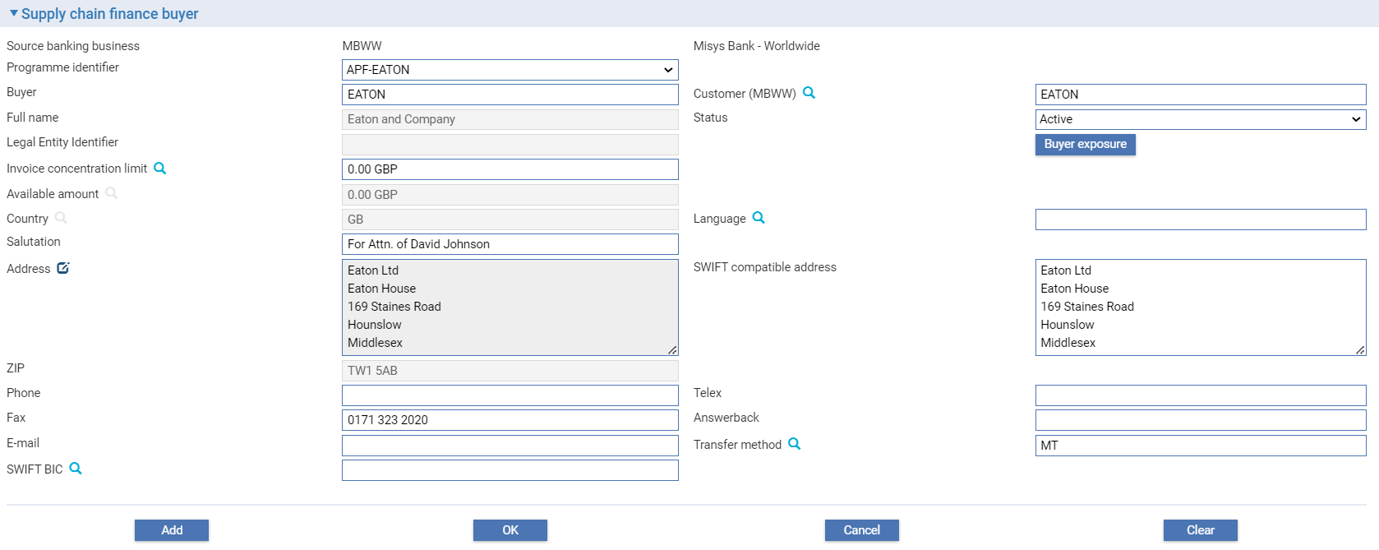

It is mandatory to add an Invoice concentration limit for the buyer.

For an existing buyer, the Buyer Exposure button displays details of any invoices outstanding against that buyer (see page 59).

The following table lists the fields used to define a new buyer and explains what to enter into them:

|  | Field | What to Enter |
| --- | --- | --- |
|  | Programme Identifier | The unique identifier for the programme. |
|  | Buyer | The buyer's short name. |
|  | Customer | If the buyer is also a customer of your bank, enter their unique customer ID here. The system retrieves and displays any information already entered for that customer. |
|  | Full Name | The buyer's full name. |
|  | Invoice Concentration Limit | The invoice concentration limit allocated to this buyer. If a default currency has been set using the system option FactoringLimitsCurrency, then this is the currency used here. Otherwise, local currency is used as the default, and can be overridden.  The limit defined here is the total face value of unpaid or outstanding invoices that can be recorded against this buyer at any one time.  If you set this figure to zero, then the limits set for all seller/buyer combinations involving this buyer are also automatically set to zero. |
|  | Available Amount | The buyer's unutilised limit amount. This figure is calculated as the invoice limit amount (defined above) less any exposure resulting from invoices raised against the buyer. See the Supply chain Finance User Guide – Trade Innovation for details of this calculation.  This figure is used for limit checking purposes during transaction processing when the input clerk is recording new invoices or amending existing ones.  It is updated by the system as invoices for this buyer are entered, amended, settled or cancelled.  The Buyer Exposure button displays details of the buyer's current exposure - see the next section. |
|  | Status | The buyer's status. Once you have entered details of a buyer you can use this field to change their status from 'Active' (the default) to 'Blocked' or 'Referred' if circumstances require. |
|  |  | When calculating the amount available for drawdown, the system disregards invoices against buyers whose status is not 'Active'. |
|  | Country | The buyer's country of residence. |
|  | Language | The language to be used for documents. If blank, the language used is English. |
|  | Salutation | The text to appear at the beginning of correspondence sent to the buyer. Depending on how document templates have been set up, you can enter just a salutation, for example 'Dear Sir'; a salutation, such as 'Dear', followed by a name; or, if the salutation has been included in the document template, just a name.  See the System Tailoring User Guide – Trade Innovation for more information on document templates. |
|  | Address | The buyer's prime address, up to five lines, used for mailing purposes.  If the buyer is a customer of your bank, the address is taken from their customer details. If the buyer is not a customer of your bank, you should adopt the same approach to entering address details here as when entering address details for customers. |
|  |  | During transaction processing the first line of the address can be used for partial searches in the Full Name field in browser windows.  Click on  to update the Structured Name and Address. |
|  | ZIP | The post code or ZIP code. |
|  | Phone | The buyer's telephone number. |
|  | Telex | The buyer's telex number. |
|  | Fax | The buyer's fax number. |
|  | Answerback | The buyer's fax number. |
|  | Transfer Method | The transfer method to be used for correspondence. |
|  | SWIFT BIC | The buyer's SWIFT BIC address (see page 116), if relevant. If your bank uses a SWIFT BIC file you can use the browser to select an address from that file, although the value you enter here is not required to match with an entry on the SWIFT BIC file. |

Under a Seller centric programme, you may add a number of buyers. Each buyer is added as an individual record on the system and once created, may be filtered on in the normal way:

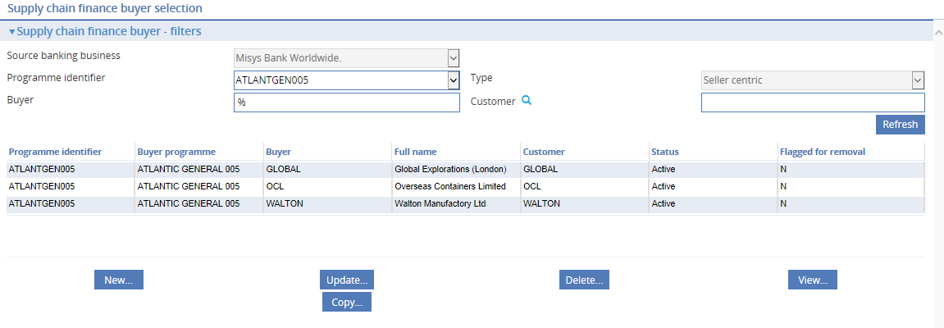

#### Viewing a Buyer's Exposure

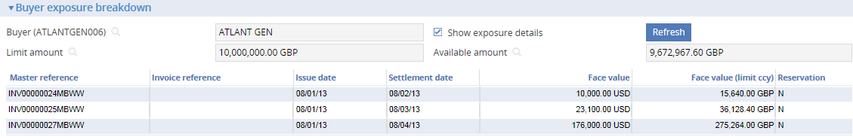

The Buyer Exposure Breakdown window shows the buyer's current exposure. Check the Show Exposure Details field to list all the invoice-related exposure entries recorded against the buyer. The face value of each invoice is shown in the currency of the invoice, and also in the limit currency, calculated using current spot exchange rate. These values are recalculated during overnight processing using the latest spot exchange rates.

The Reservation column indicates whether exposure arising from an invoice is actual exposure (Y) or just a reservation (N).

### Sellers

The system permits you to set up sellers for use in both seller and buyer centric finance programmes. Under a seller centric programme, the seller may be a customer of your bank. For buyer centric finance, the seller may, or may not be a customer of your bank, but they will have a relationship with the programme buyer.

Under a seller centric programme, you can assign a single seller via the Sellers button. You can search for and select the seller using the ‘Customers’ filter.

A seller centric programme will have a single seller but one or more buyers, depending on the seller’s trading relationships. Buyers are added to a seller centric programme in the same way as a buyer centric one. They may or may not be customers of your bank.

Select the Supply chain finance|Programmes menu option.

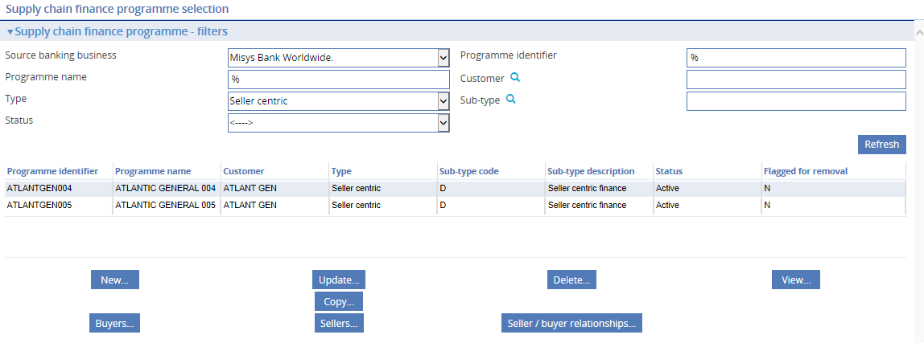

On the screen that appears, select a seller centric programme then click the Sellers button.

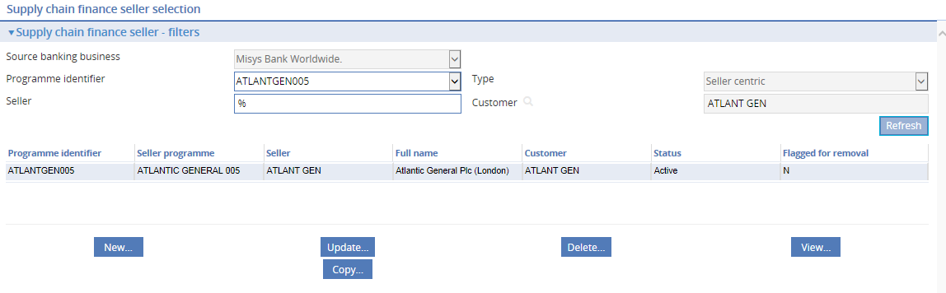

You can use this window to create, amend and delete sellers in the usual way.

To enter details of a new seller, click **New**.

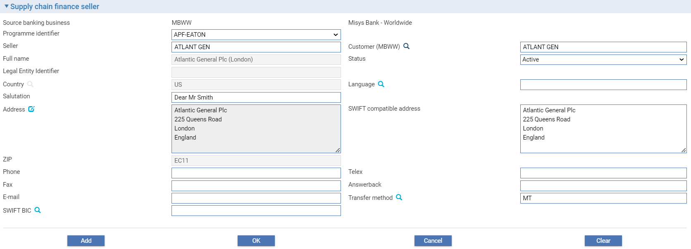

The following table lists the fields used to define a new seller and explains what to enter into them:

|  | Field | What to Enter |
| --- | --- | --- |
|  | Programme Identifier | The unique identifier for the programme. |
|  | Seller | The seller’s short name. |
|  | Customer | If the seller is also a customer of your bank enter their unique customer ID here. The system retrieves and displays any information already entered for that customer. |
|  | Full Name | The seller’s full name. |
|  | Status | The seller’s status. Once you have entered detailed of a seller you can use this field to change their status from 'Active' (the default) to 'Blocked' or 'Referred' if circumstances require. |
|  |  | When calculating the amount available for drawdown, the system disregards invoices against sellers whose status is not 'Active'. |
|  | Country | The seller's country of residence. |
|  | Language | The language to be used for documents. If blank, the language used is English. |
|  | Salutation | The text to appear at the beginning of correspondence sent to the seller. Depending on how document templates have been set up, you can enter just a salutation, for example 'Dear Sir'; a salutation, such as 'Dear', followed by a name; or, if the salutation has been included in the document template, just a name.  See the System Tailoring User Guide – Trade Innovation for more information on document templates. |
|  | Address | The seller's prime address, up to five lines, used for mailing purposes.  If the seller is a customer of your bank, the address is taken from their customer details. If the seller is not a customer of your bank, you should adopt the same approach to entering address details here as when entering address details for customers.  During transaction processing the first line of the address can be used for partial searches in the Full Name field in browser windows.  Click on  to update the Structured Name and Address. |
|  | ZIP | The post code or ZIP code. |
|  | Phone | The seller's telephone number. |
|  | Telex | The seller's telex number. |
|  | Fax | The seller's fax number. |
|  | Answerback | The seller's fax number. |
|  | Transfer Method | The transfer method to be used for correspondence. |
|  | SWIFT BIC | The seller's SWIFT BIC address (see page 116), if relevant. If your bank uses a SWIFT BIC file you can use the browser to select an address from that file, although the value you enter here is not required to match with an entry on the SWIFT BIC file. |

Under a Buyer centric programme, you may add a number of Sellers. Each seller is added as an individual record on the system and once created, may be filtered on in the normal way:

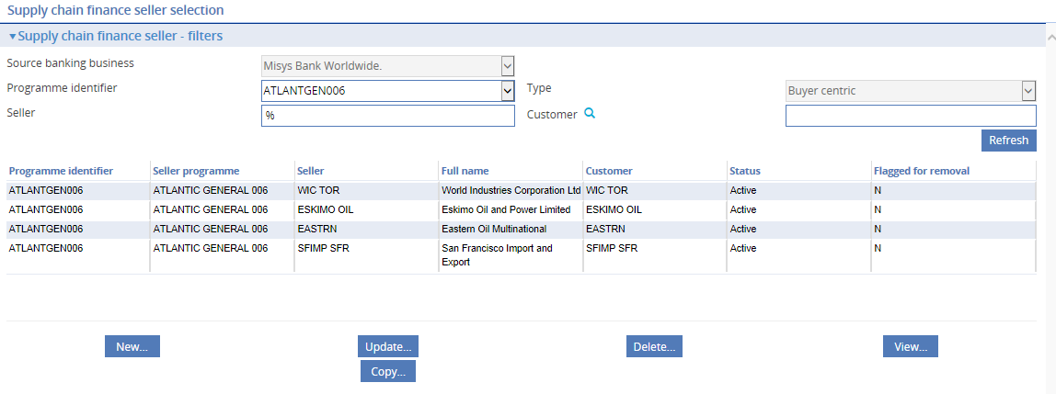

### Seller/Buyer Relationships and Limits

Seller/buyer relationships are recorded, and limits set against them using the Supply chain Finance|Programmesmenu option.

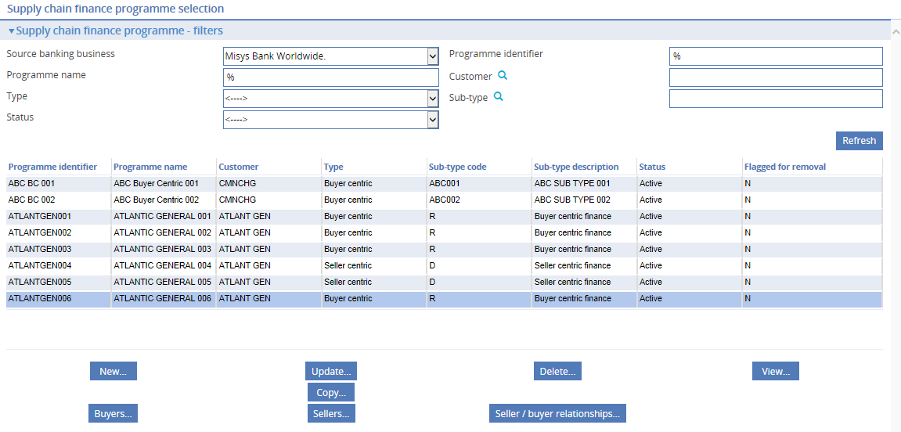

On the screen that appears, select a buyer or a seller programme then click **Seller/Buyer Relationships**.

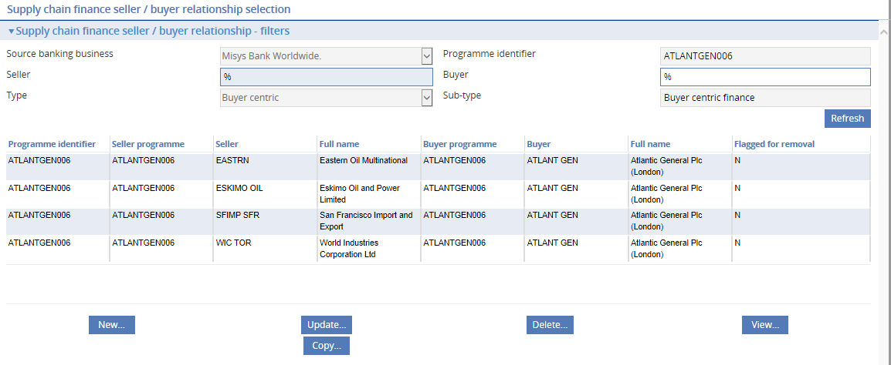

You can use this window to create, amend and delete seller/buyer relationships in the usual way.

1. You cannot delete a seller who is linked in a relationship with a buyer - the seller/buyer relationship link must be deleted first but this is prevented if active invoices still exist. Also, when you delete a seller, the seller’s details are not immediately removed from the system - the seller’s status is set to 'Blocked' and the buyer is flagged for removal (the 'N' in the Flagged for Removal column changes to a 'Y'). The seller’s details are then removed from the programme during overnight processing, unless relationships still exist for the seller. This means that the seller can be reactivated if necessary before overnight processing begins.

To enter details of a new seller/buyer relationship click **New**.

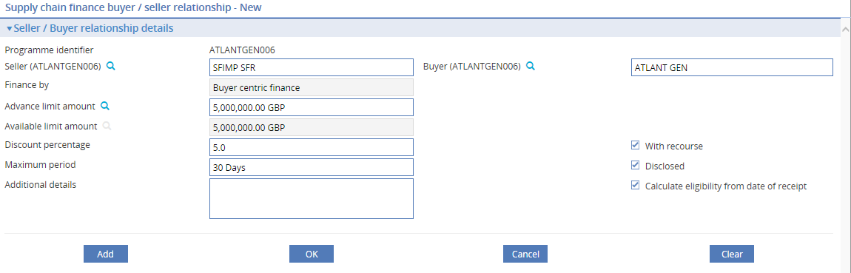

Use the Seller field to select the seller. The Finance by field then changes to show whether the relationship is being established under a seller or buyer centric programme. The following table explains what to enter into the fields used to define a seller/buyer relationship:

Use the Seller field to select the seller. The Finance By field then changes to show whether the relationship is being established under a seller or buyer centric programme. The following table explains what to enter into the fields used to define a seller/buyer relationship:

|  | Field | What to Enter |
| --- | --- | --- |
|  | Seller | The seller for the programme. |
|  | Buyer | The buyer's for the programme. |
|  | Advance Limit Amount | The advance limit allocated to this seller/buyer relationship.  The figure entered here defines the limit for financing against invoices for the buyer or seller, depending on whether the programme is buyer or seller centric.  If a default currency has been set using the system option. SupplyChainFinanceLimitsCurrency, then this is the currency used here. Otherwise, local currency is used as the default, and can be overridden.  If the buyer's invoices limit is ever set to zero, then this figure is also set to zero automatically by the system. |
|  | Available Limit Amount | The unutilised advance limit amount for the seller/buyer relationship. This figure is calculated as the advance limit amount (defined above) less any exposures resulting from discounting individual invoices. See the Supply chain Finance User Guide – Trade Innovation for details of this calculation.  This figure is used in discounted advance calculations. It limits the amount available to the customer as an advance, against an invoice for this buyer.  It is updated by the system whenever invoices are discounted and advances are settled for this buyer. |
|  | Discount percentage | The percentage of the value of invoices for this seller/buyer relationship eligible for financing. It must be set to a value in the range 0 – 100.  This is used in finance calculations. |
|  | With Recourse | Indicate whether invoices from the seller or buyer (depending on whether buyer or seller centric) are with recourse or not. The value entered here is used as the default when details of the customer's invoices raised against this buyer are recorded in the system. |
|  | Disclosed | Not used for Pool based factoring (since all Pool based factoring invoices are considered disclosed). |
|  | Maximum Period | The period defined here is used to validate whether the invoice settlement date for invoices for this seller/buyer relationship is within the agreed term. If an invoice's due date falls within the period specified here, measured against the current processing date, it is eligible for drawdown. |
|  | Calculate Eligibility From Date Of Receipt | Indicate whether invoice eligibility should be calculated from the date of receipt of an invoice, rather than from the date of issuance of an invoice. |
|  | Additional Details | Any additional information applicable to invoices for this seller/buyer relationship. |
|  | Vendor code | Permits entry of a unique reference ID of the counterparty to default into transactions. |

### Viewing the Programme/buyer Exposure

Clicking **Programme/buyer Exposure** displays a window that shows the programme’s current exposure at the seller/buyer level.

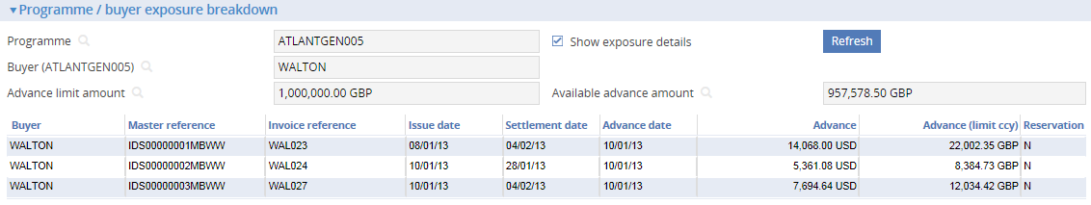

Check the Show Exposure Details field to list all the exposure entries relating to financed advances recorded against the seller/buyer limit. The value of each advance is shown in the currency of the advance, and also in the limit currency, calculated using current spot exchange rate. These values are recalculated during overnight processing using the latest spot exchange rates.

The Reservation column indicates whether an exposure entry represents actual exposure (Y) or just a reservation (N).

### Interfacing to a Corporate Access System

When Trade Innovation is interfaced with a corporate access system, the following supply chain finance static data can be sent to and received from the system. This takes place upon successful creation, update and/or deletion.

* Programmes
* Programme sub-types
* Buyers
* Sellers
* Buyer / Seller relationships

The messages used to download these details are defined via the **Branch level data | Download | Define static data messages** menu item.

The automatic downloading of this data and the sending of subsequent updates are controlled by the following system options:

| System Option | Description |
| --- | --- |
| DownloadSCFProgrammesFromBranch | This option is used to define the source banking businesses from which supply chain finance programme information is required by the corporate access system. Enter either <ALL> or nominated source banking businesses in the format XXXX,YYYY e.g. MB01,MB02 |
| DownloadSCFProgrammeChanges | If set to Yes, the corporate access system receives supply chain finance programme change information from Trade Innovation. If set to No, changes are not downloaded |

The download messages allow full details to be sent to any corporate access system.

When Trade Innovation Supply Chain Finance is used with Corporate Channels, the content of all download messages are used in processing by Corporate Channels. For other corporate access systems, all programmes and buyer/seller data, etc. may not be required and the messages should be tailored accordingly.

Creation of Supply chain finance programmes

The following example shows how supply chain finance programmes are created between Trade Innovation and Corporate Channels.

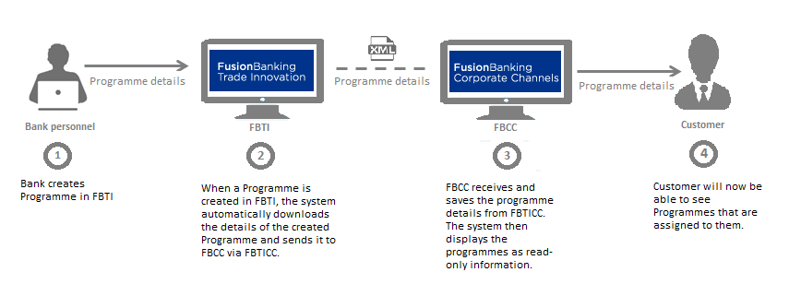

Programmes can only be created and modified in Trade Innovation.

Whenever a programme is created, updated or deleted, Trade Innovation sends messages detailing the changes to Corporate Channels.

The available limits associated with a programme are also updated as a result of processing every transaction and the updated details are sent from Trade Innovation to Corporate Channels.

1. Only programmes with sub-types that are not ‘Pool based factoring’ are sent to Corporate Channels.

Assignment of counterparty in a programme

Once a programme is available in Corporate Channels, the customer can create and/or assign counterparties to the programmes. Below is an example of how counterparties are expected to be on-boarded in both systems.

Counterparty on-boarding works in conjunction with ‘Maker checker’ functionality allowing the bank to ‘Approve’ or ‘Reject’ the counterparty details. You need to ensure that the relevant maker checker system options are enabled. You may refer to *Maker Checker User Guide* – Trade Innovation on how to set-up maker checker.

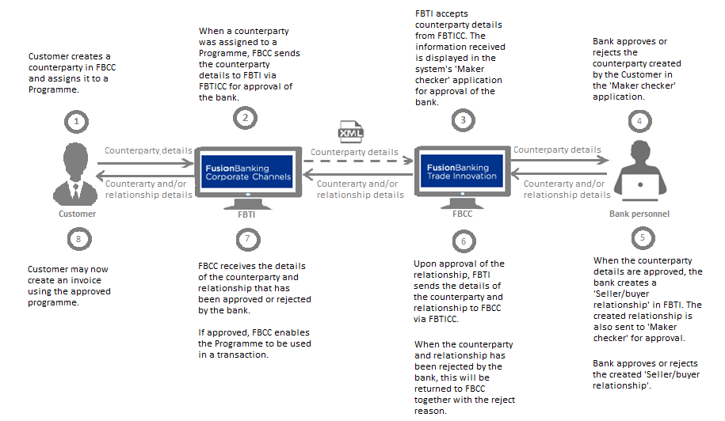

Whenever counterparty or relationship details are updated, Trade Innovation sends messages detailing the changes to Corporate Channels to ensure that the information in both systems is in step. The available limits associated with a counterparty and relationship are also updated as a result of processing every transaction and the updated details are sent from Trade Innovation to Corporate Channels.

## Account Officers

The system allows you to set up account officers and then assign them to customers as you enter customer details. An account officer can be defined as individual members of staff or as a department, and is responsible for the customers assigned to them.

When you select the General|Account Officers menu option the system lists existing account officers by their code and name.

If Maker Checker is being used in your system, you will only be allowed to view this function. Any changes will need to be made in the Maker Checker application. See the *Maker Checker User Guide – Trade Innovation* for further details.

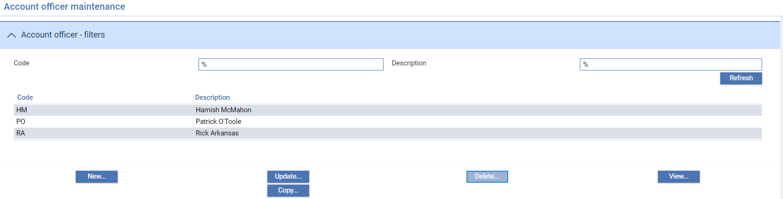

To create a new account officer click **New**.

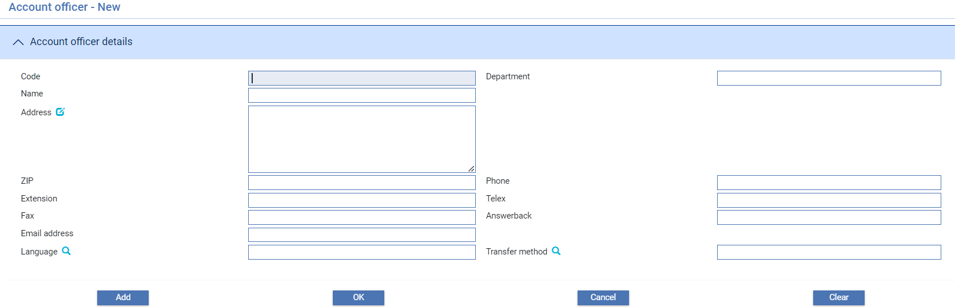

The following table explains what to enter into these fields to define a new account officer:

|  | Field | What it Holds |
| --- | --- | --- |
|  | Code | A unique alphanumeric code for the account officer. |
|  | Department | The department to which the account officer belongs. |
|  | Name | The name of the member of staff or department acting as account officer. |
|  | Address | The account officer address. This is used for producing approval forms for credit risk management purposes only. |
|  | ZIP | The post code or ZIP code. This is a free format field. |
|  | Phone | The account officer's telephone number at this address. This is a free format field. |
|  | Extension | The account officer's telephone extension at this address. This is a free format field. |
|  | Telex | The account officer's telex number at this address. This is a free format field. |
|  | Fax | The account officer's fax number at this address. This is a free format field. |
|  | Answerback | The account officer's answerback number at this address. This is a free format field. |
|  | Email address | The account officer's Email address. This is a free format field |
|  | Language | The language in which documents for this address are to be produced. If blank, the language used is English. |
|  | Transfer Method | The transfer method to be used for correspondence for this address. |

## Customer Charge Groups

When you select the General|ChargeGroups menu option the system lists existing customer charge groups using their code and description.

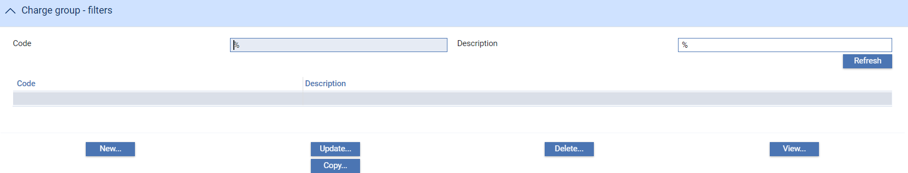

The system permits you to delete a customer group while it still has customers attached to it, but will produce a warning message in such circumstances.

To create a new customer charge group click **New**.

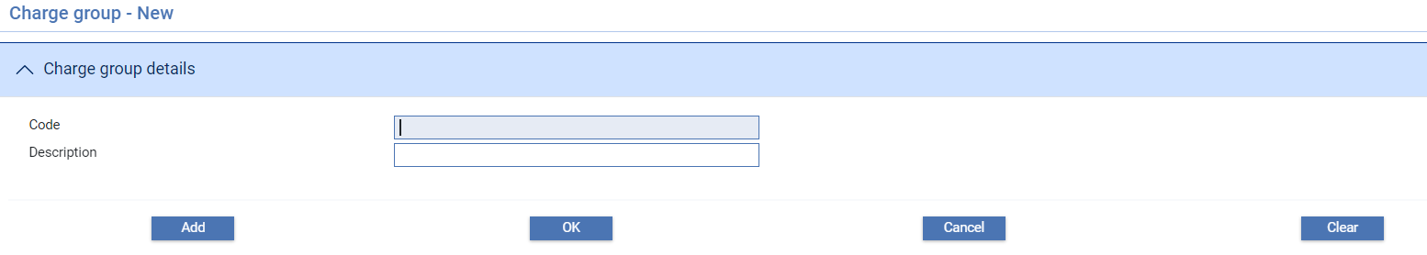

Use the Code field to enter a unique alphanumeric code for the customer charge group, then enter a description for the customer charge group into the Description field.

## Customer Groups

The system allows you to group customers together using a group identifier. You can assign customers to a group when you first enter their details or through subsequent maintenance.

Groups are defined at the same level as the customer source banking business allowing a group to be associated with any customer belonging to that part of the bank’s business. When a customer is added through the customer service or replication, the system will check if the Group already exists in the data and if not, a group record will be created.

When you select the Customer Maintenance|Groups menu option the system lists existing customer groups using their code and description for the source banking business selected.

If Maker Checker is being used in your system, you will only be allowed to view this function. Any changes will need to be made in the Maker Checker application. See the *Maker Checker User Guide – Trade Innovation* for further details.

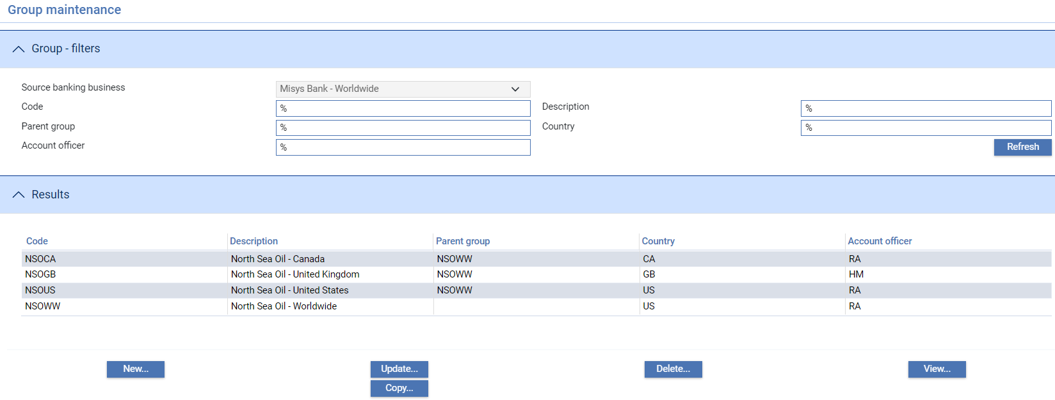

The window displayed can be used to list all the customer groups set up on the Trade Innovation database alphabetically by customer group identifier. You can view or amend the details of a customer group hierarchy by selecting it and clicking either **View** or **Update**.

To create a new customer group click **New**

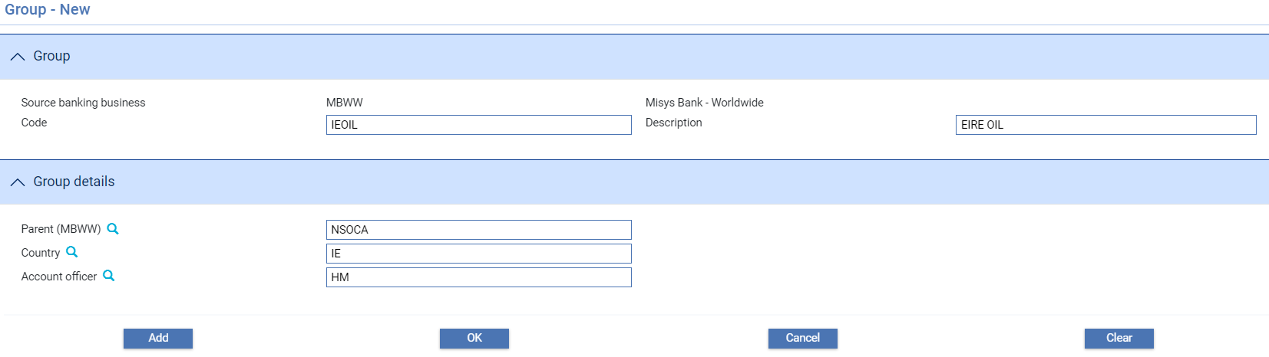

A New group can also be created by clicking on Copy to replicate an existing group setup and amend the details as required.

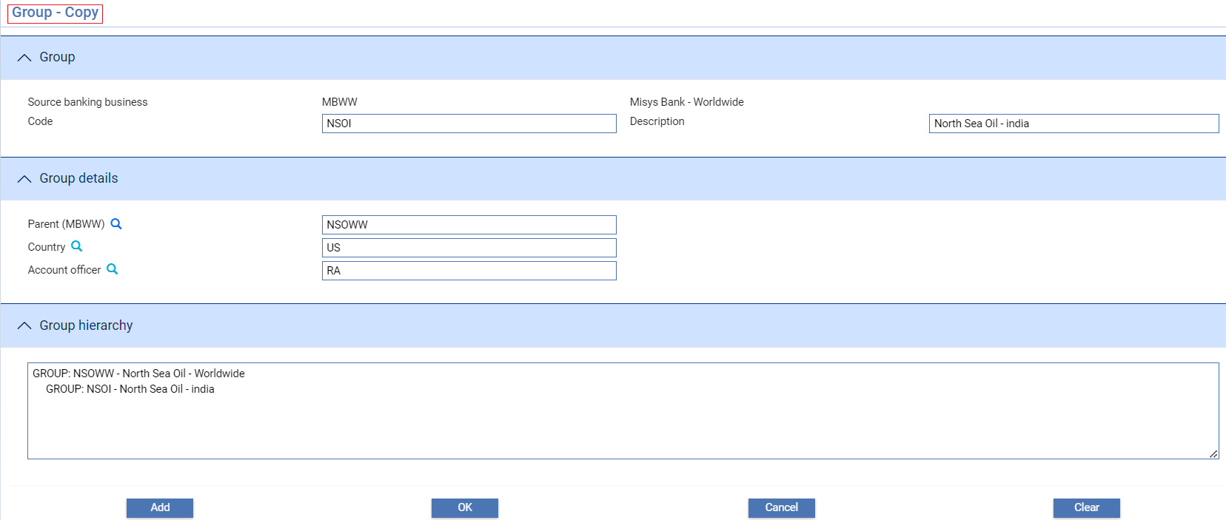

Use the Code field to enter a unique alphanumeric code for the customer group, then enter a description for the customer group into the Description field.

Use the browser buttons in the Group details pane to select the customer group's parent group, country and account officer. These fields are optional. Click **Add** to save the new group.

If you enter a parent group, when you click **Refresh** the system displays the hierarchy in the Group Hierarchy field. 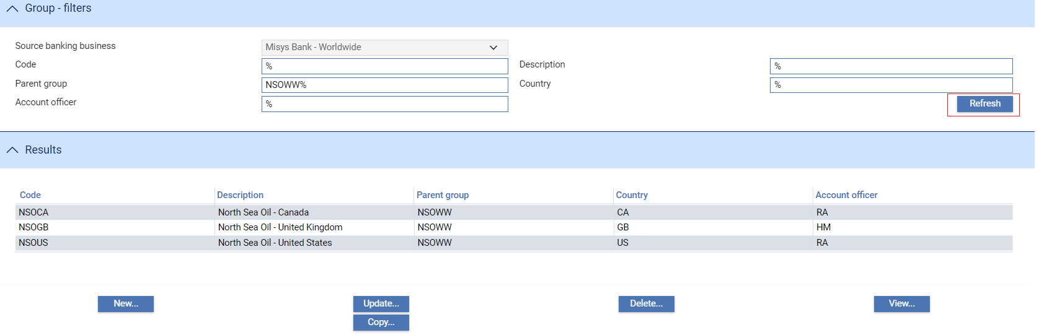

## Customer Types

When entering details of a new customer, you must assign that customer a customer type. Customer types consist of a type code, a description and a qualifier - one of the following values:

* Customer/Corporate
* Bank
* Correspondent

These qualifiers enable users to restrict the display in the Customer Browser window to customers of a particular type.

When you select the General|Customer Types menu option, the system lists existing customer types by code, showing their description and category.

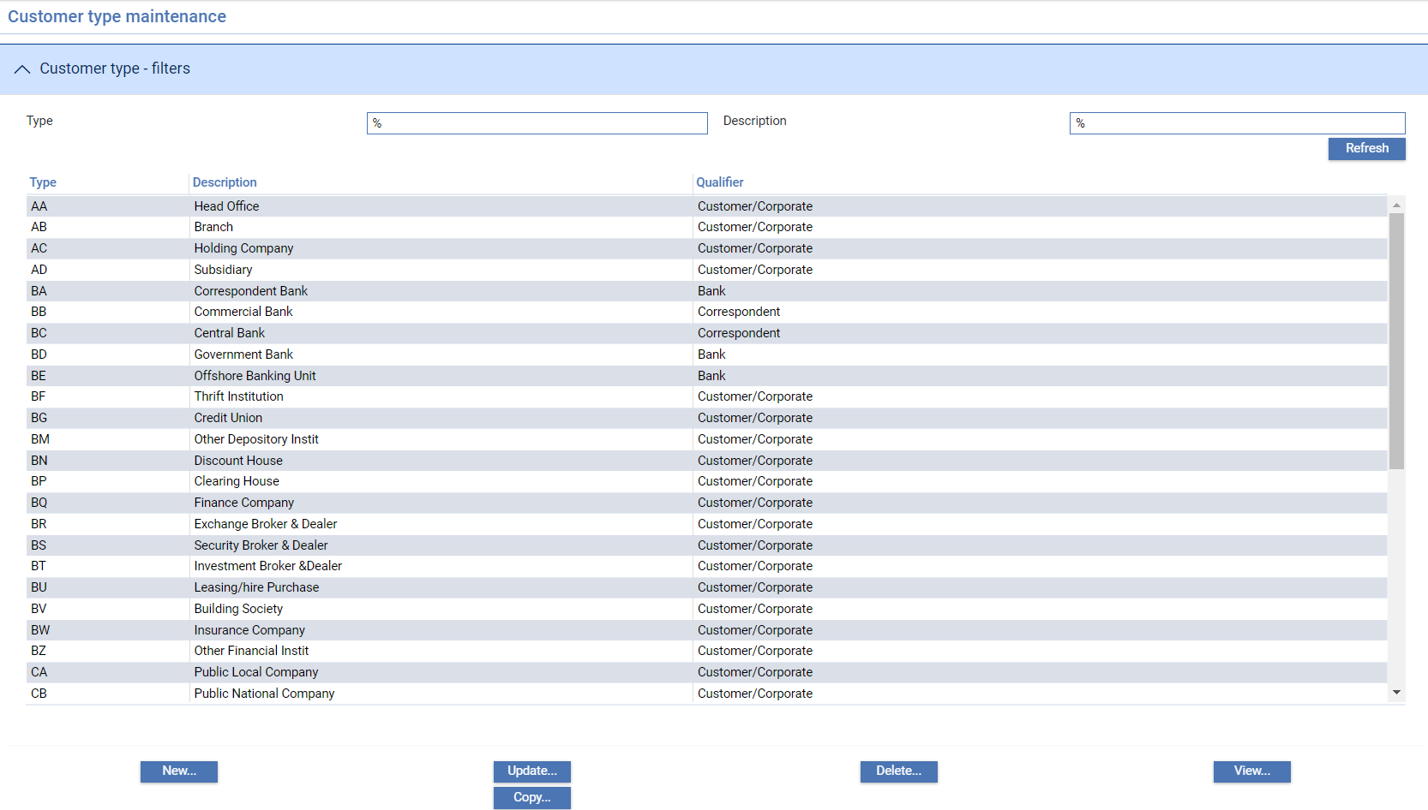

If your bank is using Departmental limits, the suppress limit check is set is displayed.

To create a new customer type click **New**.

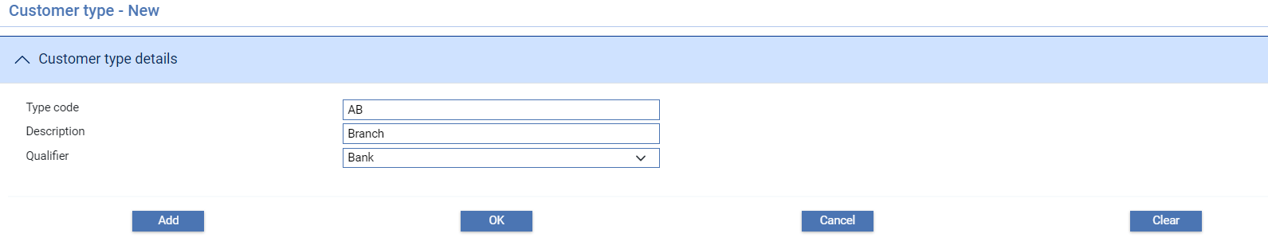

Use the Type Code field to enter a unique alphanumeric code for the customer type. Enter a meaningful description of the customer type into the Description field.

Use the Qualifier field to select which category - Customer/Corporate, Bank or Correspondent - the customer type belongs to.

Check Suppress limit checking if limit checking is not required for this type of customer.

# Accounts

This chapter explains how to set up accounts - customer accounts, charge accounts and internal accounts - and the parameters that govern how they behave, including:

* Charge codes used for charge profit and loss accounting
* System parameters used for internal liability contra and suspense accounts
* Account types, which determine the basic characteristics of the account
* Transaction codes, which determine whether available balance checking is to be performed

## Accounts in Trade Innovation

The system allows account details to be retrieved from different sources for different parts of the bank’s business. This source is determined by the ‘service’ associated with the main banking entity that represents a single General Ledger. The service definition allows accounts to be retrieved from either:

* An internal service – where details are added manually in the system or replicated to the system from an external system or
* An external service – where real time requests are made to an external system to open accounts or retrieve account details

The system permits you to define three types of account:

* Customer accounts - accounts for customers, including other banks, corporations and private individuals
* Internal accounts - used by your bank as contra accounts used for recording liability, accruals and suspense accounts
* Charge accounts - which are used as profit-and-loss accounts to receive charge income. These are also a type of internal account

Account numbers are uniquely identified by a back office account key which is up to 34 alphanumeric characters.

### Account Branch Change

The system allows external systems to pass details of account branch changes allowing your bank to amend the branch of a customer accounts e.g. where a customer’s accounts are moved to another branch. Any requested changes to a customer's accounts are stored and applied to the database during the next overnight processing, see the Business Operations Guide – Trade Innovation.

1. When account branch changes are applied to a completed event, account details included in release items, such postings are not updated by the account branch change to ensure that historical entries show the original account number. However, when viewing the event input fields for completed events any account number shown will display the new account number (as the underlying account data referenced has been changed).

## Account Browser

The account browser allows you to search on Customer, Charge (SK), or Internal (SP) accounts.

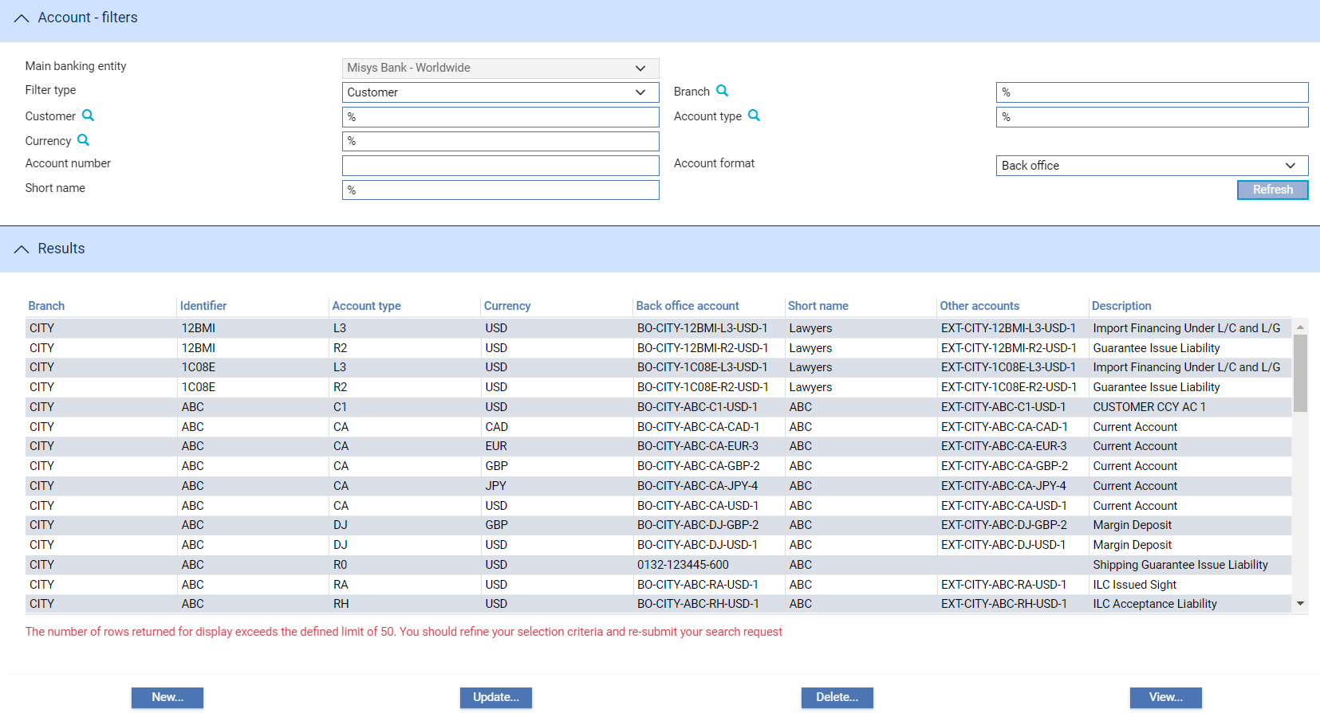

Where account details are maintained in Static Data, the system will default your main banking entity automatically if you are assigned to a single entity. However, when your role covers multiple main banking entities, you will need to specify the account source main banking entity you want to work at. This automatically controls the scope of accounts for branches you can access.

The service associated with the main banking entity is an “Internal” service. You will be able to select the New and Update buttons as all data is entered manually for that source (provided that the relevant security capabilities are mapped). If the data is supplied by an “External” service, the data cannot be maintained.

If Maker Checker is being used in your system, you will only be allowed to view this function. Any changes will need to be made in the Maker Checker application. See the *Maker Checker User Guide – Trade Innovation* for further details.

When New... is selected, the following screen is shown:

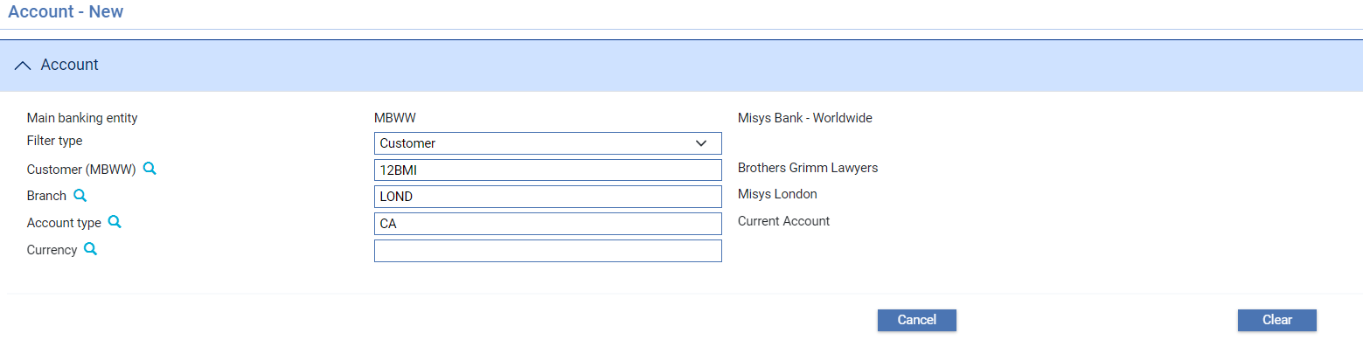

In the Filer type field, identify the type of account you wish to open and click **Refresh**. The fields displayed in this window change, depending on what you select here.

For a customer account:

* Identify the customer
* Select the branch. The system displays the customer's branch as the default
* Select the account type to be used to open the account. You cannot select an internal account type here
* Select the currency of the account

For a charge income account:

* Identify the charge code to be used (see page 77). The system retrieves and displays the account type assigned to that charge code
* Select the branch. The system displays your input branch as the default
* Select the currency of the account

For an internal account:

* Identify the system parameter to be used. The system retrieves and displays the account type assigned to that system parameter.
* Select the branch. The system displays your input branch as the default
* Select the currency of the account

1. If you select SP101 as system parameter the system displays an additional currency field at the bottom of the window into which you can enter the currency against which the currency of the account is to be traded. If the branch system option FxPostionNotCcyPair is set then SP101 accounts are simply defined by currency rather than currency pair.

When you have completed the basic input the system will automatically displays two further panes. The first allows you to enter additional account details, while the second allows you to enter special instructions against the account, in the same way as for customers (see page 36).

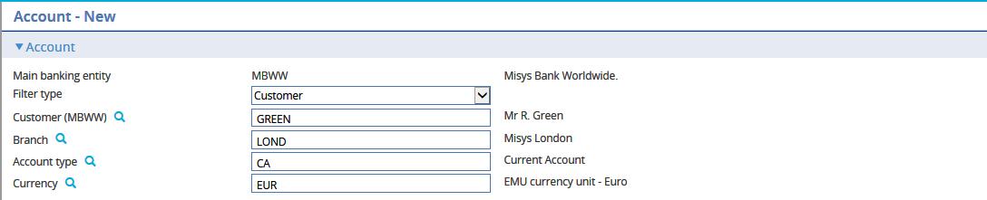

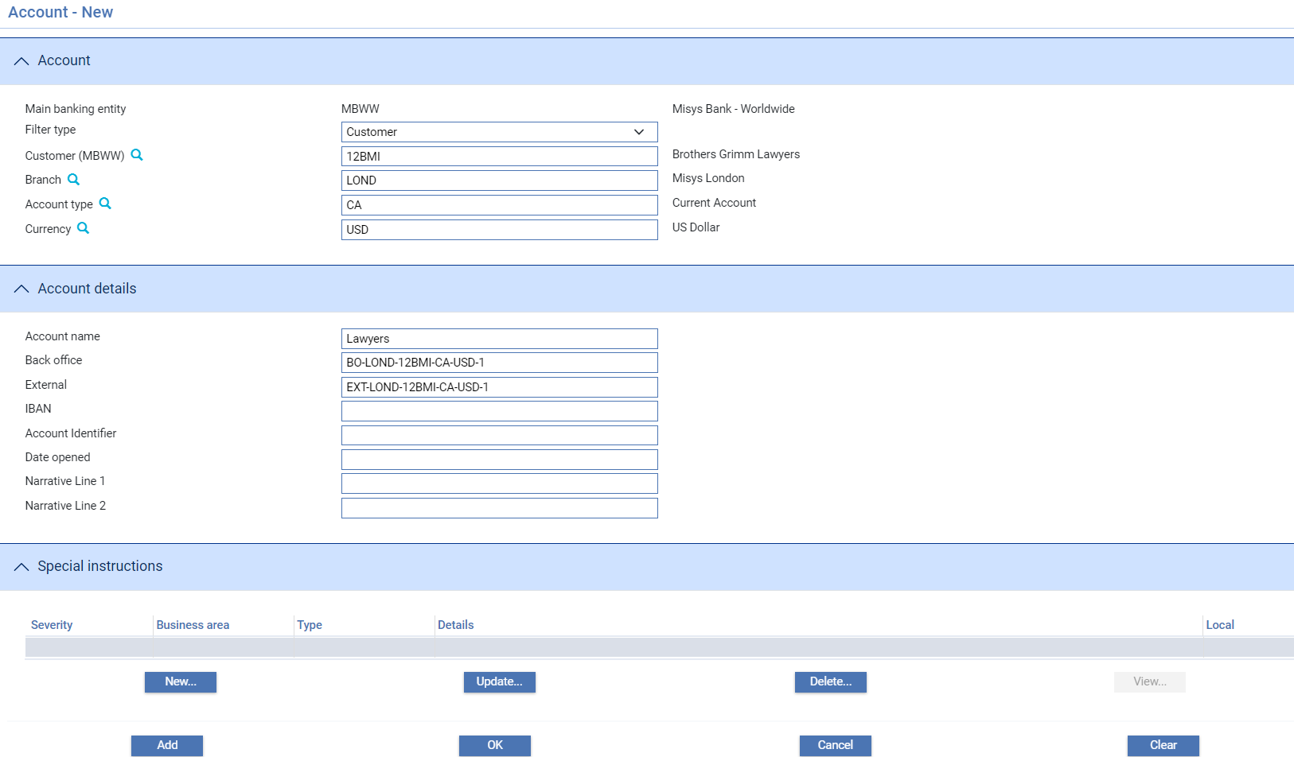

The following table explains what to enter into them:

|  |  |  |
| --- | --- | --- |
|  | Field | What to Enter |
| Account – the account to be opened | | |
|  | Main banking entity | Main banking entity entered on the previous screen. |
|  | Filter type | The Customer, System parameter or Charge code selection entered on the previous screen. |
| If any of the following details are changed , the remaining Account details and Special instructions are automatically refreshed. | | |
|  | Identifier | The Customer, System parameter or Charge code identifier for the account entered on the previous screen. |
|  | Branch | The branch code entered using the previous window. |
|  | Account type | The account type associated with the account derived from previous window. |
| Account details | | |
|  | Account Name | Enter a name for the account. Default values are:   * For customer accounts the customer's short name. * For charge accounts the charge code abbreviation and currency code, separated by a hyphen. * For internal accounts the system parameter abbreviation and currency code, separated by a hyphen. |
|  | Currency | The currency of the account. This is carried over from the previous window. |
|  | Back Office | The number of the back office account that corresponds to this account. This must be unique. |
|  | External Account | The number of the external account that corresponds to this account. If entered, this must be unique. This field is optional. |
|  | IBAN | The IBAN associated with the account. If entered, this must be in a valid IBAN format. |
|  | Date Opened | The date the account was opened. The system uses today's date as the default. |
|  | Narrative 1/ Narrative 2 | Free-format narrative fields for entering additional information about the account. |

### Account Types

The system uses account types to control characteristics of accounts, such as whether or not the account is contingent.

The following tables provide examples of the account types that must be set up for use by the system:

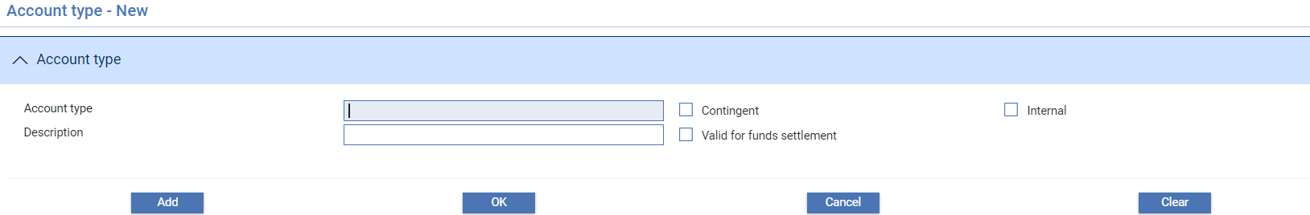

The following table explains what to enter into the fields in this window:

|  |  |  |
| --- | --- | --- |
|  | Field | What to Enter |
|  | Account Type | The account type's unique alphanumeric code. |
|  | Description | A meaningful description of the account type. |
|  | Contingent | Check this field if the account type denotes a contingent account. |
|  | Internal | Check this field if the account type denotes an internal account. |
|  | Valid for Funds Movements | Check this field if the account type denotes an account that is valid for funds settlement. |

## Transaction Codes

Each debit and credit posting in the system must contain a transaction code which identifies the nature of the posting. Transaction codes are used during available balance checking to establish whether over line conditions are reported as an error, in which case the event is rejected, or as a warning, in which case the event can proceed.

Transaction codes are also used to allow any postings generated in relation to a participated deal or shared liability to be reversed automatically if the liability amounts involved in a transaction are amended. The transaction code used on the posting provides a reversal transaction code which is used if the posting has been set up as a debit, but a credit is generated (or vice versa).

For information on setting up reversal postings see the System Tailoring User Guide – Trade Innovation.

You should define a list of transaction codes to cover all the major functions of your bank, which include:

* Trade finance
* Ordinary debit/credit transactions
* Foreign exchange deal transactions
* Financing and discounting transactions
* Funds settlements

Transaction codes are associated with postings when postings are set up, see the System Tailoring User Guide – Trade Innovation.

For internal profit and loss accounts, the transaction codes used are provided by the charge codes.

For internal accounts used to record liability and as settlement suspense accounts, the transaction codes used are provided by the system parameters.

When you select the Accounting|Transaction Codes menu option, the system lists existing transaction definitions using their code and name.

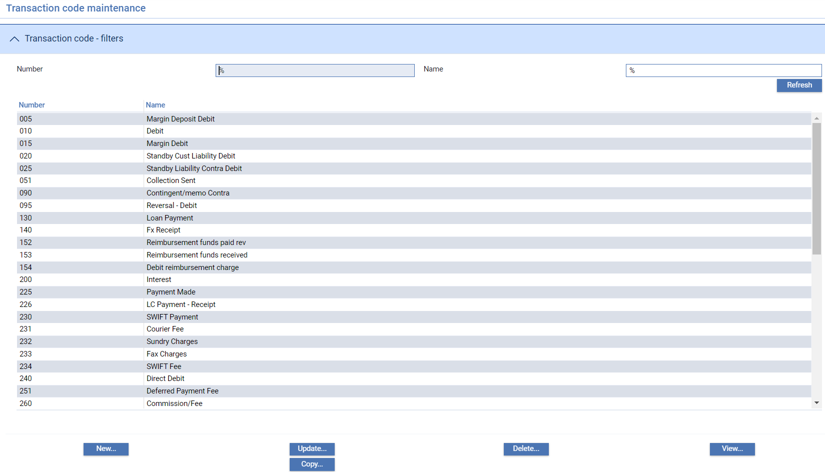

To create a new transaction code, click **New**.

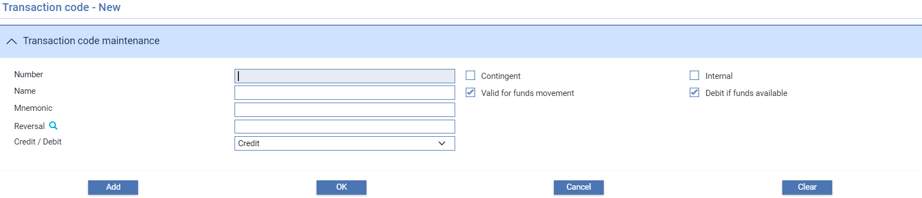

The following table explains what to enter into the fields in this window:

|  |  |  |
| --- | --- | --- |
|  | Field | What to Enter |
|  | Number | The unique transaction code. |
|  | Name | A description of the transaction. |
|  | Mnemonic | A unique identifier for the transaction code. |
|  | Contingent | Check this field if the transaction code is valid for contingent accounts. |
|  | Internal | Check this field if the transaction code is valid for internal accounts. |
|  | Debit if Funds Available | Used in balance checking for debits to accounts using this transaction code. If an account requires checking, then this flag determines whether over line conditions are reported as an error, in which case the event is rejected, or as a warning, in which case the event can proceed.  If the flag is checked, over line conditions are reported as an error. If it is unchecked, they are reported as a warning. |
|  | Reversal | For use with reversal postings generated following amendments to the amounts involved in shared liability or a participated deal. When a posting is defined, it must be defined as either a debit or a credit. However, for a reversal posting it is possible that a posting defined as a credit might be required to generate a debit. The system can tell by the net amount calculated when such a circumstance occurs, and will apply the appropriate transaction code. |
|  | Credit/Debit | Select whether the transaction code is to be used for debits or for credits. |

## Charge Codes

Charge codes are used to create profit and loss accounts. The charge code is used to define the basic attributes of the account, including account type, together with the default transaction codes used when posting to the account.

When you select the Accounting|Charge Codes menu option, the system lists existing charge codes using their code and description.

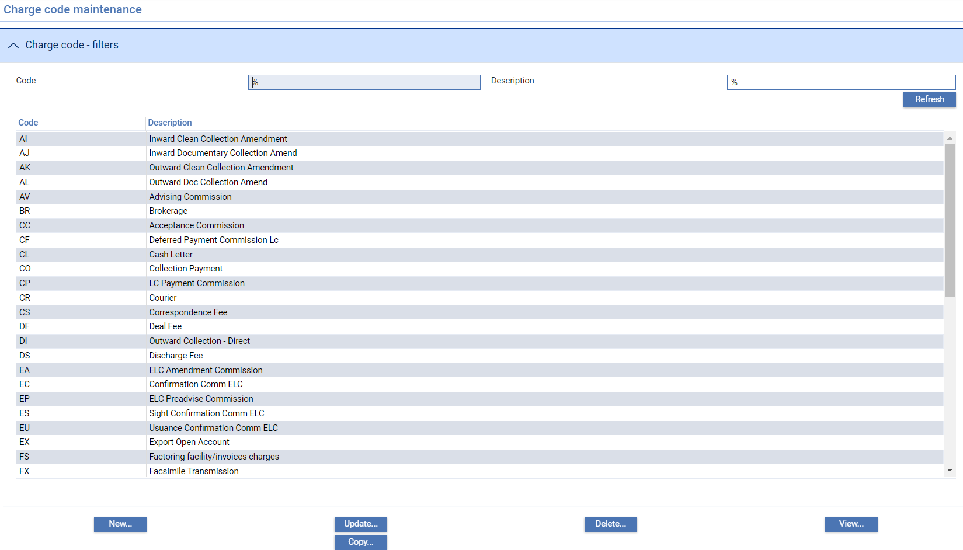

To create a new charge code, click **New**.

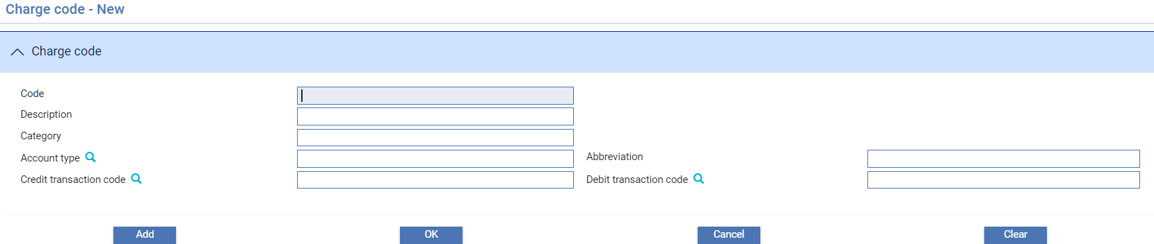

The following table explains what to enter into the fields in this window:

|  | Field | What to Enter |
| --- | --- | --- |
|  | Code | The unique alphanumeric charge code identifier. |
|  | Description | A description of the type of profit and loss account used by the charge code. |
|  | Category | General Ledger category associated with the charge code. |
|  | Account Type | The account type to be used when setting up accounts using this charge code. |
|  | Abbreviation | A code which is used to construct the short name for accounts opened using this charge code. |
|  | Credit Transaction Code | The default transaction code to be used for credits generated by the system to this account. You must select or enter a transaction code that is valid for internal accounts. |
|  | Debit Transaction Code | The default transaction code to be used for debits generated by the system to this account. You must select or enter a transaction code that is valid for internal accounts. |

### System Parameters

System parameters are used for internal contra accounts, accrual and suspense accounts. The system parameter is used to define the basic attributes of the account, including account type, together with the default transaction codes used when posting to the account.

The following system parameters hold the accounting information used to open the appropriate internal accounts when processing charges:

|  | Parameter | Accounting Information |
| --- | --- | --- |
| SP145 | Tax Accumulation | The tax accumulation account used to record credit charge payments on behalf of the revenue authorities where a charge is liable to tax. |
| SP101 | Current Exchange Position | Exchange position accounts are used to convert funds between two currencies if charges are not booked in the currency collected from the customer. |
| SP620 | Unearned Income | Used to handle the daily accrual of periodic charges where charges have been taken in advance. |
| SP621 | Income Receivable | Used to handle the daily accrual of periodic charges where charges are taken in arrears. |
| SP622 | Charge expenses | Used to handle the daily accrual of periodic charges due to be paid out to a participant where charges are taken in arrears. |
| SP661 | Billed income/expenses | Used to account for billed charge income/expenses before the charge has been paid. |

When you select the Accounting|System parameter menu option, the system lists the existing system parameters using their code and description.

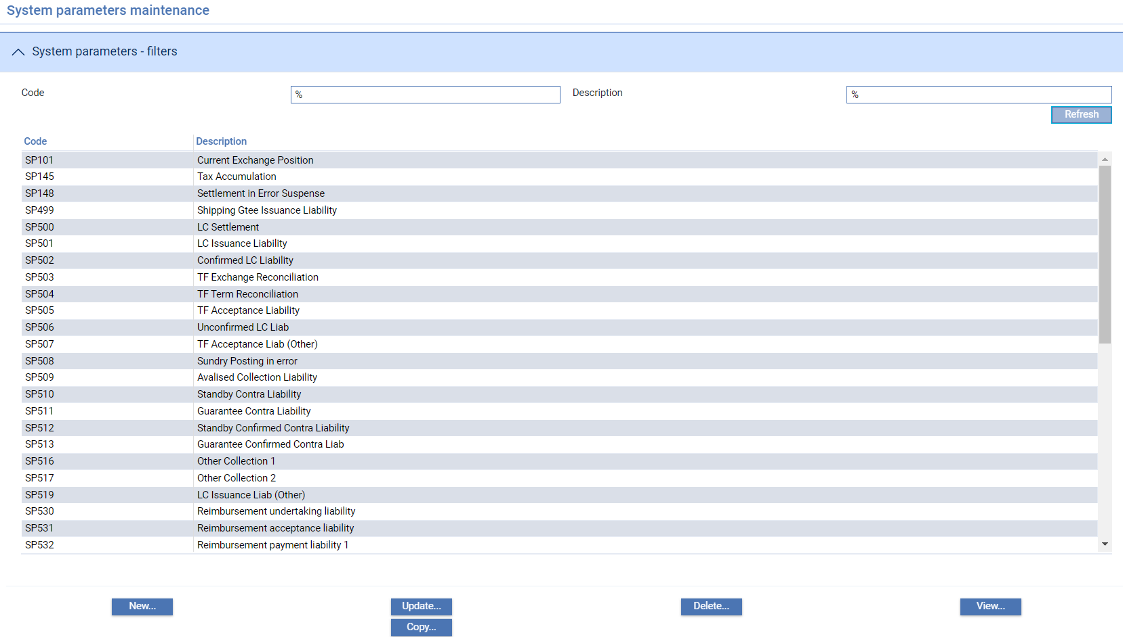

To create a new system parameter, click **New**.

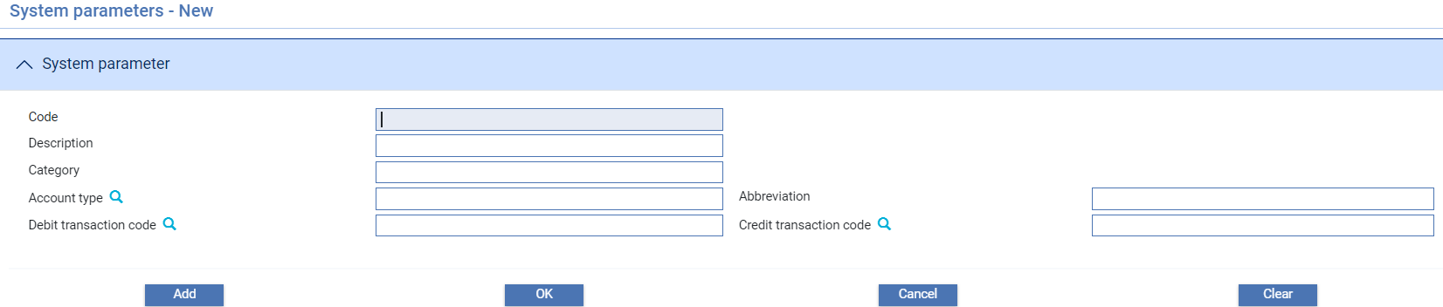

The following table explains what to enter into the fields in this window:

|  |  |  |
| --- | --- | --- |
|  | Field | What it Holds |
|  | Code | The unique system parameter code. |
|  | Description | A description of the system parameter which should reflect what the account is used for. |
|  | Category code | General Ledger category associated with the system parameter. |
|  | Account Type | The account type to be used when setting up accounts using this system parameter. |
|  | Abbreviation | A code which is used to construct the short name for accounts opened using this system parameter. |
|  | Debit Transaction Code | The transaction code to be used for debits generated by the system to this account. You must select or enter a transaction code that is valid for internal accounts. |
|  | Credit Transaction Code | The transaction code to be used for credits generated by the system to this account. You must select or enter a transaction code that is valid for internal accounts. |

# Financing and Foreign Exchange Deal Types

This chapter covers deal types, a parameter used to govern the characteristics of financing and foreign exchange deals that are generated from the system.

## Deal Types

The system uses the deal type parameter to govern how different types of deal are to be processed for each product your system supports. These deal types define, among other things, how interest is to be calculated and whether or not the discount to yield formula is to be used. (For more information on setting up product options and interest types, see the System Tailoring User Guide – Trade Innovation.)

When a new trade finance product is being set up, deal types must be entered for:

* Standard foreign exchange deals
* Financing deals using the standard discount formula
* Financing deals using the discount to yield formula
* Negotiations under a collection order involving interest at maturity, discount or discount to yield
* Trust receipt loans against an import letter of credit involving interest at maturity, discount or discount to yield
* Advances under a collection order involving interest at maturity, discount or discount to yield
* Payment with financing against an import letter of credit involving interest at maturity, discount or discount to yield

1. If your system has the financing module implemented you do not need to set up financing deal types. Their functionality is replaced by product-level parameters and interest type settings.

When you select the Accounting|Deal Types menu option the system lists existing entries by their code, and shows their description and the type of deal to which they relate.

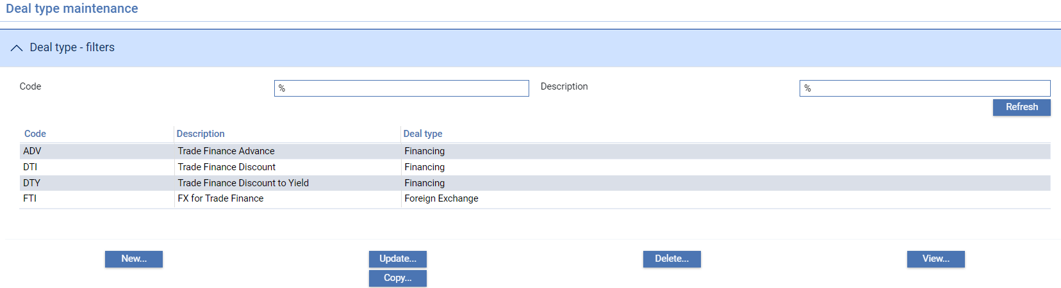

To create a new deal type click **New**.

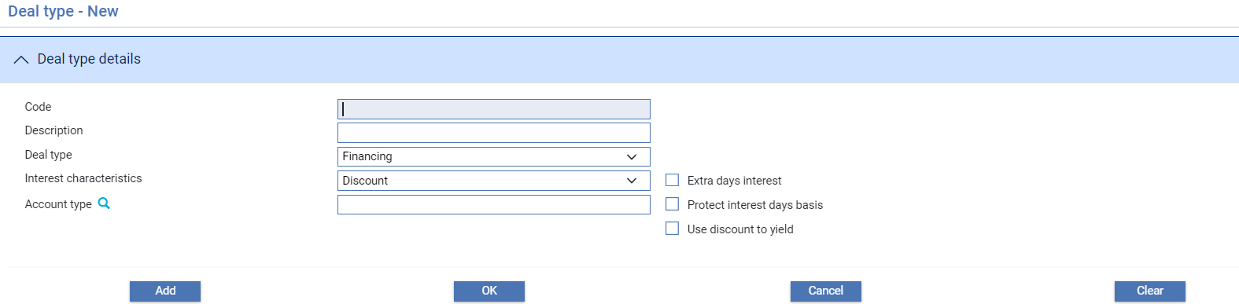

The following table explains what to enter into the fields in this window:

|  |  |  |
| --- | --- | --- |
|  | Field | What to Enter |
|  | Code | The deal type's unique alphanumeric code. |
|  | Description | A meaningful description of the deal type. |
|  | Deal Type | Indicates whether the deal type is a foreign exchange deal or a finance deal. If you select ‘Foreign Exchange’, the fields described below disappear. |
|  | Interest Characteristics | For financing deals only, indicates whether the interest calculated on the deal is to be discounted with interest payable at inception, or variable. |
|  | Extra Days Interest | For financing deals only, check this box if the maturity date of a deal is to be included in interest calculations. |
|  | Protect Interest Days Basis | For financing deals only, check this box if the interest days basis is to be protected during deal input. If you check this box, then the default interest days basis for the currency cannot be changed for this type of deal. |
|  | Use Discount to Yield | For financing deals only, check this box if the discount to yield formula is to be applied. Leave it blank if the standard discount formula is used instead. |

# Nostros, Vostros, Clearing Systems, and Correspondents

This chapter explains how to set up nostros (including the default nostros to be used by branches), vostros, clearing system details and the correspondents your bank will use.

## Nostros, Vostros, Clearing Systems and Correspondents in Trade Innovation

The following sections provide an overview of how nostros, vostros, and correspondents are set up and used in the system, and how clearing systems are used to support additional settlement methods.

Nostros, Clearing Systems and Customer Standing Settlement Instructions are definable by main banking entity as they refer to accounts held within that part of the bank’s business.

In the following example, MBUK – Misys Bank UK – is a main banking entity. Accounts are held by main banking entity and used to define Nostros, Default nostros and Clearing Systems. During transaction input the behalf of branch determines the main banking entity from within which Nostros and Clearing systems can be selected:



## Nostros

When you select the Accounts|Nostro menu option, the system lists all existing nostros associated with the selected main banking entity.

If Maker Checker is being used in your system, you will only be allowed to view this function. Any changes will need to be made in the Maker Checker application. See the *Maker Checker User Guide – Trade Innovation* for further details.

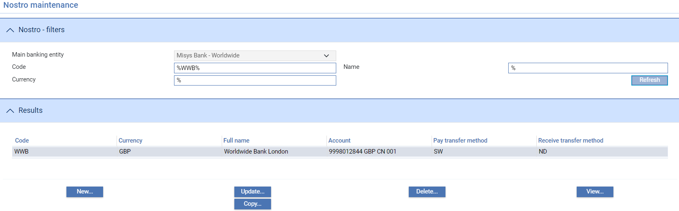

The following table explains what each of the columns in this window shows:

|  |  |
| --- | --- |
| Heading | What it Shows |
| Code | The nostro's unique identifier |
| Currency | The currency of the nostro. |
| Full Name | The nostro's full name. |
| Account | The number of the account. |
| Transfer Method | The transfer method to be used for notifying payments from the nostro. |
| Receive Transfer Method | The code of the transfer method to be used for notifying receipts of funds to the nostro. |

To enter details of a new nostro click **New**.

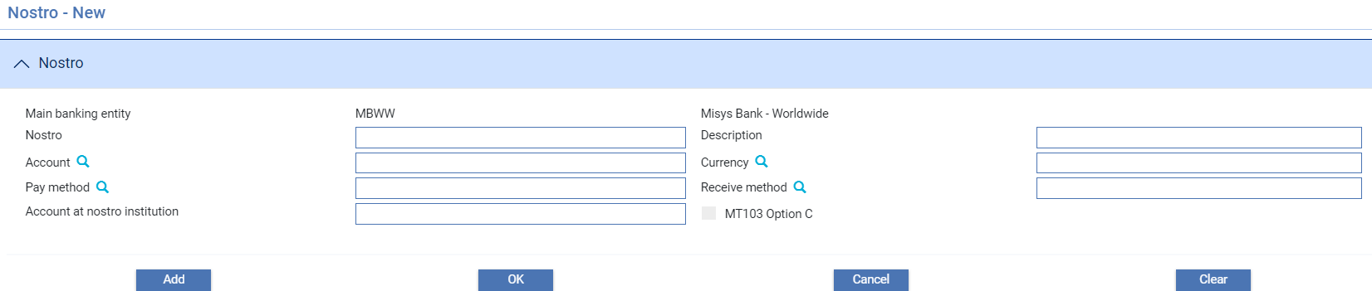

When adding a Nostro, the Nostro is defined for the main banking entity within which you are filtering. You can then add a Nostro by entering a mnemonic and an account number within that main banking entity.

Similarly, when you browse for Nostros as part of transaction settlements or Master SSIs, only the relevant nostros and accounts from the main banking entity associated with the behalf of branch are displayed.

The following table explains what to enter into the fields in this window to define a nostro:

|  |  |  |
| --- | --- | --- |
|  | Field | What to Enter |
|  | Nostro | The nostro's unique alphanumeric mnemonic. |
|  | Description | The full name of the nostro. |
|  | Account | Use these fields to select or enter the number of the customer account to be used as the nostro. Each customer account can only be associated with one nostro. |
|  | Currency | The currency. This must be the same as the currency of the account identified using the previous field. |
|  | Pay Method | The transfer method to be used for notifying payments from the nostro. All pay settlements made using this nostro will use this transfer method unless a specific transfer method is entered for an individual settlement or for a customer's default settlement instructions using this nostro. |
|  | Receive Method | The transfer method to be used for notifying receipts to the nostro. All receive settlements made using this nostro will use this transfer method unless a specific transfer method is entered for an individual settlement or for a customer's default settlement instructions using this nostro. |
|  | Account at Nostro Institution | This field is used to specify the account number of the corresponding account at the nostro institution. |
|  | MT103 Option C | Check this field if this nostro accepts SWIFT MT103 Customer Transfer messages in format C. |

## Default Nostros

When you select the Accounts|Default Nostro menu option, the system lists existing default nostros for the selected main banking entity by branch, showing for each the currency, instruction group, unique identifier and full name of the nostro used for settlement.

If Maker checker is being used in your system you will only be allowed to view this function. See *Maker Checker User Guide – Trade Innovation* user guide for further details.

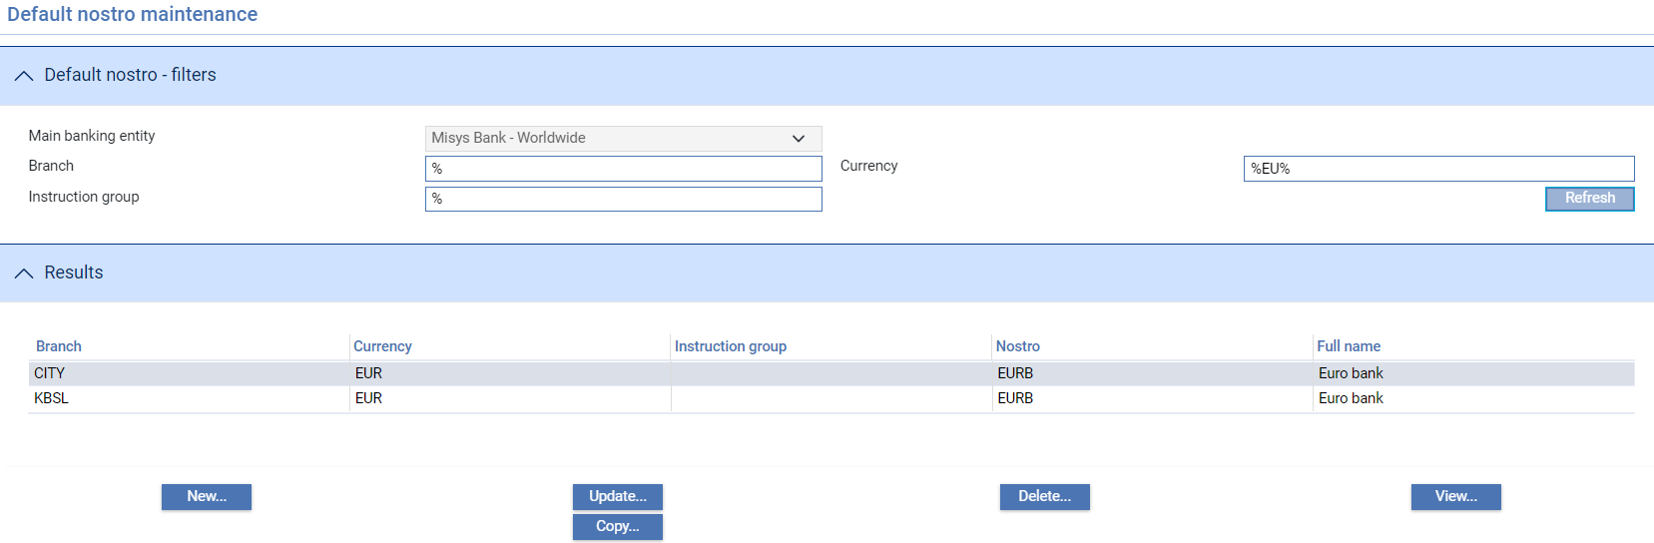

To create a new default nostro click **New**.

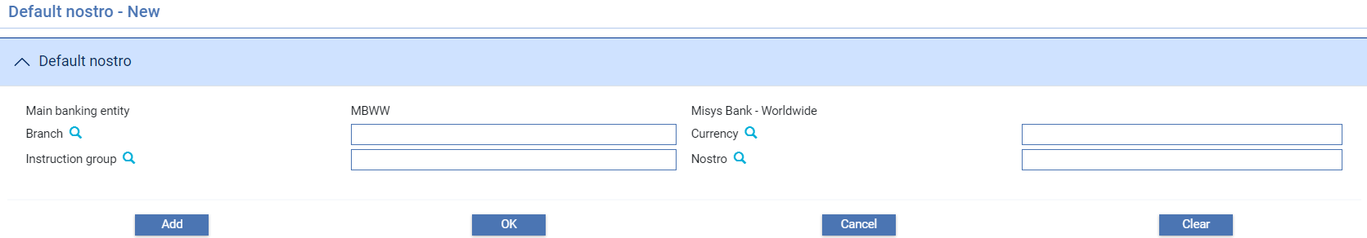

The following table explains what to enter into the fields in this window to define a default nostro:

|  | Field | What to Enter |
| --- | --- | --- |
|  | Branch | The branch. |
|  | Currency | The currency for which this nostro is to be the default. |
|  | Instruction Group | The code of the instruction group for which the nostro is being set up. If you enter a value here, then only those products whose instruction group matches it will use this nostro for settlement.  If you leave this field blank, the nostro can be used for all products. |
|  | Nostro | The mnemonic of the nostro. The system issues a warning (which you can override) if the underlying account of the nostro selected here is in a different currency from that specified in the **Currency** field.  If you do specify a nostro with an underlying account that is different from the currency of the default nostro then, provided that the currencies are either Euro member currencies or a Euro member currency and the Euro, during transaction processing the system automatically creates the foreign exchange deal required in order to settle payment or receipt of funds in the account currency, rather than the transaction currency. |

### Vostros

When instructing another bank to pay funds to a beneficiary, you may credit their account in your books rather than instructing one of your nostros to settle the funds. A vostro account is simply an account in your books that is identified as a vostro account by specifying its account type against the VostroAccTyp system option. When you settle via a vostro, the system allows details of the account to be credited in our books to be entered together with instructions for the receiving bank on how to transfer funds to the beneficiary.

## Clearing Systems

Clearing systems are set up using the Accounts|Clearing System IDs menu option. When you select this menu option the system lists existing clearing systems for the selected main banking entity.

If Maker Checker is being used in your system, you will only be allowed to view this function. Any changes will need to be made in the Maker Checker application. See the *Maker Checker User Guide – Trade Innovation* for further details.

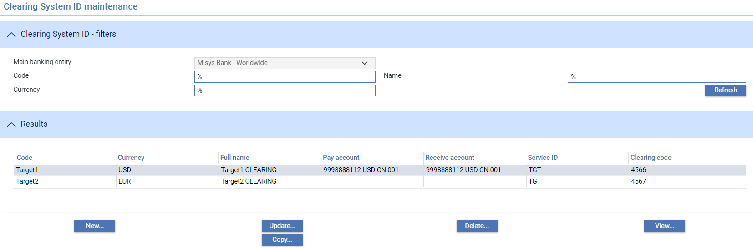

The following table explains what each of the columns in this window shows:

|  |  |
| --- | --- |
| Heading | What it Shows |
| Code | The clearing system's unique identifier. |
| Currency | The currency of the clearing system. |
| Full Name | The clearing system's full name. |
| Pay Account | The number of the account from which payments are made using this clearing system. |
| Receive Account | The number of the account to which payments are made using this clearing system. |
| Service ID | The clearing system's ID (e.g. TGT – Target). When the clearing system is used in settlements, the value entered here is automatically output in Header (Block 3) of MT103 and/or MT202 SWIFT messages, as appropriate. |
| Clearing Code | Your bank's number within this clearing system. |

To enter details of a new clearing system click **New**.

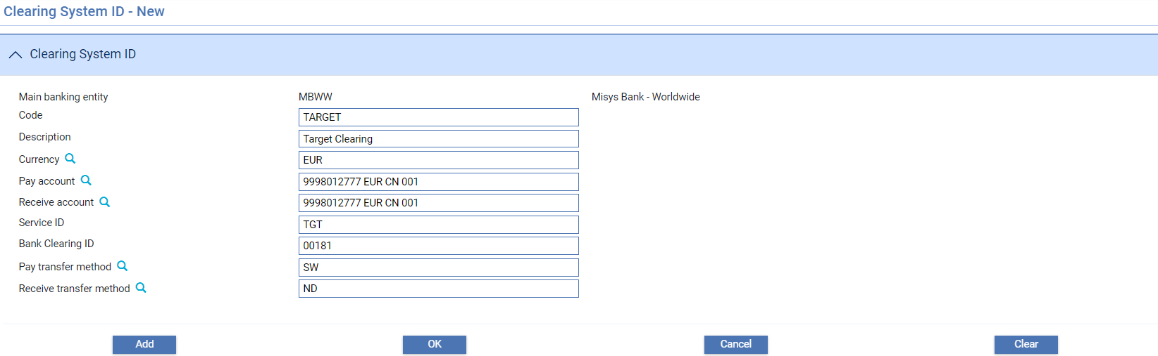

The following table explains what to enter into the fields in this window to define a Clearing system:

|  | Field | What to Enter |
| --- | --- | --- |
|  | Code | The clearing system's unique identifier. |
|  | Description | The clearing system description. |
|  | Currency | Currency of the clearing system. |
|  | Pay Account | The account to be used when settling payments through this clearing system. The account entered must be a valid account in the main banking entity in which the Clearing system is being defined. |
|  | Receive Account | The account to be used when receiving payments through this clearing system. The account entered must be a valid account in the main banking entity in which the Clearing system is being defined. |
|  | Service ID | The clearing system's service ID (e.g. TGT – Target) When the clearing system is used in settlements, the value entered here is automatically output in Header (Block 3) of MT103 and/or MT202 SWIFT messages, as appropriate. |
|  | Bank Clearing ID | Your bank's number within this clearing system. |
|  | Pay Method | The transfer method to be used when notifying payments via the Clearing system. |
|  | Receive Method | The transfer method to be used when notifying receipts of funds via the Clearing system. |

## Correspondents

To set up correspondent banks for each individual country, first select the Nostros|Correspondents menu option. When you select this menu option the system lists existing correspondents for the selected source banking business and country.

If Maker Checker is being used in your system, you will only be allowed to view this function. Any changes will need to be made in the Maker Checker application. See the *Maker Checker User Guide – Trade Innovation* for further details.

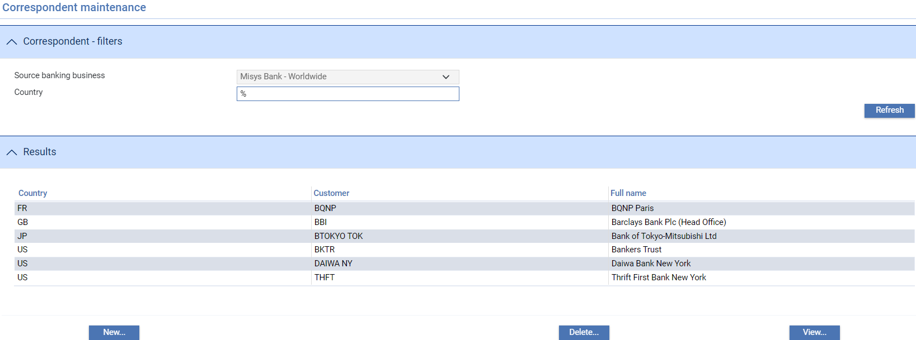

When you enter a country and click **Refresh** this window lists all the Correspondents set up on your system and you can select them to view or delete in the usual way.

To enter details of a new Correspondent click **New**.

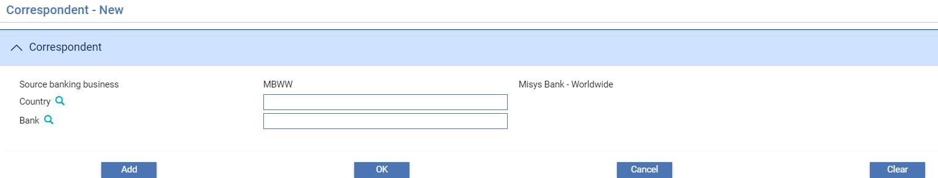

The following table explains what to enter into the fields in this window to define a nostro:

|  |  |  |
| --- | --- | --- |
|  | Field | What to Enter |
|  | Country | Country for which the correspondent is to be used. |
|  | Bank | The customer ID of the bank that is to be used as a correspondent. |

When you click **Add** the selected bank is added to the list of correspondents for that country.

If you set up a single correspondent bank for a country, the system will always use that bank. If you set up more than one, the system will use them in turn, although the input clerk can override the selection during processing and choose another bank set up as correspondent in the relevant country,

# Instruction Groups and Transfer Methods

This chapter covers instruction groups and transfer methods.

## Instruction Groups

Instruction groups are used to group together products that share the same settlement accounts. When setting product options using the system tailoring application, an instruction group is assigned to each product type. During transaction processing, the instruction group for the product indicates which customer settlement instructions and/or default nostros for branches are to be used when settling a transaction.

For more information on setting product options see the System Tailoring User Guide – Trade Innovation.

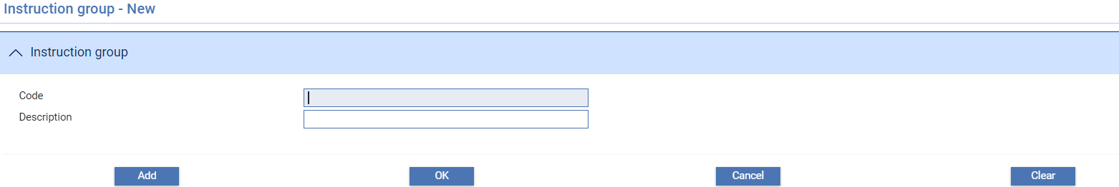

Use the Code field to enter a unique alphanumeric code for the instruction group, then enter a description of the instruction group into the Full Name field.

## Transfer Methods

Transfer methods are used throughout the system to determine how correspondence should be sent to parties. Each transfer method has an associated transmission method that determines the physical means by which correspondence is to be sent.

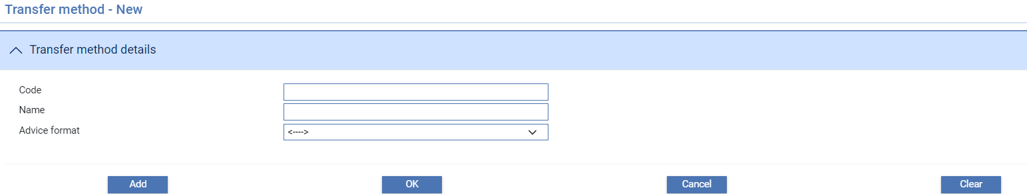

Use the Code field to enter the transfer method's unique alphanumeric code, then enter a description of the transfer method into the Name field. Use the Advice Format drop-down to select the transmission method to be used by this transfer method.

# Currencies, FX Rates, and Base/Diff Rates

This chapter covers the currencies, foreign exchange rates, base rates, differential rates and base rate groups used by the system.

## Currencies

The Country|Currencies menu option allows basic details of each currency to be defined.

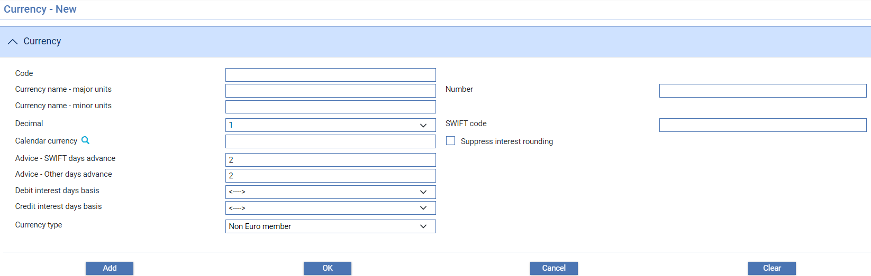

The following table explains what to enter into these fields to define a new currency:

|  | Field | What to Enter | |
| --- | --- | --- | --- |
|  | Code | The unique code of the currency. This should conform to ISO standards. | |
|  | Currency Name - Major Units | The name of the currency's major unit (for example, US Dollar or Pounds Sterling). | |
|  | Currency Name - Minor Units | The name of the currency's minor unit (for example, Cent or Pence). | |
|  | Number | The currency's unique three-digit number. The value entered here should correspond to ISO numbers. | |
|  | Decimal | The number of decimal places for the currency. | |
|  | SWIFT Code | The code used for SWIFT interbank transactions in this currency. This must conform to ISO standards. | |
|  | Calendar Currency | The currency that is to provide the calendar to be used to determine what are valid business days for settlement in this currency. Typically, this will be the same value as you entered in the Code field. However, you can use a different currency code here, or you can leave the field blank to use the local currency calendar. | |
|  | Suppress Interest Rounding | Determines whether, when interest is calculated, it is rounded up or truncated. If this box is checked, interest will be truncated; if it is unchecked, interest will be rounded up. | |
|  | Advice - SWIFT Days Advance/  Advice - Other Days Advance | The number of days in advance of the settlement that pay and receive advices are to be sent. You can enter one value for advices to be sent by SWIFT and another value for advices to be sent by methods other than SWIFT. Each field permits a figure in the range 0-9. | |
|  | Debit Interest Days Basis | The default interest days basis for calculating debit interest in this currency. This is used if no interest days basis is entered against a finance deal during transaction processing. | |
|  | Credit Interest Days Basis | The default interest days basis for calculating credit interest in this currency (reserved). | |
|  | Currency Type | Use this field to define a currency as a euro member currency or as a non euro member currency.  You do not need to define non euro member currencies - by default, currencies are presumed by the system to be non euro member currencies unless specified here as euro member currencies or the euro itself.  If you select 'Euro Member' in this field and the system displays the additional fields illustrated below: | |
|  | | | |
|  |  | | Use the In Date and End Date fields to enter the start and end of the transition period for the currency; and use the Fixed Rate field to enter the fixed rate provided by the European Central Bank for conversions between this currency and the euro. |

### Updating Spot Rates

The system is delivered with a standard set of currencies, and you can set and maintain the spot rate using the Rates|Spot Rates menu option. When you select this option the system displays the Rate definition selection window that allows you to perform the necessary maintenance on all of the spot rates for a specific main banking entity. It lists all the currencies on your system, showing their code, description and the current spot rate.

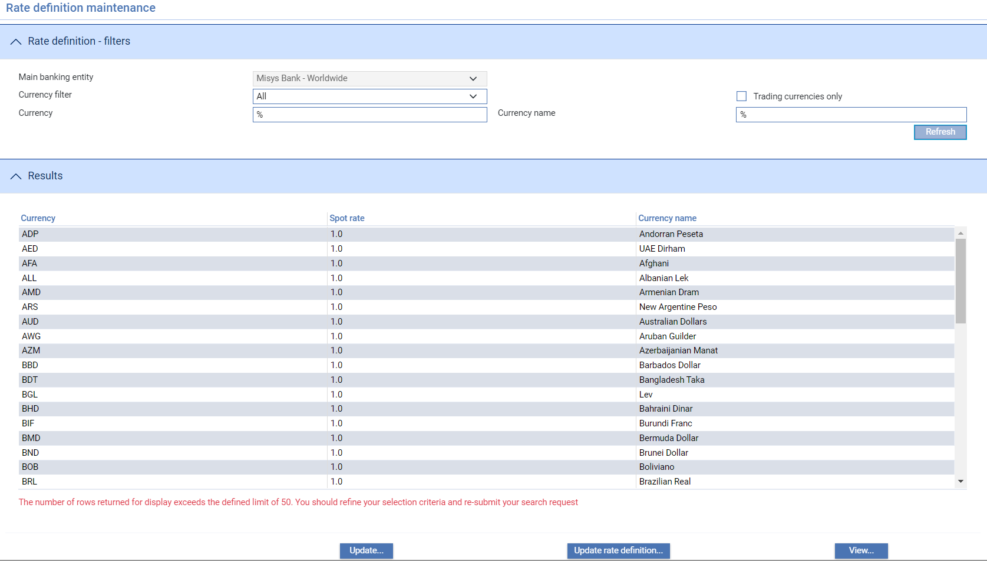

1. Spot rates cannot be maintained through user input or gateway messages for a main banking entity which is in extended business hours during the end of day.  
     
   For instructions on using this window to perform rate fixing during business hours see the Business Operations Guide – Trade Innovation.

In addition to the usual filters, this window includes:

* Main banking entity, which displays the current details for a main banking entity
* A drop-down list, which allows you to list all currencies, the Euro only, Euro member currencies only, or non-Euro member currencies only
* The Trading Currencies Only check box, which, if checked, causes the window to display only those currencies used for trading

Click **Refresh** after setting these filters.

The first time you open this window, all the standard currencies delivered with the system will display a spot rate of '1.0'. Subsequently, they will show the current spot rate for each currency.

The Update Rate Definition button allows the following details to be changed for the currency:

|  |  |  |
| --- | --- | --- |
|  | Field | What to Enter |
|  | Invalid trading currency | If the currency is not a valid trading currency, check this box, otherwise leave it blank. If you flag a currency as not a valid trading currency, the system will prevent any new transactions from being created in that currency. |
|  | Reciprocal | Indicates whether the exchange rate is reciprocal or non-reciprocal against base currency. |
|  | Quotation units | Used to preserve more decimal precision. This field can have values of the power of 10. |
|  | Previous Rate | Previous day’s exchange rate – stored during overnight processing. |

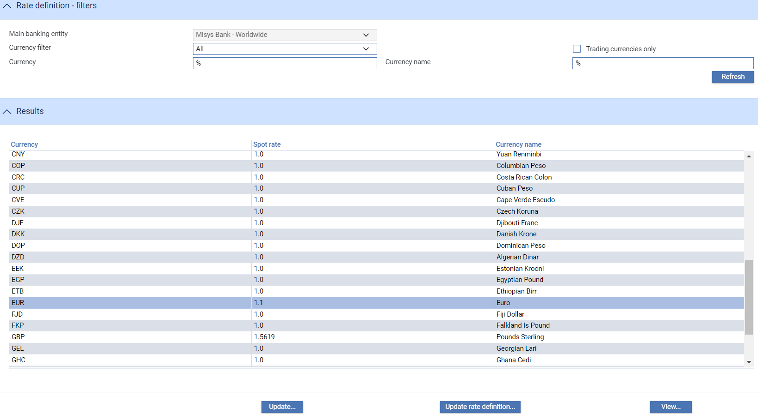

When you select a currency for Update or by double-clicking on it, the system opens the Currency rate – Update window which displays information for the currency.

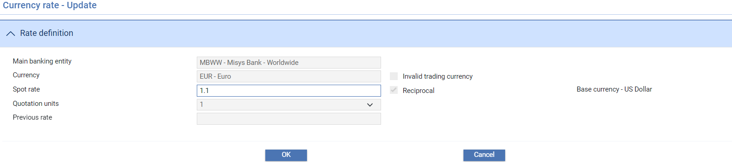

The spot rate is shown in the middle field, where you can overtype it. Click **OK** to save any changes you make.

1. If you have implemented Euro processing, the system ignores any spot rates entered against Euro member currencies once their in date has been reached.  
     
   The system issues a warning if the new rate you enter exceeds the exchange rate tolerance set up for the main banking entity, but will allow you to continue.

## Foreign Exchange Rates

The system permits you to set up a number of different types of exchange rates for each currency. When defining product options, see the System Tailoring User Guide – Trade Innovation, you identify which exchange rate type each product will use for converting principal and charge amounts. The system uses this exchange rate type in conjunction with the currency to identify and apply the appropriate exchange rate, although it can generally be overridden by the input clerk.

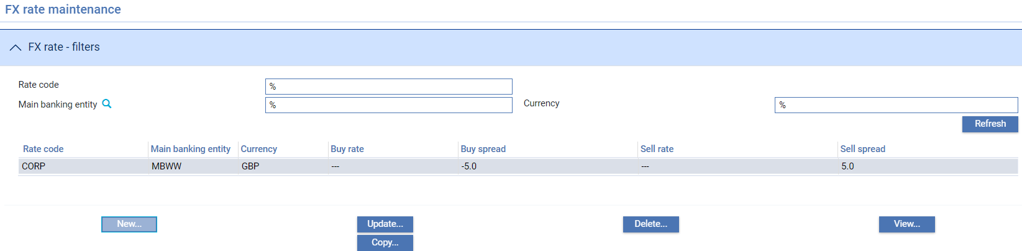

The system also uses exchange rate types to identify the exchange rates to be used for individual customers.

1. You do not have to use this facility. If you prefer, your bank can simply use the spot rate defined for each currency. This is the rate applied as default if no other rate has been defined.  
     
   FX rates cannot be maintained through user input or gateway messages for a main banking entity which is in extended business hours during the end of day.

Setting up exchange rates is a two-stage process:

* First you must define the types of exchange rate your system will use (see page 93). For example, you may want to set up different rates for corporate customers and for banks. These are defined as an alphanumeric code and a description, plus information on rate fixing and the reference rate used
* Once you have set up an exchange rate you can then define the actual exchange rates it will use for each currency (see page 94)

#### Example

If you set up the following two exchange rate types:

|  |  |  |  |
| --- | --- | --- | --- |
| Rate code | CORP | based on | spot rate |
| Rate code | CORP01 | based on | CORP |

And the spot rate used is:

EUR/GBP spot rate = 1.24

The following rates result:

|  |  |  |  |  |
| --- | --- | --- | --- | --- |
| CORP EUR/GBP | = | Buy % spread 10% | = | 1.364 |
|  |  | Sell % spread -10% | = | 1.116 |
| CORP01 EUR/GBP | = | Buy spread 0.0125 | = | 1.3765 |
|  |  | Sell spread -0.0125 | = | 1.1035 |

### Setting Up Exchange Rate Types

When you select the FX/Base rate codes|FX Rate Codes menu option the system lists each of the foreign exchange rate codes set up on your system, showing the code and description.

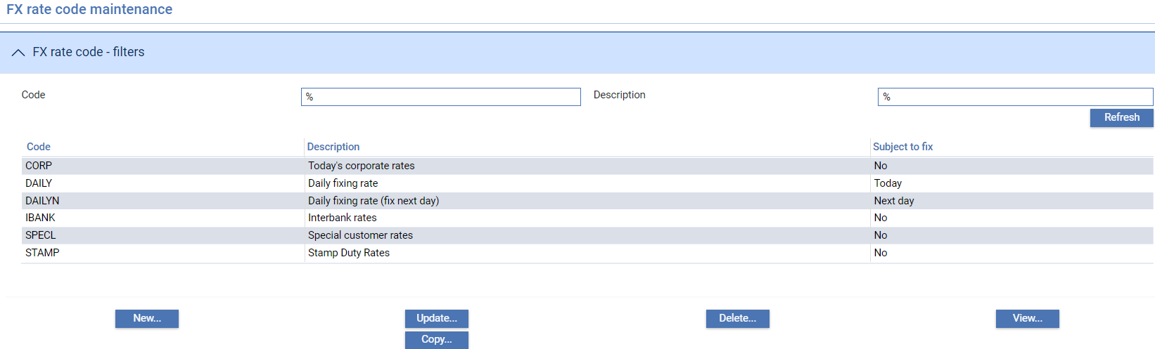

The Subject To Fix column indicates whether the rate code is affected by rate fixing.

Special processing applies when amending and deleting rate types - see the subsequent sections.

To create a new exchange rate type click **New**.

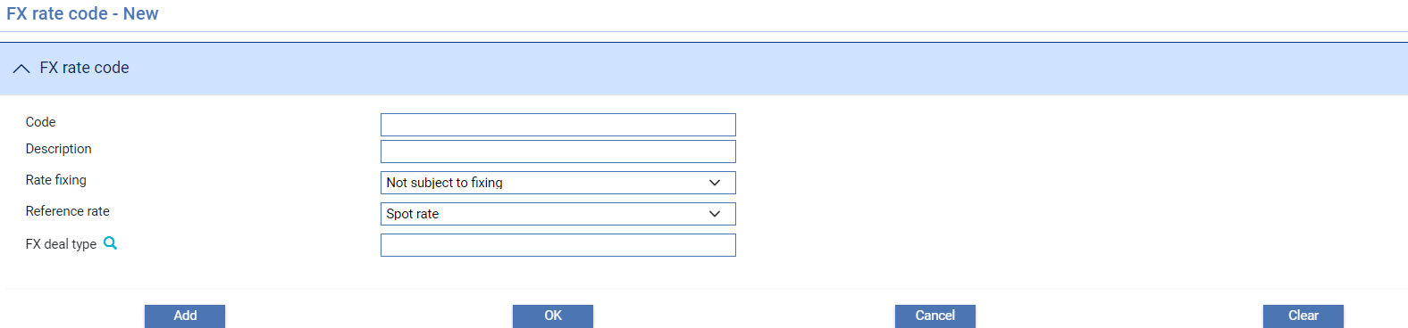

Enter a unique alphanumeric code for the exchange rate type into the Code field, and a description of the exchange rate type into the Description field.

If the foreign exchange rates for a rate code are to be based on another rate code rather than on the spot rate, select ‘Rate Code’ in the Reference Rate field. In the field that appears enter the appropriate rate code into the FX Rate Code field.

You may specify the FX deal type for the rate code using the FX Rate Code field. If the deal type is not specified here, during transaction processing, the system will use the deal type set up for the product instead.

The FX Deal Type field may be disabled, if your system is set so that FX deal types are not required, see the System Tailoring User Guide – Trade Innovation.

If the foreign exchange rate code will be affected by rate fixing during business hours select one of the following in the Rate Fixing field:

* Fix Rate Today, if events awaiting rate fixing are to be updated using the current business day's new foreign exchange rate.
* Fix Rate Next Day, if events awaiting rate fixing are to use the new foreign exchange rates entered on the following day instead.
* To Be Negotiated, if events awaiting rate fixing are to use manually entered negotiated rates. (This option is available only if the ExtendedRateFixingAllowed system option is set to Yes)

1. If your bank does not require rate fixing (the system tailoring/trade finance system option ‘Fixing Required’ is not checked), then the Rate Fixing field should be set to ‘Not subject to fixing’.

Once you have specified a value in the Rate Fixing field and clicked **OK**, you cannot subsequently change that value when updating the exchange rate code. If you need to alter the rate fixing value, you must delete the rate code and replace it.

1. For detailed instructions on how to perform rate fixing during business hours see the Business Operations Guide – Trade Innovation.

Be careful to delete rate types that are subject to fixing only once you have made sure that there are no incomplete transactions that refer to them.  
You will not be able to delete a foreign exchange rate type while it still has exchange rate information held against it.

### Setting Up Exchange Rates

Once you have created an exchange rate type you can define the buy and sell rates it will use for each currency against base currency, either as fixed exchange rates, or in relation to the spot rate or to another referenced rate code. When you select the Rates|FX rates menu option the system lists existing exchange rates.

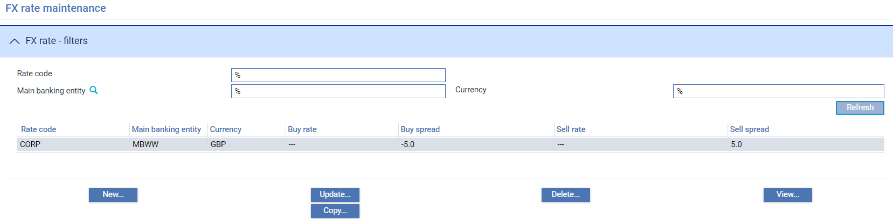

To create a new exchange rate click **New**.

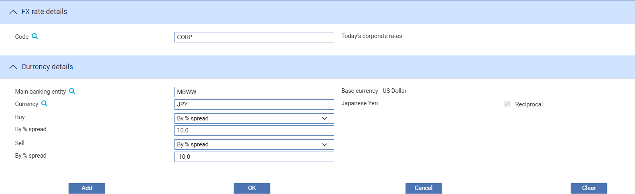

The following table explains what to enter into the fields in this window:

|  |  |  |
| --- | --- | --- |
|  | Field | What to Enter |
|  | Code | The exchange rate type for which the exchange rate is being defined. The browse button allows you to list and select from existing exchange rate types. |
|  | Main banking entity | The main banking entity. |
|  | Currency | The currency for which you are setting up the exchange rate. Once you select a currency, the Reciprocal flag indicates whether the currency rate is quoted reciprocally or not. |
|  | Reciprocal | If the selected currency is quoted reciprocally, the Reciprocal flag is checked automatically. |

Use the Buy/Buy Rate fields and the Sell/Sell Rate fields to define the rate at which your bank will sell the currency. These values can be defined in one of three ways:

* As a standard rate. Select 'By Rate' and enter the rate into the field provided. Note that you cannot select 'By Rate' if the exchange rate type on which this rate is based uses rate fixing.
* As a differential (positive or negative) using points. Select 'By Spread' and enter the rate into the field provided. For a negative spread, use the prefix '-' followed immediately (without a space) by the amount. The value entered here is applied to the spot rate, or other rate referenced by the rate type, recorded for the currency on your system.
* As a differential (positive or negative) by percentage. Select 'By % Spread' and enter the percentage into the field provided. For a negative spread, use the prefix '-' followed immediately (without a space) by the percentage. The value entered here is applied to the spot rate, or other rate referenced by the rate type, recorded for the currency on your system.

## Base Rate Codes

The FX/Base rate codes|Base rate codes allow you to define the base rate codes used by your bank. During transaction processing the base rate code is used to retrieve the appropriate base rate value for the behalf of branch in which the transaction is being entered.

Base rate codes that are marked as ‘Interbank offered rate’ can only be used for interests where interpolation is triggered; while codes that are not tagged as ‘interbank offered rate’ can only be used for non-interpolated interest schedules.

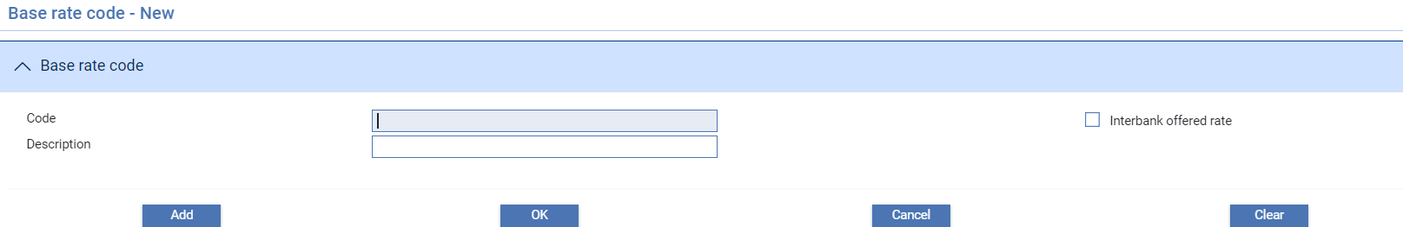

## Base Rate Groups

The FX/Base rate codes|Group Base Rate codes menu option permits you to group base rate codes together. During transaction processing the user can enter a group identifier rather than an individual base rate code, in which case the system will retrieve the highest rate within that group and apply it to the transaction.

When you select this menu option the system lists all the base rate groups already set up on your system.

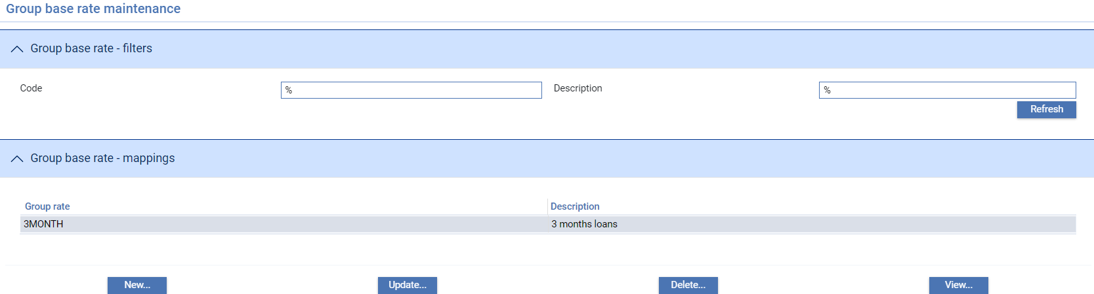

To create a new base rate group click **New**.

To add a base rate to an existing group, highlight the group in this window and click **Update**.

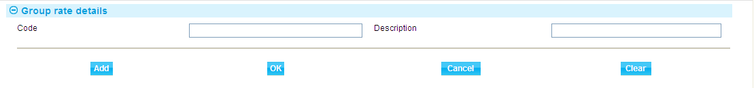

Enter a unique code for the group and a description.

1. When you use this window to update an existing base rate group, additional buttons are present to let you add base rates to it.

### Adding Base Rates to the Group

Once you have added a group you can add base rates to it. Select the group and click **Update**.

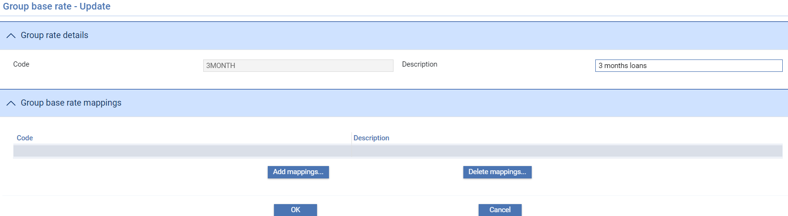

Use the Add Mappings button to select base rates to be added to the group.

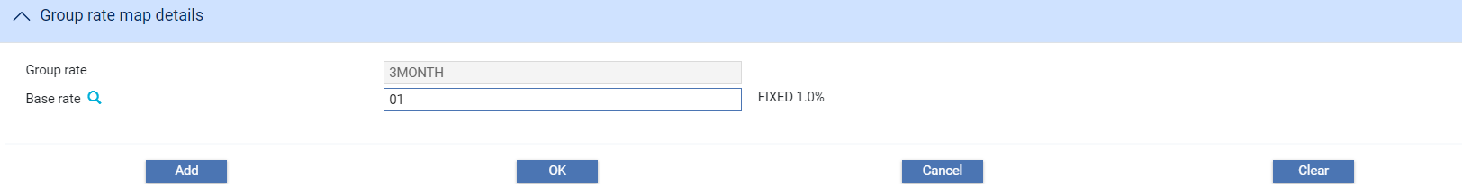

In the window that appears select the base rate and click **Add**.

When you close this window the base rates you have added are listed in the Group Base Rate Mappings pane.

## Base Rates and Differential Rates

Base rates define the underlying interest rates used by your bank. They are used in conjunction with differential rates to establish the interest rate to be used in charge and interest schedules. Any changes you make to base or differential rates take immediate effect for all subsequent transactions.

When you make changes to the interest rate the system updates the current rate, and creates an historical entry recording the previous rate and the date it became obsolete. If necessary you can also enter historical rates manually.

1. Historical rates stored for euro member currencies are unaffected by the implementation of euro processing - the rates are stored for the purposes of back valuation in their original form.

### Base Rates

The Rates|Base rates menu allows you to enter details of the interest rates to be used by different parts of the bank’s business. The window displayed allows you to select the business branch that rates are to be entered for. The branches displayed are those branches which have the internal ‘Base rate’ service mapped to them. This allows the bank to define base rates across one or more main banking entities. When the menu option is selected, the following window is displayed allowing the business branch required to be selected.

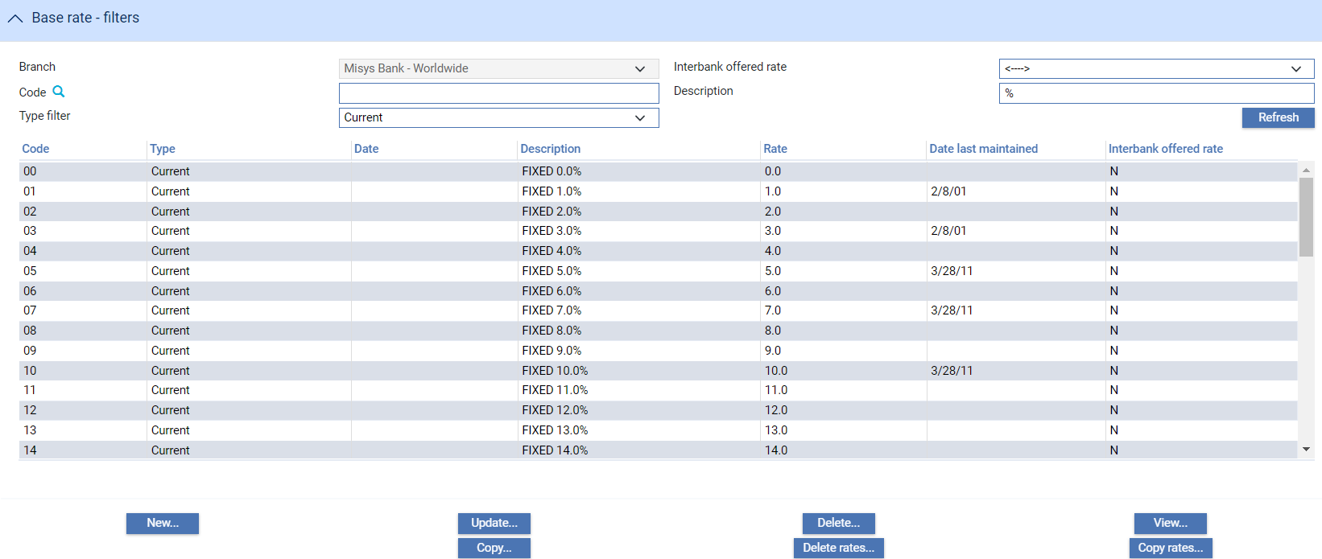

When New is selected, you can enter interest details for a new base rate to be used by the banking business against the specified base rate code.

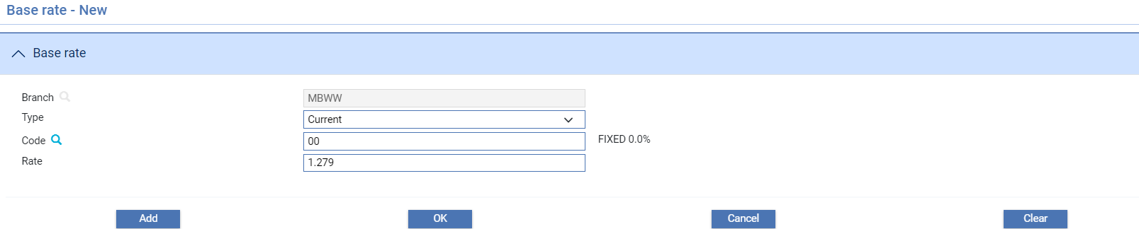

Use the Code field to enter or select the required base rate code. Enter the associated interest rate itself into the Rate field as a percentage in the range -99999.9999999 to +99999.9999999. For a negative value, use the prefix '-' followed immediately (without a space) by the amount. For a new rate, leave the Type field set to ‘Current’.

To enter a historical rate, enter or select the required base rate code of the rate and select 'Historical' in the Type field. Enter the date the rate became (or will become) obsolete into the Date field that appears.

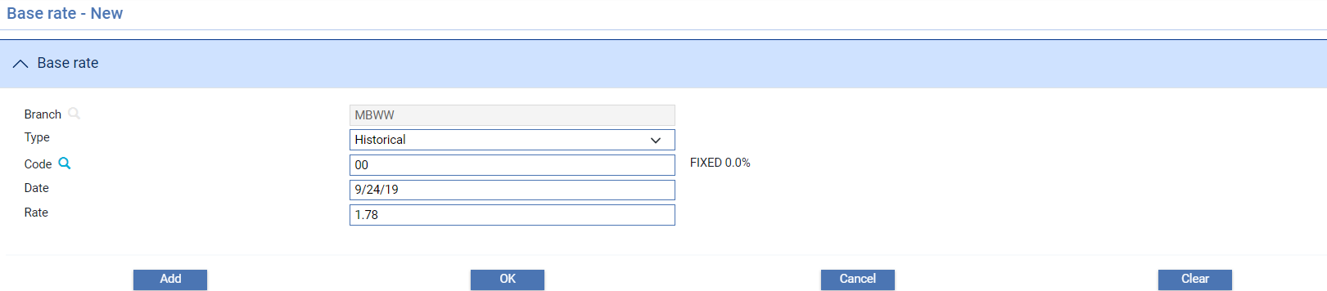

If you change a base rate, the system automatically generates an historical record of the previous rate, using the same code and description and using the current processing date as the date on which the historical rate became obsolete. You can subsequently amend the historical rate, if required.

#### Deleting Base Rates for a Base Rate Code

The Delete Rates button allows you to delete all base rates held for a base rate code, for example, where the rate code is no longer used in the banking business. When selected, the following window is displayed:

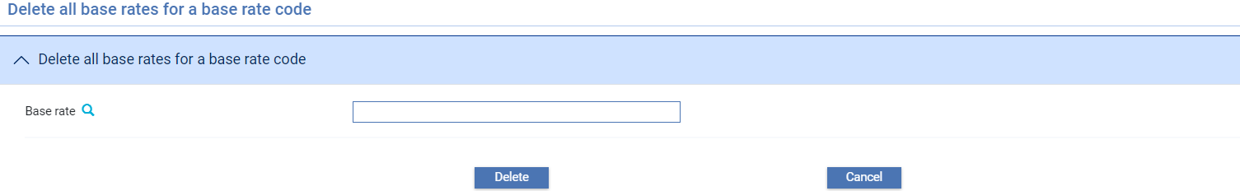

When delete is selected the following message is displayed:

“Deleting set of rates for base rate code 'xx' from ***Banking business*** may affect previously calculated interest. Do you wish to continue?”

If ‘Yes’ is selected – all rates are deleted, if ‘No’, you are returned to the previous display.

#### Copy Rates for a Base Rate Code

The Copy rates button allows you to copy all base rates or specific base rates from another business branch.

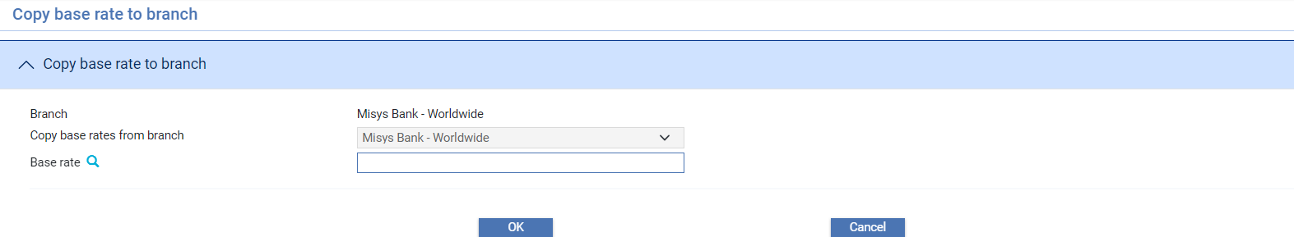

If a base rate code is not selected the following message is displayed:

“Are you sure you want to copy ’All’ base rates from Branch1 to Branch 2“

Allowing all base rates to be copied to the current business branch.

### Differential Rates

Differential rate codes and rates apply at the overall zone level. Differential rates are normally used in conjunction with base rates or actual rate to provide an additional rate element.

Differential rates can be applied in one of two ways:

* As a ‘specific rate’ entered either onto the schedules used to calculate interest, or during transaction processing
* As a ‘code’ which corresponds to a differential rate stored as part of your system's static data. Each differential rate is defined as a unique two-character code, a description, and the differential rate to be applied

If a financing agreement specifies that all trust receipt loans for that customer are to be charged at 0.5% above LIBOR, the differential rate can be entered as an actual rate on the schedules set up for that customer, or on financing transactions for that customer as they are created on your system. There is no need in such a case to use a static data differential rate.

Differential rates are useful, however, for variable differential rates, that may be applicable to a group of customers. For differential rates used in this way, you are advised to set up a differential rate and attach it via interest rate mapping to the relevant financing transactions. As the differential rate changes, the effect is reflected automatically in the interest calculations for all affected financing transactions.

For example, you bank may set up a penalty premium differential rate to be applied to loans that are not fully repaid on the due date. The penalty premium differential rate is determined by the bank and can be changed without notice. The penalty premium can be defined as a differential rate of 2% and attached to transactions, via interest rate mapping, as a code rather than an actual fixed rate. If your bank decides to change the rate to 4%, you need only change the rate in one place - the differential rate definition - for all transactions using that differential rate to begin using the new rate automatically for the effective rate change date onwards.

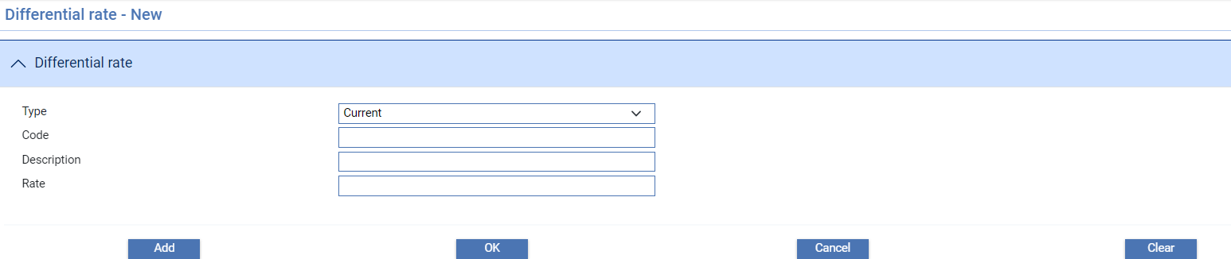

When entering a new rate use the Code field to enter a unique alphanumeric code for the rate and the Description field to enter a meaningful description of it. Enter the rate itself into the Rate field as a percentage in the range -99999.9999999 to +99999.9999999. For a negative value, use the prefix '-' followed immediately (without a space) by the amount. For a new rate, leave the Type field set to ‘Current’.

To enter a historical rate manually, enter the code of the rate (you do not need to enter a description) and the historical rate. Select 'Historical' in the Type field. Enter the date the rate became (or will become) obsolete into the Date field that appears.

If you change a base rate or differential rate, the system automatically generates an historical record of the previous rate, using the same code and description and using the current processing date as the date on which the historical rate became obsolete. You can subsequently amend the historical rate, if required.

If you change the description of a current rate, the system automatically changes the description of all historical rates associated with it.

# Countries, Calendars, Languages, and the Dictionary

This chapter covers static data relating to countries, calendars, languages and the trade finance dictionary, which stores the text strings used when creating documents. It also explains how to translate descriptions of some of the static data items into languages other than the default language.

## Countries

Each country is defined in the system as a code and a name. When setting up and viewing other static data, such as customers, and during transaction processing, countries are identified by their code, although a browser permits the user to display country codes and their associated names.

Each the system customer has a country of residence which is attached to any accounts set up for that customer. For an account denominated in Euro, during settlement the system uses the calendar set up for the customer's country of residence to determine valid settlement days for that account.

When you select the Country|Countries menu option the system lists existing entries in alphabetical order by country code. The Tenor field is reserved for future use.

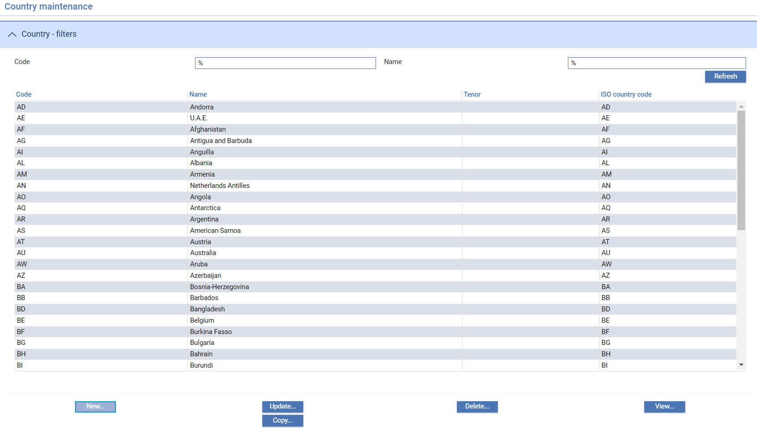

To define a new country click **New**.

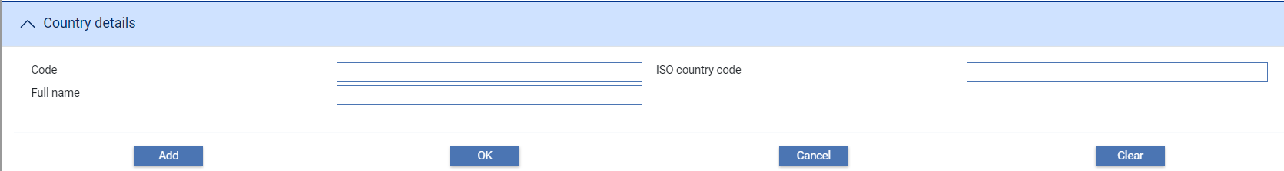

Use the Code field to enter the country's unique alphanumeric code, together with the ISO country code and name of the country into the Full Name field.The ISO country code field is displayed if the Zone option ISOCountryCodesUsed is set to No. See the *System Tailoring User Guide* for more details.

## Calendars

The system allows you to enter local branch, country and currency calendars.

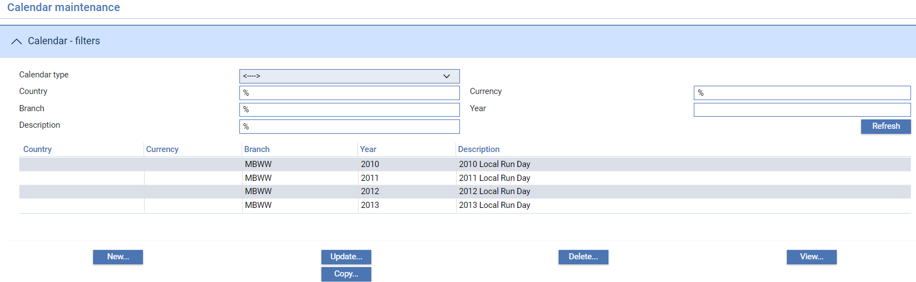

When adding a calendar, you must first select a Calendar type in the browser and select **New**. The window displayed allows you to enter a new calendar and to define the standard working week for a particular year for the calendar type, any holidays that fall on a day of the week that is normally a business day, and any special working days that fall on a day of the week that is normally a non-working day.

If Maker Checker is being used in your system, you will only be allowed to view this function. Any changes will need to be made in the Maker Checker application. See the *Maker Checker User Guide – Trade Innovation* for further details.

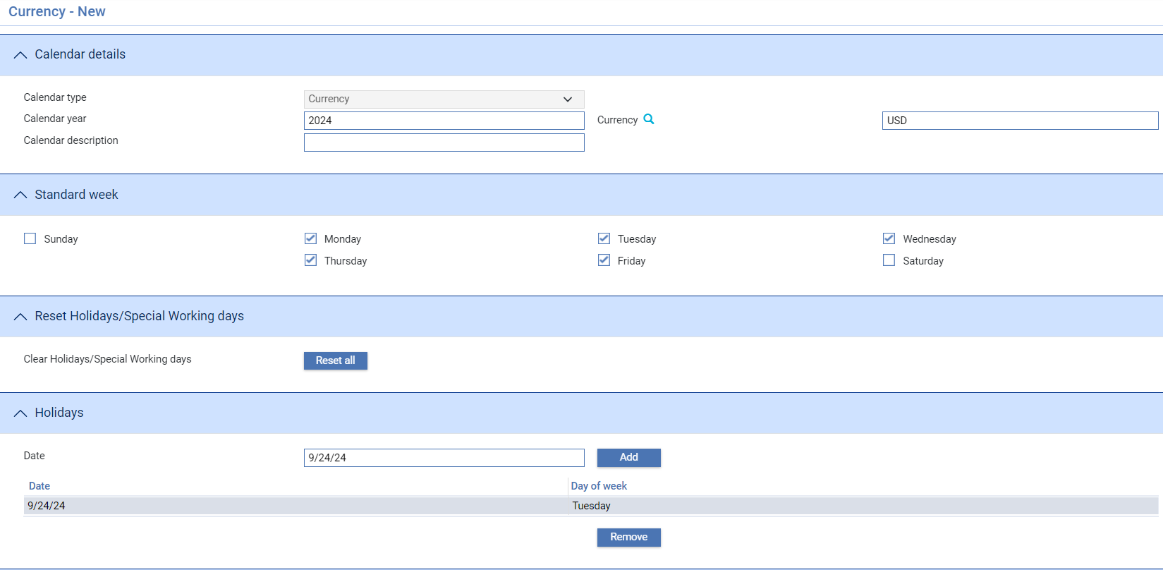

Use the Year field to identify the year for which you want to set up a calendar, and the Description field to enter a meaningful description of the calendar entry to help you identify it in the browser window.

The check boxes in the Standard Week pane are enabled when a Calendar year is input. Each check box represents a day of the week, beginning with Sunday. By default, each of the week day boxes is checked and the boxes for Saturday and Sunday are unchecked. Uncheck any boxes that represent days that are not business days for the selected currency or country. You can use the Reset All button to reset the values in this pane to their defaults.

To identify any additional holidays, enter the date of the holiday into the Date field in the Holidays pane using the date format set up for your system, and click **Add**. To identify a non-working day as a business day enter the date of the business day into the Date field in the Special Working Days pane using the date format set up for your system, and click **Add**. In both these panes, once you have entered a date it is listed, and you can subsequently select it and use the Remove button to remove it.

Once you have set up a calendar for a currency or country, the system also uses the basic information defined for the standard weekday mask to determine business days and non-working days for future years where no specific calendar has been defined.

## Languages

Each language is defined in the system as a code and a name.

When you select the Country|Languages menu option the system lists existing entries by their code and name.

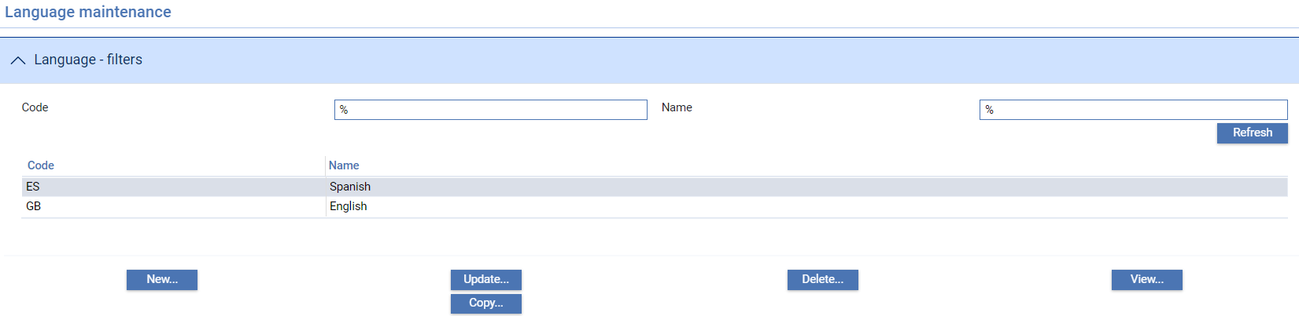

To define a new language click **New**.

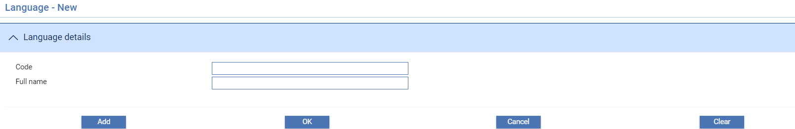

Use the Code field to enter the language's unique alphanumeric code, then enter the name of the language into the Full Name field.

When you click **Add** or **OK** to save a new language definition, the system creates a new version of the dictionary for that language. The new version of the dictionary is based on the English version; you must use the functionality described in the next section to translate individual items in the dictionary into the appropriate language.

## The Trade Finance Dictionary

The system is delivered with a trade finance dictionary, which includes text strings used when constructing the documents delivered with the system. Each entry in the dictionary consists of a unique code and the text string itself. The system creates a default dictionary, with English text, as part of the installation process.

The trade finance dictionary also contains:

* Two entries that are used to define the values used for amount (see page 104) and date abbreviations (see page 105). Amount abbreviations are defined in the dictionary entry AABBR, and date abbreviations in the dictionary entry DABBR
* A number of entries in the format 'DP' followed by a number which define the dispatch types (see page 104) your system will use
* Bank definable entries in the format ‘EVT’ followed by two alphanumeric characters used to define Correspondence Further ID for use in Correspondence events.

First use the static data maintenance application's Country|Languages menu option to add the language into which you wish to translate the trade finance dictionary. The action of creating a new language creates a new set of dictionary entries for that language with English text, which you can then translate.

The system facilities allow you to overwrite the text strings in each dictionary to produce different language versions of the dictionary, and to add new entries to the dictionary for additional the system event fields. During document processing the system uses the document addressee details to select the appropriate language version of the dictionary, and uses the entries from that dictionary to create the document. If it cannot find a dictionary in the appropriate language, it uses the English dictionary instead.

The trade finance dictionary also allows you to set up and the maintain amount and date abbreviations used during input for each language your system supports.

1. Finastra suggest that you do not change the wording of the text strings in the English (GB) version of the dictionary. Further, you should not delete any of the entries delivered with the system from either the English or any other language version of the dictionary.

When you select the Country|Trade Finance Dictionary menu option, the system lists entries in the English version of the dictionary.

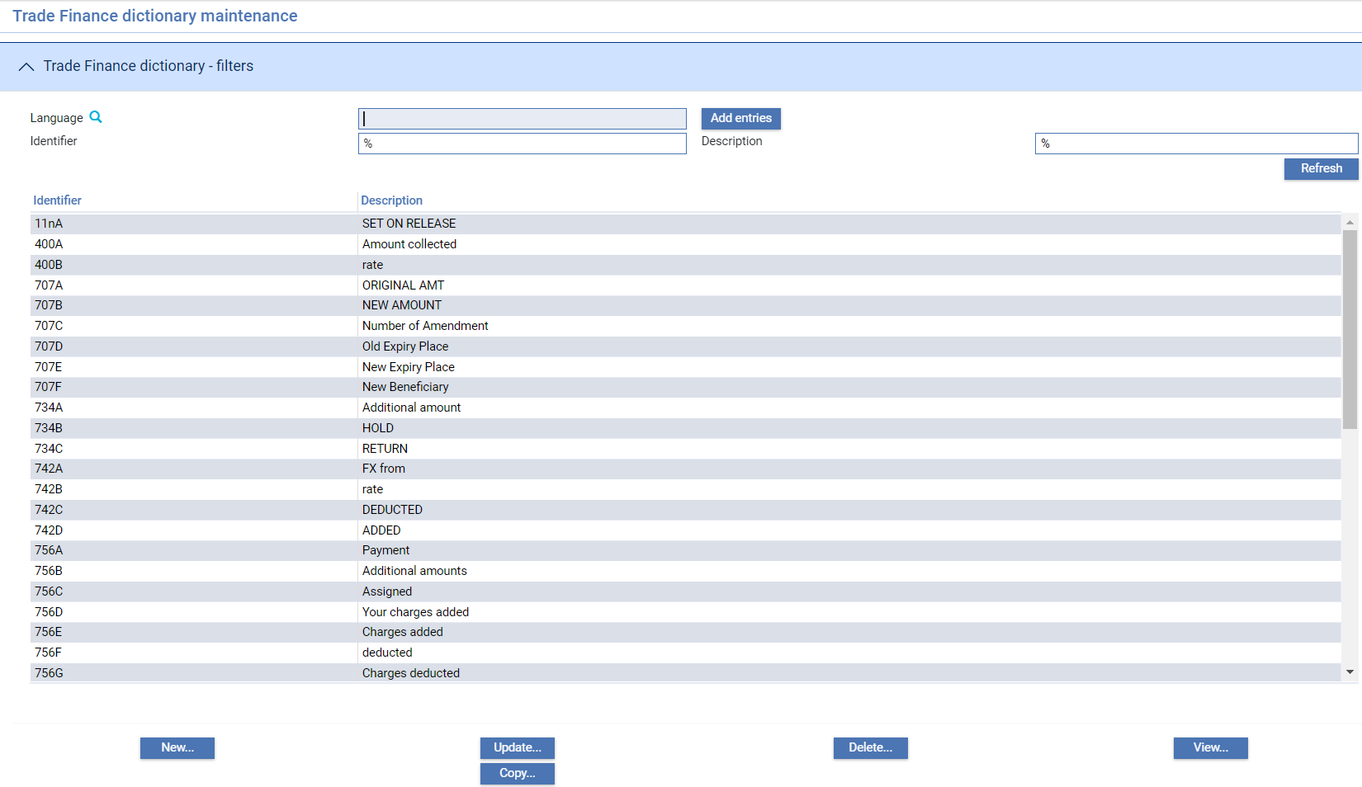

1. Some entries are blank, and are intended for use in documents where you may wish to include a text string at a particular point if certain conditions are met, or leave a blank instead. One entry, with the code HD, is used to define the label given to the bank-defined banner panes that display summary transaction information during transaction processing.

To view an existing version of the dictionary in another language, select the code of the language in the Language field and click **Refresh**. If a version of the dictionary already exists for the selected language, then the system displays the entries in it.

Initially, all language versions of the system dictionary are in English. If you wish to translate items into a non-English version of the dictionary, enter the code for the language into the Language field and click **Add Entries**. Then select the dictionary entry and click **Update**.

### Creating a New Language Version of the Dictionary

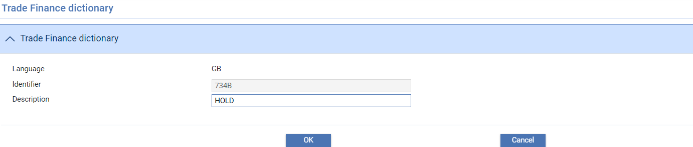

In the window that appears the system shows the value of the text in the default English dictionary for reference. The Description field holds the actual language version of the text which you can overtype.

Overtype the value in the Description field with the new value for this language version of the dictionary, and click **OK** to close the window and save the changes.

As delivered, the trade finance dictionary includes entries for all the event fields used in the document set delivered with the system. These include entries defining the standard abbreviations used during transaction processing for entering dates (see page 105) and amounts, (see page 104) which you can amend.

You can add new entries to support any additional fields you wish to include in documents created by your bank by clicking **New**, with the default English version of the dictionary displayed.

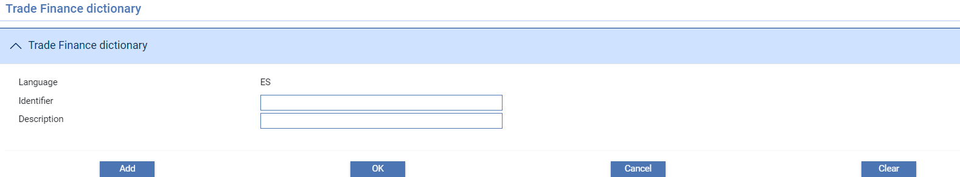

Enter the code of the database field, and the text string to appear in documents, then click either **Add** or **OK** to create the new entry.

When you create a new entry in the English version of the dictionary, the system automatically creates the same entry in all other language versions of the dictionary.

#### Dispatch types

The system includes functionality that allows the input clerk to allocate a dispatch type to an item of correspondence during transaction processing. This functionality is implemented using the CorrespondenceTypeCharge system option, and it allows the input clerk to assign a dispatch type to 'Mail' documents via the Documents window. The dispatch type allocated to an item of correspondence can be used in setting rules, typically to govern which charges for correspondence are generated automatically in order to facilitate the consolidation of correspondence charges.

Dispatch types are set up as a special type of entry in the trade finance dictionary.

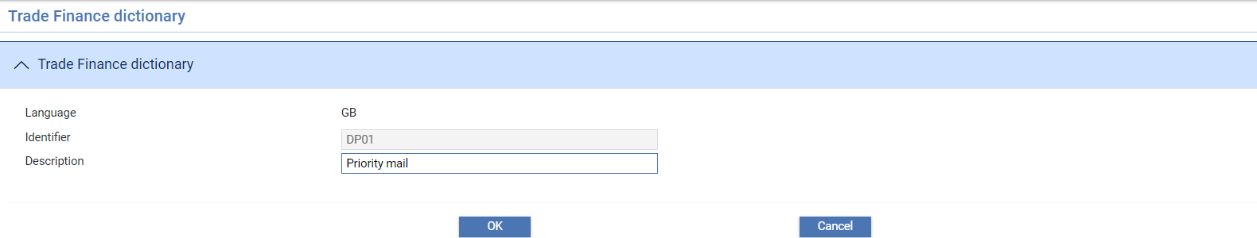

The identifier has the letters 'DP' followed by a number. The Description field holds a text string that appears in drop-down lists when rules are being set, and in the window used to edit documents during transaction processing.

1. Dispatch types must be set up separately in each language version of the trade finance dictionary your system will use.

#### To Tailor Amount Abbreviations

The standard abbreviations for amounts delivered with the system are:

|  |  |
| --- | --- |
| H | Hundreds |
| T | Thousands |
| M | Millions |
| B | Billions |

For example:

|  |  |  |  |
| --- | --- | --- | --- |
| Input | Represents | In US Dollars | In Japanese Yen |
| 4H | Four hundred | 400.00 | 400 |
| 4.5H | Four hundred and fifty | 450.00 | 450 |
| 1.5T | One thousand five hundred | 1,500.00 | 1,500 |
| 1HT | One hundred thousand | 100,000.00 | 100,000 |
| 3M | Three million | 3,000,000.00 | 3,000,000 |
| 2B | Two billion | 2,000,000,000.00 | 2,000,000,000 |

To amend these values, first select the appropriate language in the Language field and click **Refresh**. Select the entry with the identifier AABBR and click **Update**. The system displays the existing amount abbreviations as an eight-character string.

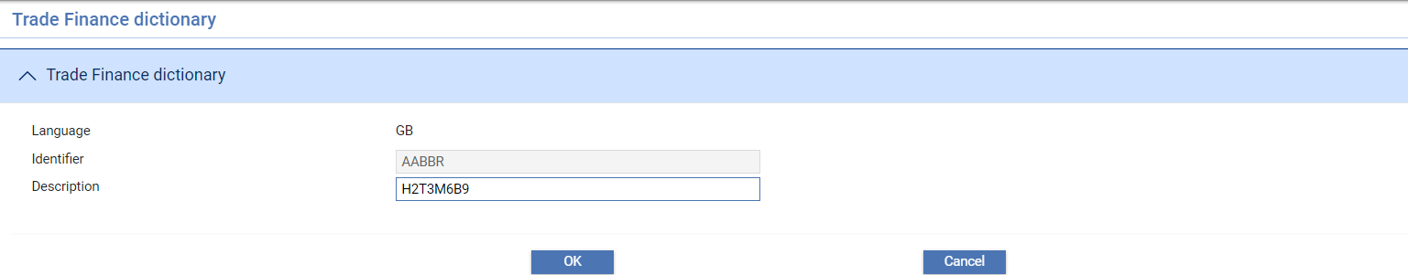

The first character is the abbreviation used for hundreds.

The third character the abbreviation used for thousands.

The fifth abbreviation is the character used for millions.

The seventh abbreviation is the character used for billions.

Overtype these four characters with the new values you wish to use as abbreviations in that language.

The characters used as abbreviations are separated by numbers, which you should not overtype.

#### To Tailor Date Abbreviations

The standard abbreviations for dates delivered with the system are:

|  |  |
| --- | --- |
| D | Day |
| M | Month |
| Y | Year |
| W | Week |
| T | Today |
| S | Spot: two business days’ time |
| N | The next business day |
| X | Day, relative to the next business day |

For example:

|  |  |
| --- | --- |
| Input | The date it gives |
| 30D | Thirty calendar days after today's processing date |
| 2M | Two calendar months after today's processing date |
| 1Y | One calendar year after today's processing date |
| 1W | One calendar week after today's processing date |
| T | The current processing date |
| S | Two business days after the current processing date |
| N | Next business day. This is only available for the maturity of a financing deal and will be one business day after the deal start date. |
| 3X | Three business days after the next business day |

To amend these values, first select the appropriate language in the Language field and click **Refresh**. Select the entry with the identifier DABBR and click **Update**. The system displays the existing date abbreviations as an eight-character string, as in the following illustration:

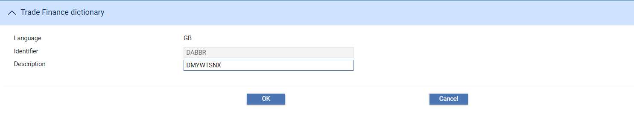

The eight characters are in the following sequence the current abbreviations for:

* Day
* Month
* Year
* Week
* Today
* Spot
* The next business day
* Day relative to the next business day

Overtype them with the new values you wish to use as abbreviations in that language.

Translating Static Data Item Descriptions

For some of the static data items described in this guide the system allows you to translate their description into the other languages supported by your system.

When you enter a description against such a static data item it is stored as the default language version of that description, and also as the version to be used for all the other languages supported by your system, unless you provide translations.

If you provide a translation of a description for a particular language in the way described below then the description's translation is used instead of the default description when customer documents are generated in that language. If a customer document is generated for a customer with a preferred language for which no translation has been provided, then the default language version of the description is used.

To translate static data item descriptions into another language select the Country|Static Data Language Descriptionmenu option.

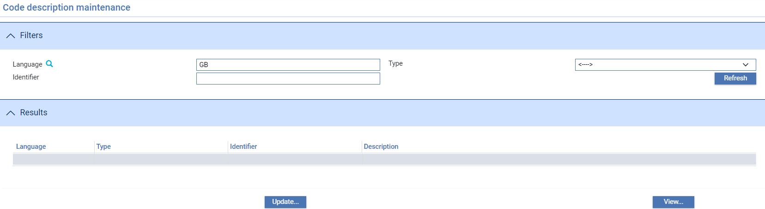

In the window that appears the language filter is set to your system's default language. If you click **Refresh**, the system lists all the static data items that have descriptions that can be translated, together with those descriptions.

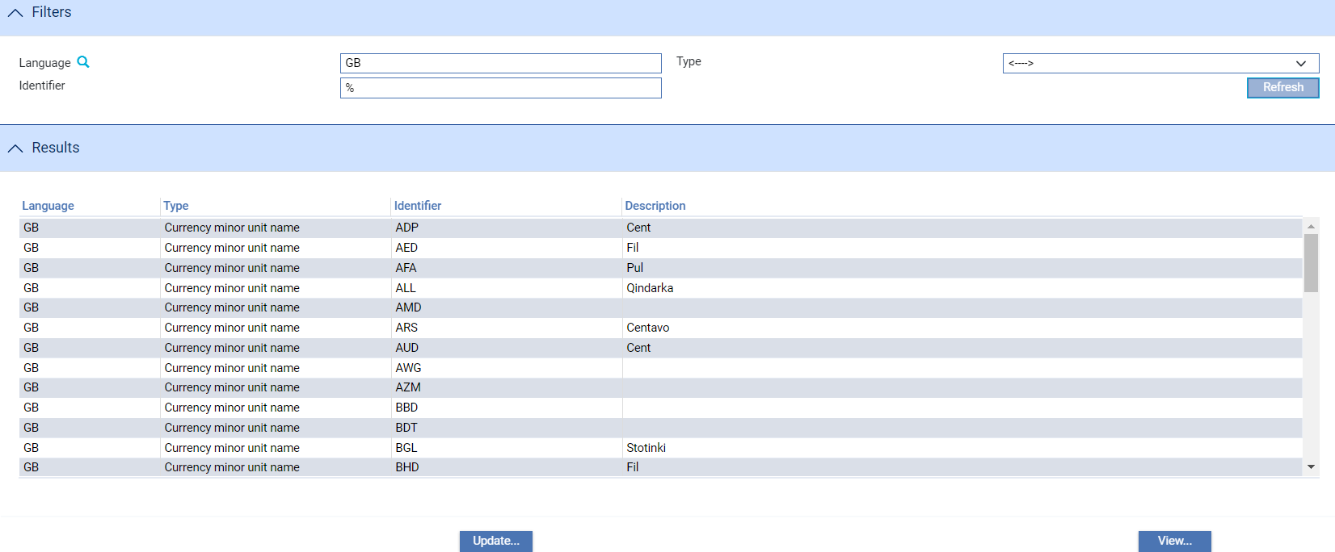

The Type field allows you to display entries for a particular static data item type.

To translate these descriptions into another language, enter the language code into the Language field. If relevant, select the static data type in the Type field. Then click **Refresh**.

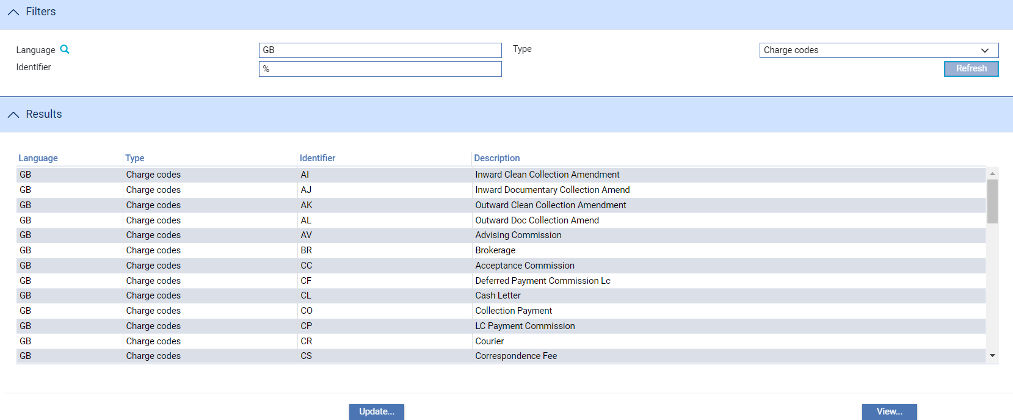

In the list that appears highlight the entry you want to translate and click **Update**. The window that appears allows you to enter a translation for the selected item's description.

The window that appears when you click **Update** shows the code of the language of the selected item, its unique event field code identifier and its static data type. You cannot amend these values.

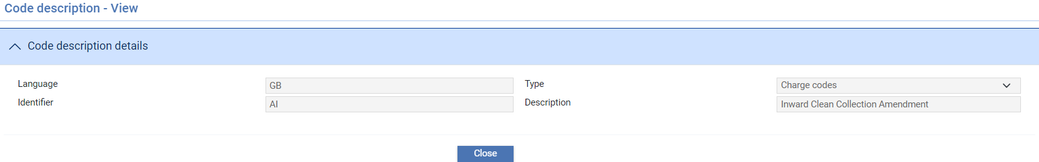

The Description field holds the default language version of the description, which you can overtype.

1. If you open this window for a static data item in the default language version, the Description field is not enabled. To change the default language version of an item's description you must use the relevant static data maintenance application menu option.

# Trade-Related Parameters

This chapter covers trade-related static data.

## Goods Codes

Goods codes provide a means of identifying the goods involved in products such as letters of credit. Goods codes satisfy the legal requirement in some countries for banks to keep a record of the type of goods being imported and exported, and are also useful for internal analysis of the type of trade your bank facilitates.

When you select the Trade|Goods Codes menu option the system lists existing entries using their code and description.

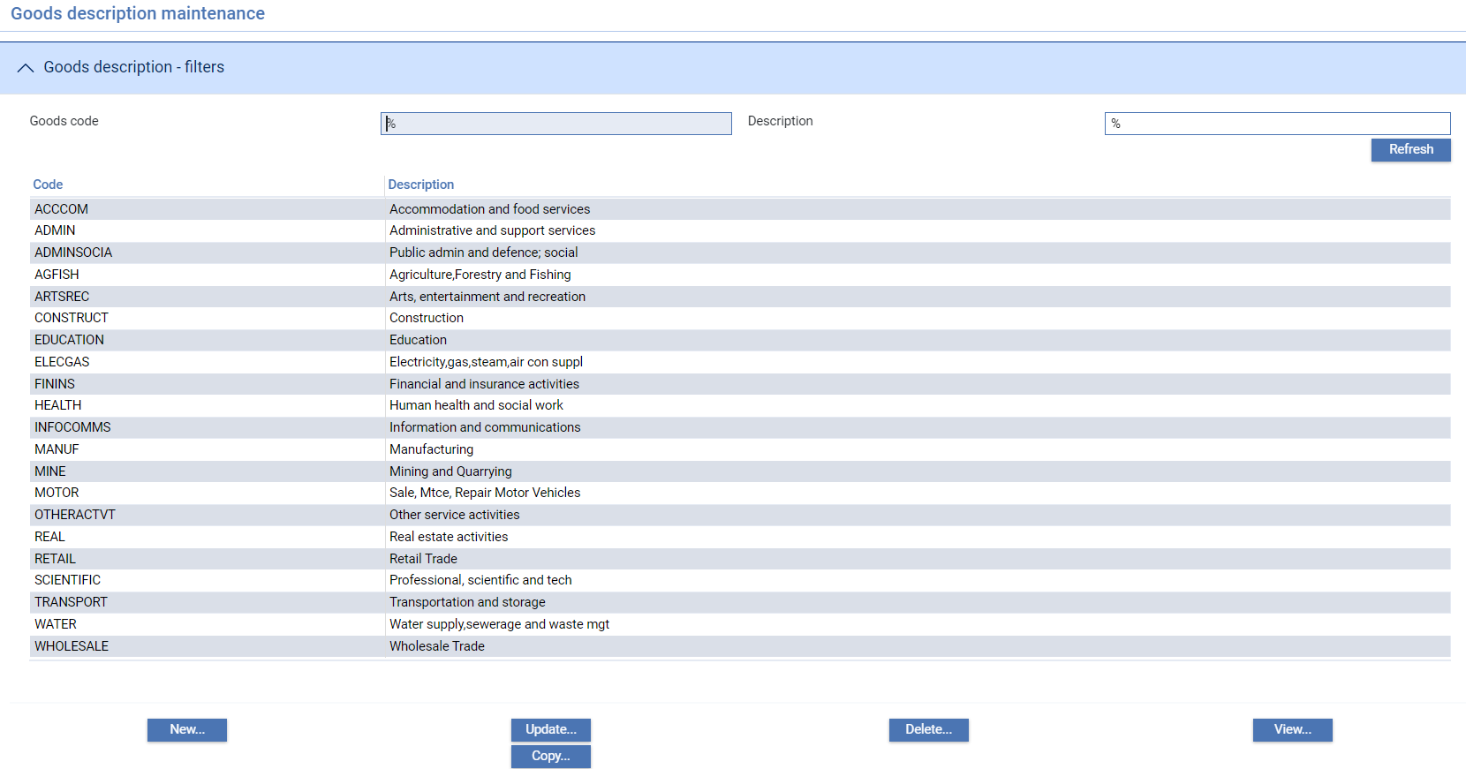

To create a new goods code click **New**.

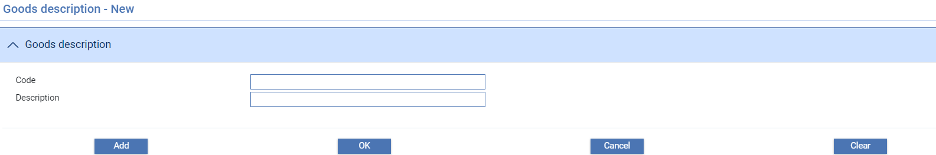

Use the Code field to enter a unique alphanumeric code for the goods, then enter a description of the goods into the Description field.

## Document Types

At certain points during transaction processing, the system allows the input clerk to identify the commercial and financial documents associated with a transaction. For documentary collection orders these will be the documents forwarded to the drawee. For letters of credit and guarantees these are the documents presented with a claim. For this purpose, you can define a list of the standard financial and commercial documents to be shown during transaction processing. The input clerk can select the appropriate documents from the list.

Documents can be categorised as:

* Commercial documents - the actual documents required to support a claim for payment
* General items, such as envelopes and covering letters

While both types of document can be recorded against a transaction, only the former are included in the customer documents generated by the system listing commercial documents received.

When you select the Trade | Document Types menu option the system lists existing entries using their code and description. The order in which the documents are shown in this window reflects the order in which the user will see them in a drop-down list, so by using the Move Up and Move Down keys the bank can adjust the sequence so that, for example, the most important documents are listed first.

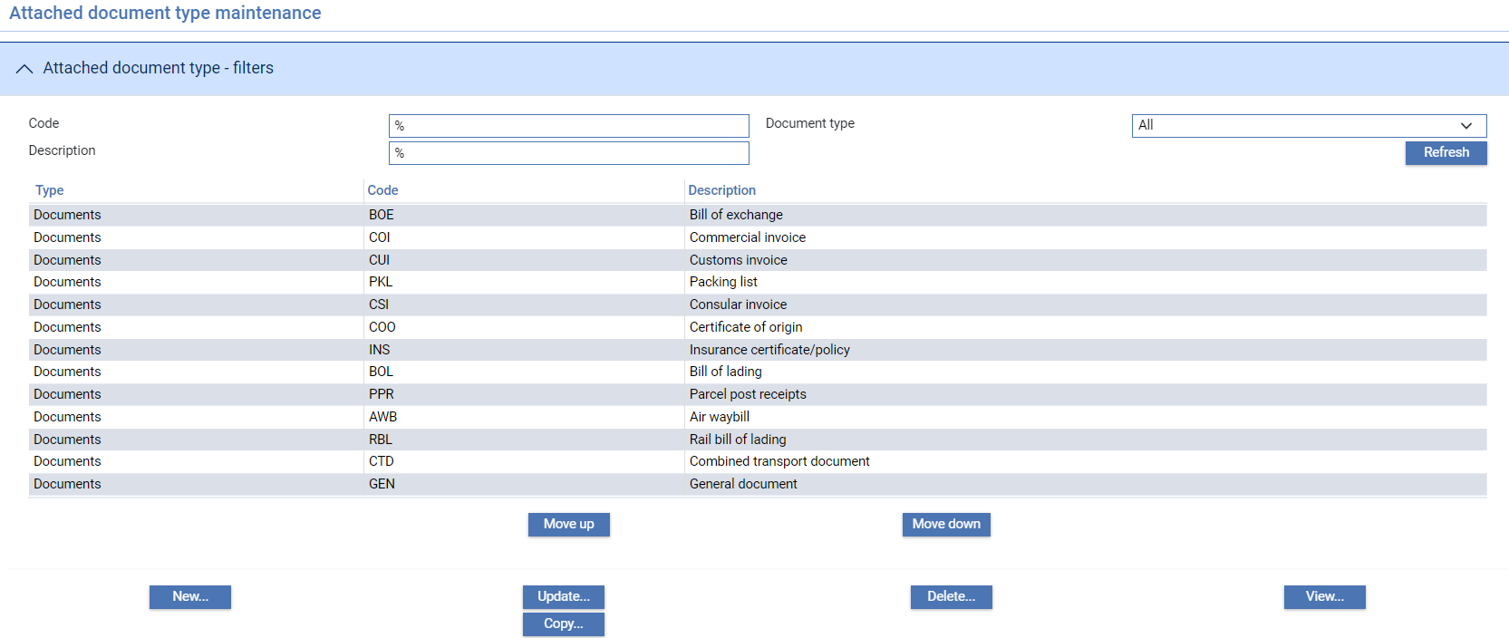

1. Where Zone General option ‘ShowAttachedDocListAlphabetically’ is set to ‘Yes’, this maintenance displays all document types in alphabetical order – as the order displayed within transaction events. The Move up and Move down keys are not shown.

To create a new document type click **New**.

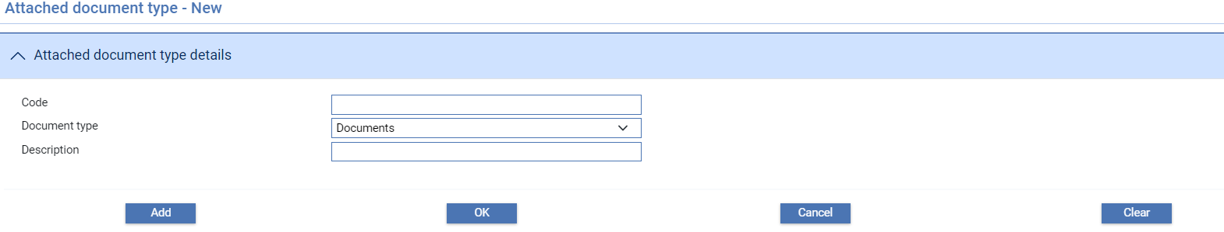

Use the Key field to enter a unique alphanumeric code for the document type then enter a description of the document type into the Description field. The Type field is used to define whether the document type is a commercial document (Documents) or a general item (General).

## Incoterms

Incoterms define who is responsible (the buyer or the seller) for paying expenses over and above the cost of the goods when in transit.

Trade Innovation is delivered with a standard set of incoterms ratified by the International Chamber of Commerce which you can modify or augment using the system.

When you select the Trade|Incoterms menu option the system lists existing entries using their code and description.

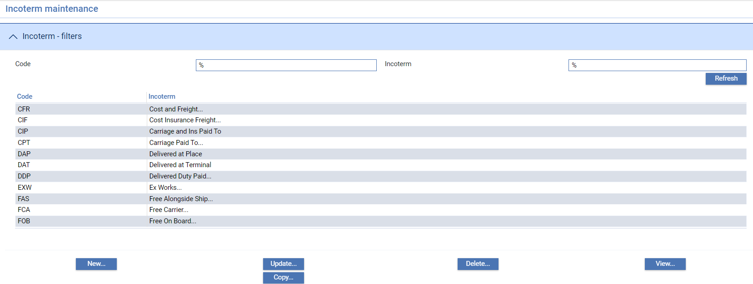

To create a new incoterm entry click **New**.

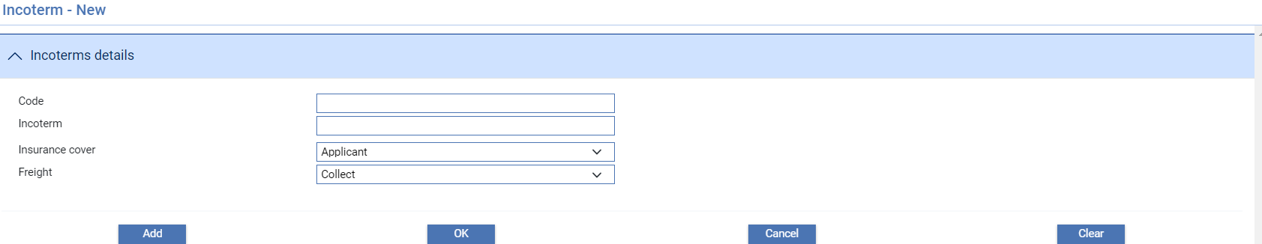

The following table explains what the values in each of these fields represent:

|  |  |  |
| --- | --- | --- |
|  | Field | What it Holds |
|  | Code | The unique alphanumeric code for the incoterm entry. |
|  | Incoterm | An alphanumeric description of the incoterm entry. |
|  | Insurance Cover | Indicates who is liable to pay for the insurance - the applicant or the beneficiary. The value entered here is applied automatically whenever the input clerk issues or advises a letter of credit. |
|  | Freight | Indicates whether freight is to be pre-paid or paid on collection. The value entered here is applied automatically whenever the input clerk issues or advises a letter of credit. |

## Collateral Types

At certain points during transaction processing, the system allows the input clerk to enter details of any collateral put up for a transaction. For this purpose, you can define a list of the standard types of collateral your bank accepts to be shown during transaction processing. The input clerk can select the appropriate collateral type from the list.

When you select the Trade|Collateral Types menu option the system lists existing entries using their code and description.

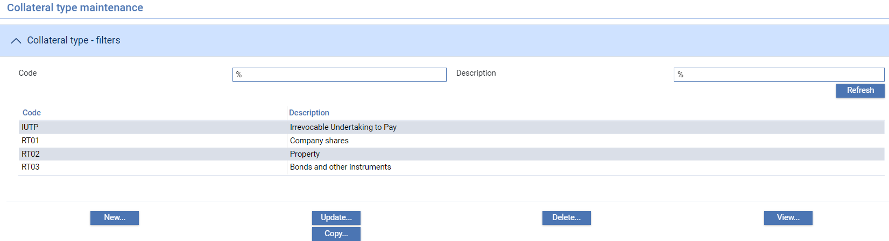

To create a new collateral type click **New**.

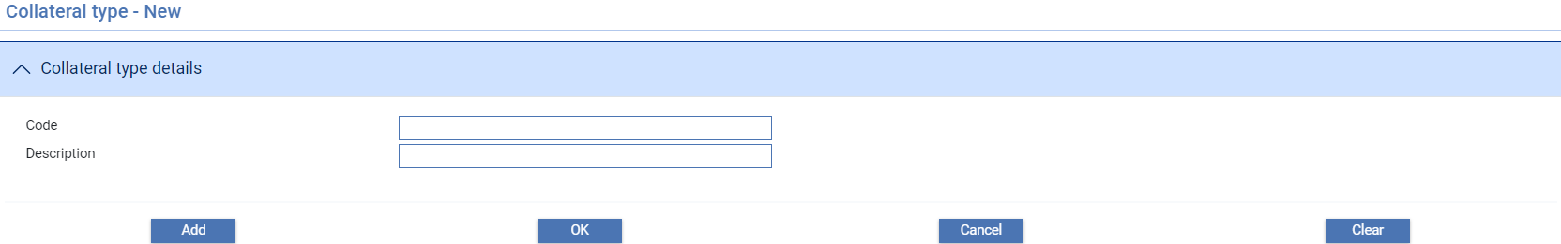

Use the Code field to enter a unique alphanumeric code for the collateral type, then enter a description of the collateral type into the Description field.

## Documents of Title

If you have the shipping guarantees functionality implemented you will need to define the documents of title for which you may issue shipping guarantees, and the information that must be entered against each of them. This is done using the Trade|Documents of Title menu option.

When you select this option the system lists existing entries using their code and description.

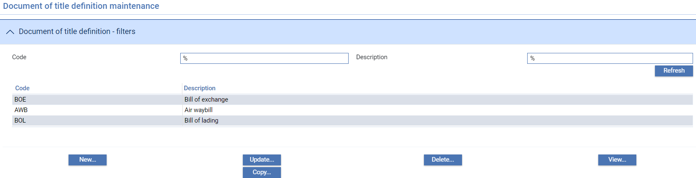

To define a new document of title click **New**.

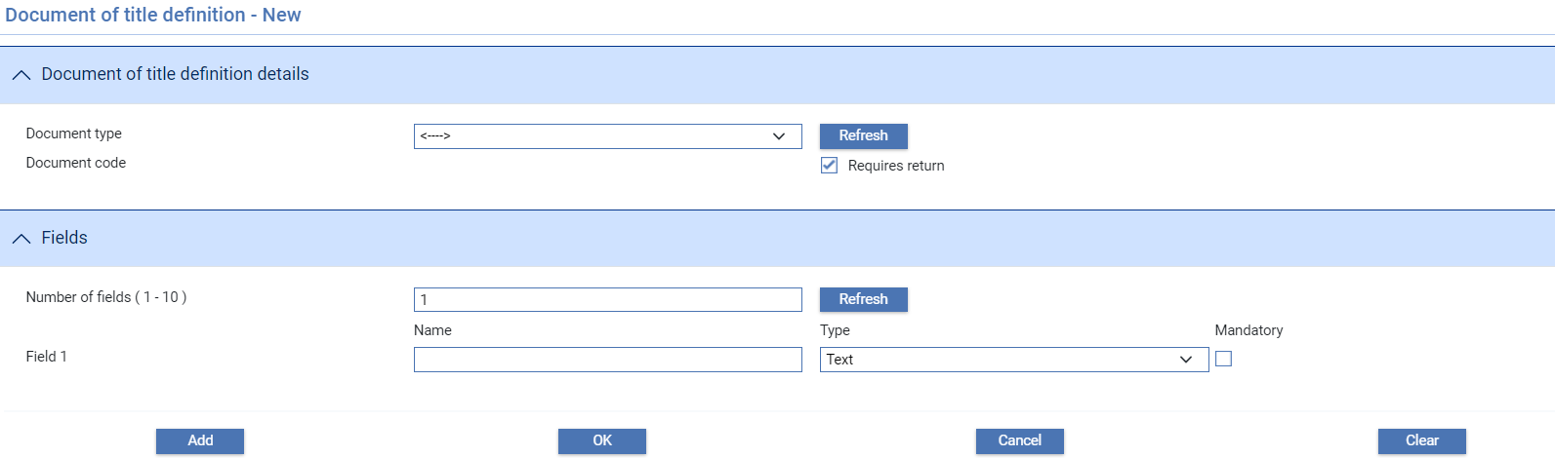

Use the Attached Document field to select the document type. For bill of lading and other document types which are endorsable you should check the Requires Return flag. (This controls how the system handles liability - documents of title which are endorsable must be returned to your bank using a Return event before the liability against the shipping guarantee is released and the shipping guarantee is booked off. Documents of title which are not flagged as endorsable do not have to be returned.)

In this window the system permits you to define input fields against each type of document of title. During transaction processing these are displayed for the input clerk to enter information when a shipping guarantee is created. For each field you can define the field's name, the type of data it will contain, and whether input will be mandatory or not.

These fields can be used in the creation of Word templates for customer documents and for the actual shipping guarantees.

1. Your bank should ensure that the fields defined here match those set up on the document template(s) used to create shipping guarantees.

Enter a value in the range 1 - 10 in to the Number of Fields field to define how many input fields the document type will have, then click **Refresh**. The system displays a set of three fields for each input field.

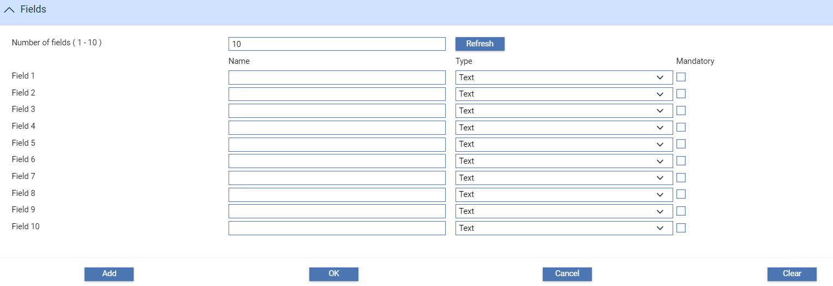

Use the Name field to enter the label that will appear against the field during transaction processing, and the Type field to define what type of data it will accept - date, text integer, money or logical flag. If input is to be mandatory check the mandatory box.

## Codes for Statutory Reporting

During settlement, the system permits the input clerk to enter up to five codes against the payment lines for that event. These codes can be used for statutory reporting and other forms of statistical analysis of payments. The system permits you to define a list of the reporting codes (see page 113) to be shown during transaction processing. The input clerk can select the appropriate reporting codes from the list.

In addition, the system permits you to set up codes for categorising the debit and the credit account used in settlement (see page 114). During settlement, the input clerk can select one of these codes to be used for the account being debited, and another for the account being credited.

To use this functionality, your bank must have set the COEAnalysisRequired system option during system tailoring, as described in the System Tailoring User Guide – Trade Innovation.

### Statistics Codes

Select the Trade|Statistics menu option.

The same functionality is used to add codes for categorising accounts (see page 114).

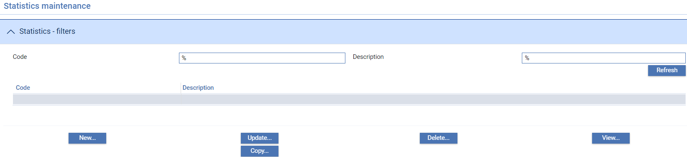

To create a new code click **New**.

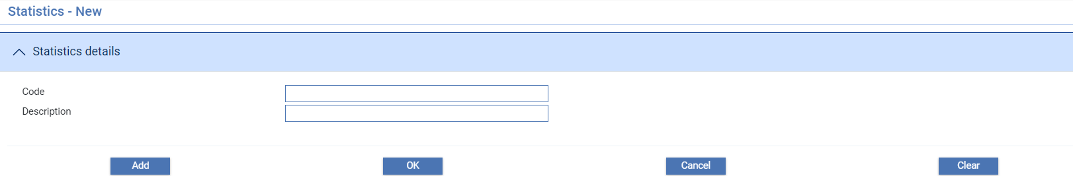

Use the Code field to enter a unique alphanumeric code, then enter a description into the Description field.

### Codes for Categorising Accounts

Select the Trade|COE Account Types menu option.

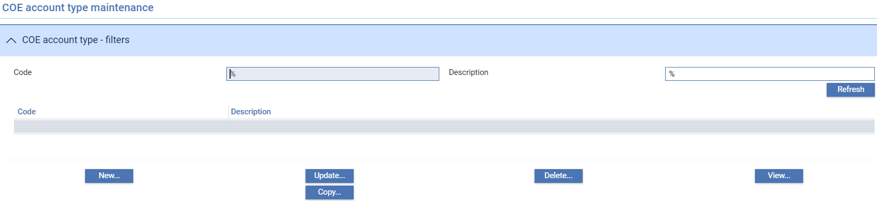

To create a new code for statutory reporting click **New**.

### Adding a New Code

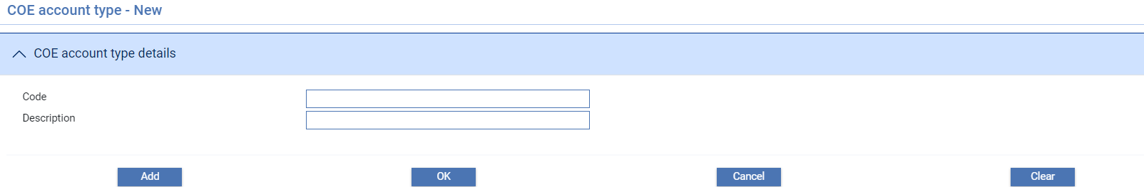

Use the Code field to enter a unique alphanumeric code, then enter a description into the Description field.

## Note Types

As input clerks enter notes against transactions using the Notes window, or special instructions against a customer, they can categorise them as belonging to a pre-defined note type. Note types identify the subject matter of a note or special instruction and so allow input clerks, reviewers or authorisers to identify them according to their subject matter.

Each note type consists of a single text string, which both describes the note type and acts as a selection field.

1. The system is delivered with a standard set of note types which you should not change. The system uses these note types during daily batch processing to generate notes against events of certain types generated as the result of diary actions.

When you select the General|Note Types menu option the system lists existing note types in alphabetical order. This window lists existing note types in alphabetical order.

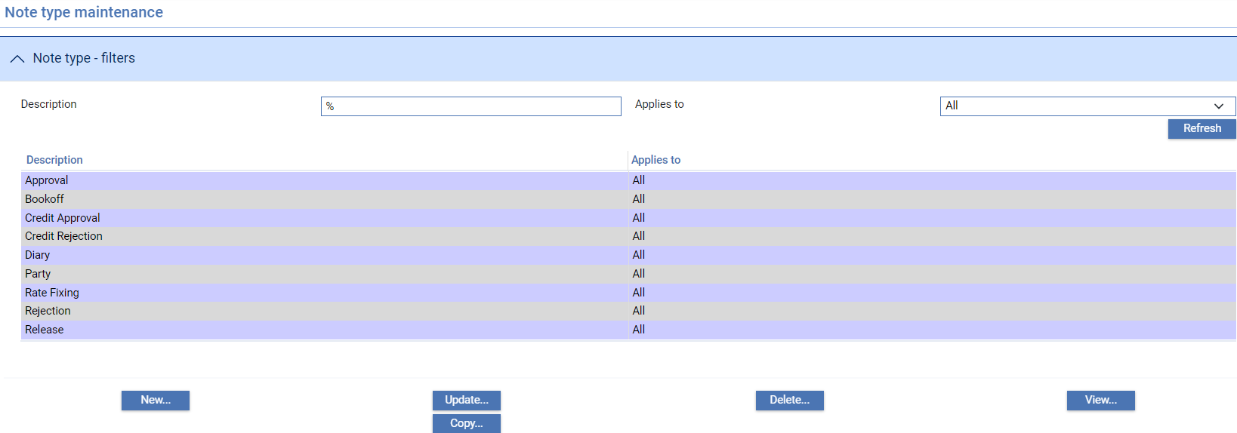

The Description column shows the category, and the Applies To column shows whether the note type is for use to categorise note types stored against transactions (Master), special instructions stored against customers (Customer) or both (All).

Each note type is displayed using the style applied to it when it was created.

To add a new note type click **New**.

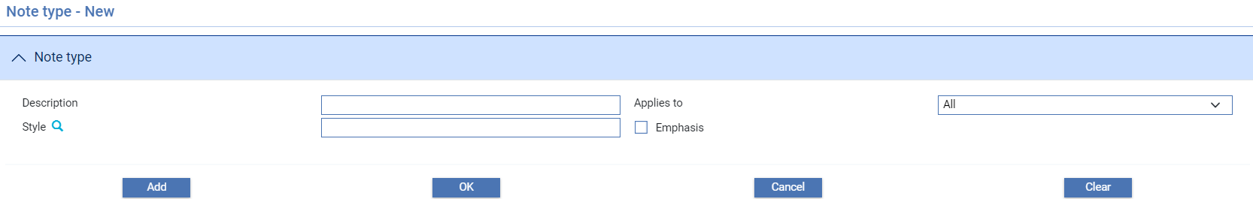

Enter the text string into the Description field.

Use the Applies To field to define whether this note type is to be used to categorise:

* Note types against transactions (Master)
* Special instructions against customer (Customer)
* Note types and special instructions (All)

Use the Style field to select the style to be used to display the special instructions. The style selected here determines the text and background colours used to display the special instructions. If the text of the note is to be displayed with a bold weighting check the Emphasis field.

# SWIFT Related Static Data

This chapter covers SWIFT BIC addresses, BIC authentication statuses, SWIFT BIC Plus IBAN, IBAN structure codes, SWIFT reject codes and SWIFT clearing codes.

## SWIFT BIC Addresses

During transaction processing, when the input clerk uses the SWIFT address browser to list and select a SWIFT party, the system retrieves and displays the SWIFT party's name and the second, third and fourth lines of their SWIFT BIC address. The static data maintenance application includes facilities to allow you to access SWIFT BIC address details, and to enter additional information on the status of those addresses relative to your bank - specifically whether they have been blocked, closed or authenticated by your bank.

Below is the transaction processing of SWIFT BIC addresses

1. First it checks if the BIC is a party of the transaction
2. If it can find the party as part of the transaction and it is only defined once then it will show the address of the party (may not be the swift address)
3. If it is assigned to multiple party like Received from and Reimbursing bank, then it will use the address of the BIC.
4. If it is not part of the party transaction then it will get this from the static customer if it can find one
5. If it cannot find one then it will check the SWIFTBIC table to see if it is in the DB.
6. If your bank has set the zone level system option UseSwiftBIC then SWIFT BICs will be validated against the SWIFT BIC file as they are entered into input fields in transaction processing.

The window displayed when you select the SWIFT|SWIFT BIC menu option allows you to list existing SWIFT BIC addresses alphabetically by bank.

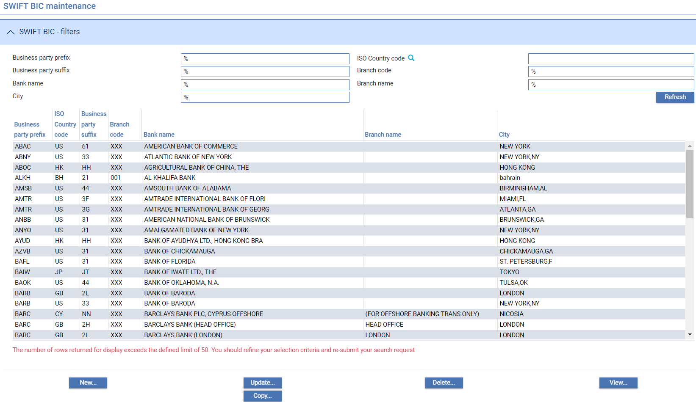

The following table explains what each of the columns in this window shows:

| Heading | What it Shows |
| --- | --- |
| Bank | The bank's SWIFT code name. |
| Country | The bank's SWIFT country code. |
| Location | The bank's SWIFT location indicator. |
| Branch | The SWIFT indicator for routing the message within the bank. |
| Bank Name | The bank's name. |
| Branch Name | The branch name. |
| City | The city. |

To enter a new SWIFT BIC address click **New**.

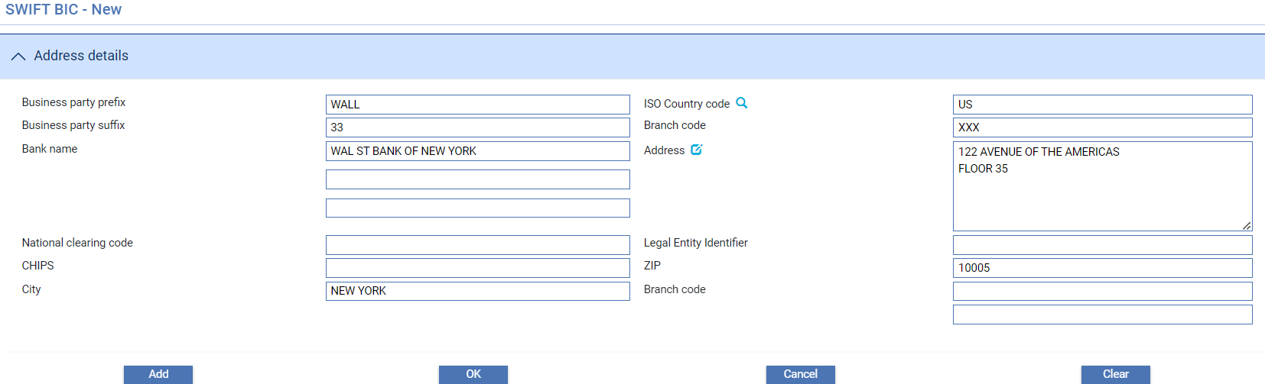

1. A gateway message exists to enable automatic upload of the SWIFT BIC file either as a full upload or delta changes using the SWIFT BIC file. Your bank must create an application to transform the data in the BIC file to the gateway message format for upload.

## TI SWIFT Details

The Customer Maintenance|TI SWIFT Details menu option allows you to view or amend the authenticated, closed, blocked and transliteration (where implemented) statuses of a SWIFT BIC held for each of the bank’s main banking entities.

Statuses can be entered for individual branches in the form of either a Head Office BIC (those with characters 9-11 set to XXX) or a Branch BIC (those with a branch reference in characters 9-11).

For all four statuses, a Head Office BIC can be set to ‘Include branches’ so that all the branch BICs do not need to be entered but will follow the default Head Office settings. Any entered branch status can either ‘Follow Head Office’ or be set independently.

The Authentication status can be set to All, Selected or None of the RMA MT message types. Where Selected is used, an additional input is available to record the message types that are authenticated.

When entering transaction events, the system will retrieve the TI SWIFT details for the main banking entity associated with the behalf of branch. The party ‘event fields’ are then set using these details allowing the bank to use rules to condition the production of SWIFT messages or bank defined error/warning messages based on these values. See Appendix B for instructions.

If Maker Checker is being used in your system, you will only be allowed to view this function. Any changes will need to be made in the Maker Checker application. See the *Maker Checker User Guide – Trade Innovation* for further details.

When the TI SWIFT Details menu option is selected, the window that is displayed can be used to list details of those SWIFT BIC addresses against which you have entered additional information, alphabetically by bank.

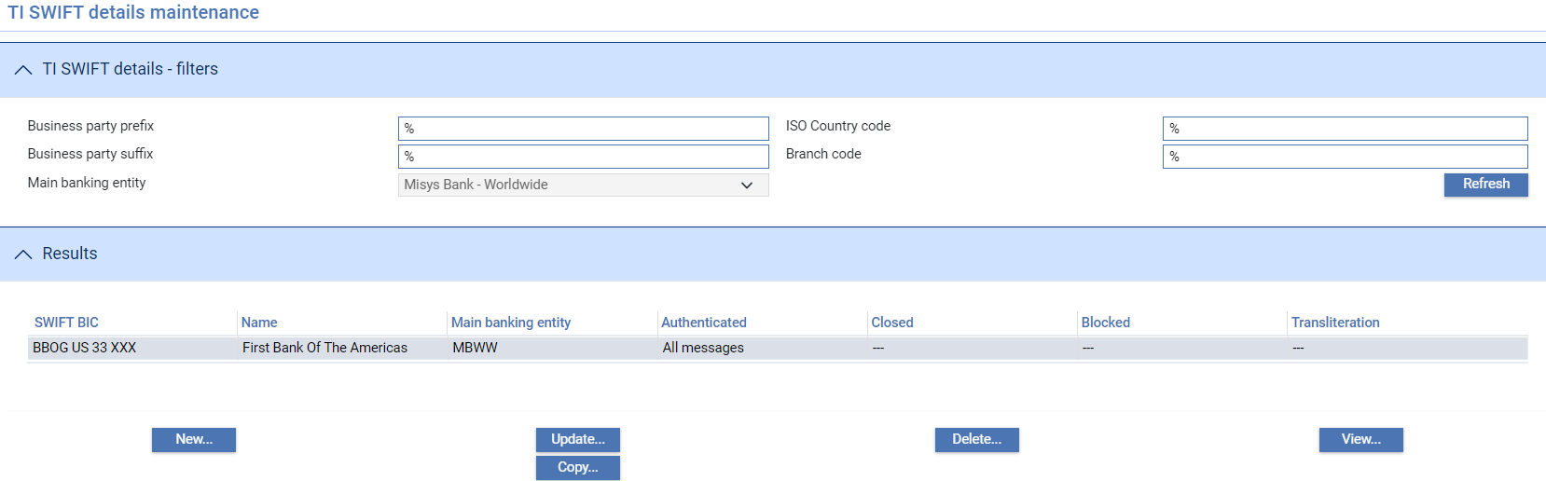

The window shows whether each address has been authenticated, closed or blocked by your bank. Additionally, if your bank has implemented Russian character transliteration it indicates if this should be done for SWIFT messages to be sent to this BIC address. Whether a Head Office BIC includes branches is indicated with the terms - all BICs, all or none. Whether a Branch BIC is following the Head office BIC is also indicated. Entries can be viewed, amended and deleted in the usual way.

To enter new TI SWIFT details, you must first enter a main banking entity on the main browser screen and then click **New**.

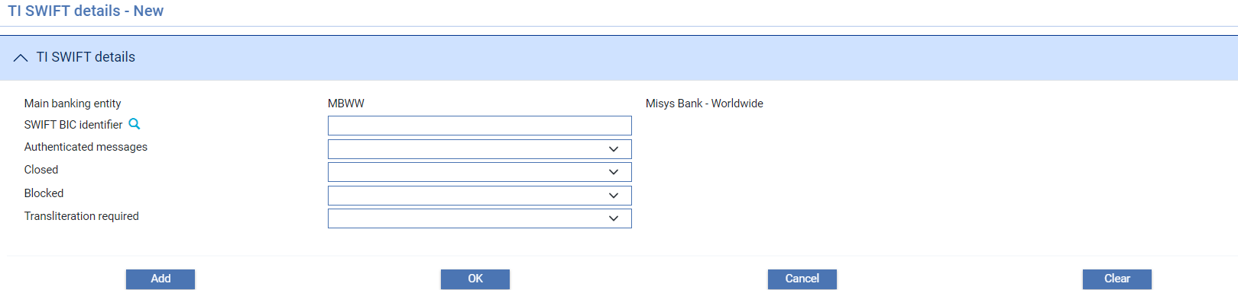

Then under SWIFT BIC identifier, if selecting a Head Office BIC: the following inputs are available - example details:

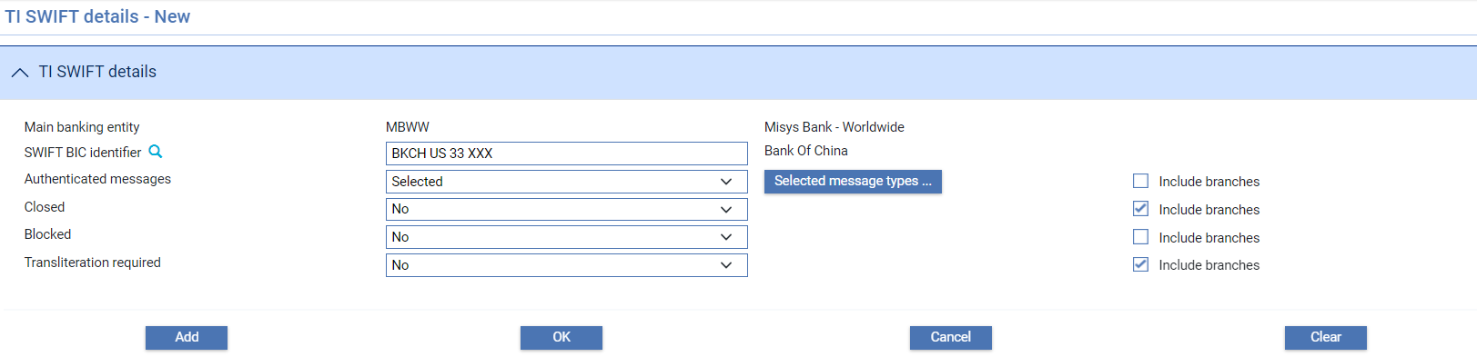

The following table explains what to enter into the fields in this window for a Head Office BIC:

|  | Field | What to Enter |
| --- | --- | --- |
|  | Main banking entity | The main banking entity to which these details apply. |
|  | SWIFT BIC identifier | The SWIFT BIC of the Head Office bank branch that is being defined (where characters 9-11 are XXX). |
|  | Authenticated messages | The SWIFT message types that are permitted to be exchanged between the banks.  Authenticated message statuses can be:   * All – all RMA controlled message types are authenticated * None – no RMA message types are authenticated * Selected – selected RMA controlled message types are authenticated (Partial authentication)   + Under Selected a button is available to record which message types are to be included as authenticated |
|  | Selected message types | Shown if Authentication is set to Selected. This input allows the user to define which MT message types are included in the authentication. |
|  | Include branches | If ticked, any branch BICs (of the same 8-character BIC reference) will follow the Head Office BIC authenticated messages setting when the branch BIC is not set up or when it is set to Follow Head Office. |
|  | Closed | If closed; ‘Yes’ or ‘No’ is available for all BICs. |
|  | Include branches | If ticked, any branch BICs (of the same 8-character BIC reference) will follow the Head Office BIC closed setting when the branch BIC is not set up or when it is set to Follow Head Office. |
|  | Blocked | If blocked; ‘Yes’ or ‘No’ is available for all BICs. |
|  | Include branches | If ticked, any branch BICs (of the same 8-character BIC reference) will follow the Head Office BIC blocked setting when the branch BIC is not set up or when it is set to Follow Head Office. |
|  | Transliteration required | If transliteration required; ‘Yes’ or ‘No’ is available for all BICs. |
|  | Include Branches | If ticked, any branch BICs (of the same 8-character BIC reference) will follow the Head Office BIC transliteration required setting when the branch BIC is not set up or when it is set to Follow Head Office. |

Alternatively under SWIFT BIC identifier, if selecting a Branch BIC, the following inputs are available - example details:

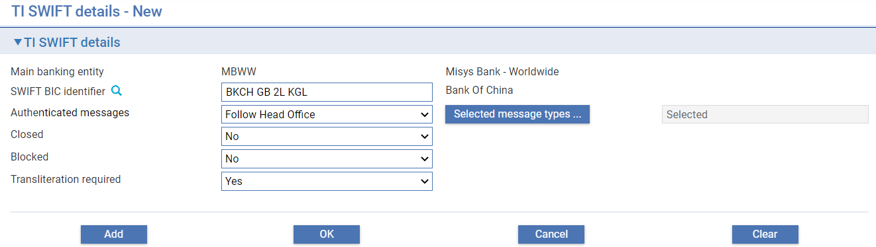

The following table explains what to enter into the fields in this window for a Branch BIC:

|  | Field | What to Enter |
| --- | --- | --- |
|  | Main banking entity | The main banking entity to which these details apply. |
|  | SWIFT BIC identifier | The SWIFT BIC of the bank branch that is being defined (where characters 9 - 11 are not XXX). |
|  | Authenticated messages | The SWIFT message types that are permitted to be exchanged between the banks.  Authenticated message statuses can be:   * All – all RMA controlled message types are authenticated * None – no RMA message types are authenticated * Selected – selected RMA controlled message types are authenticated (Partial authentication)   + Under Selected a button is available to record which message types are to be included as authenticated * Follow Head Office - is allowed if the Head Office BIC is present and is set to Include branches |
|  | Selected message types | Shown if Authentication is set to Selected. This input allows the user to define which MT message types are included in the authentication.  If status is Follow Head Office, and the Head Office status is Selected, this acts as a view function of the Head Office messages selected. |
|  | Closed | If closed; ‘Yes’ or ‘No’ is available for all BICs. ‘Follow Head office’ is allowed if the Head Office BIC is present and is set to Include branches. |
|  | Blocked | If blocked; ‘Yes’ or ‘No’ is available for all BICs. ‘Follow Head office’ is allowed if the Head Office BIC is present and is set to Include branches. |
|  | Transliteration required | If transliteration required; ‘Yes’ or ‘No’ is available for all BICs. ‘Follow Head office’ is allowed if the Head Office BIC is present and is set to Include branches. |

Banks can choose between setting up multiple Branch BIC status records or to set up the Head Office BIC to represent the settings for all branches of that Head Office. Where configuration is being maintained, moving from a single Head Office record to independent branch BIC settings, the Include branches is to be un-ticked. Existing Branch records that are set to Follow Head Office, will continue with the historic Head Office BIC settings by default. These can be viewed from the Head Office records through the toggle button **View Follow HO settings**/**Return to HO settings**.

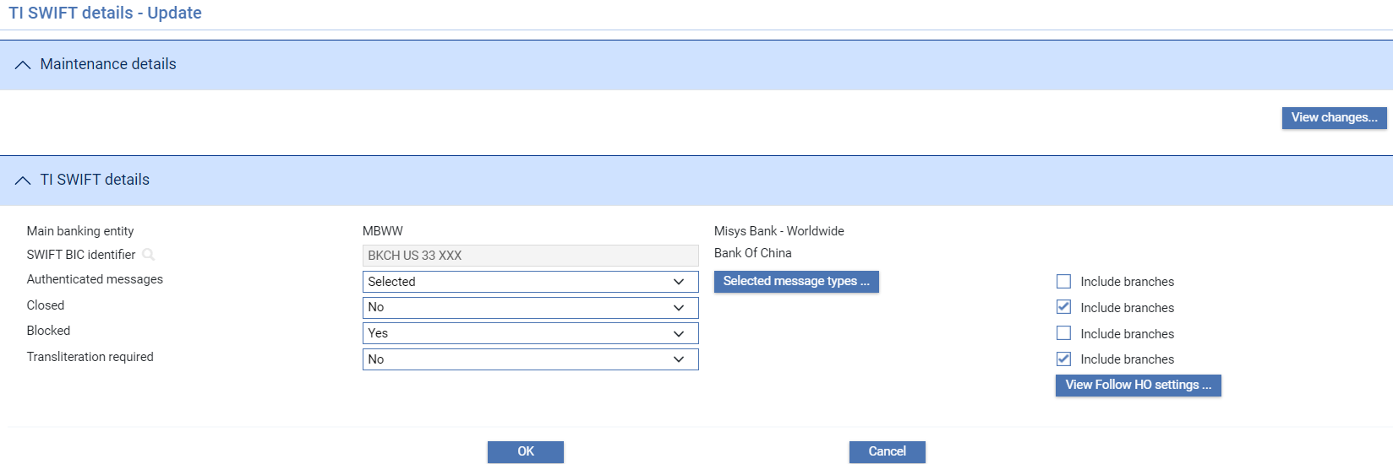

This button shows the user the Head Office settings from the last time Include branches was ticked.

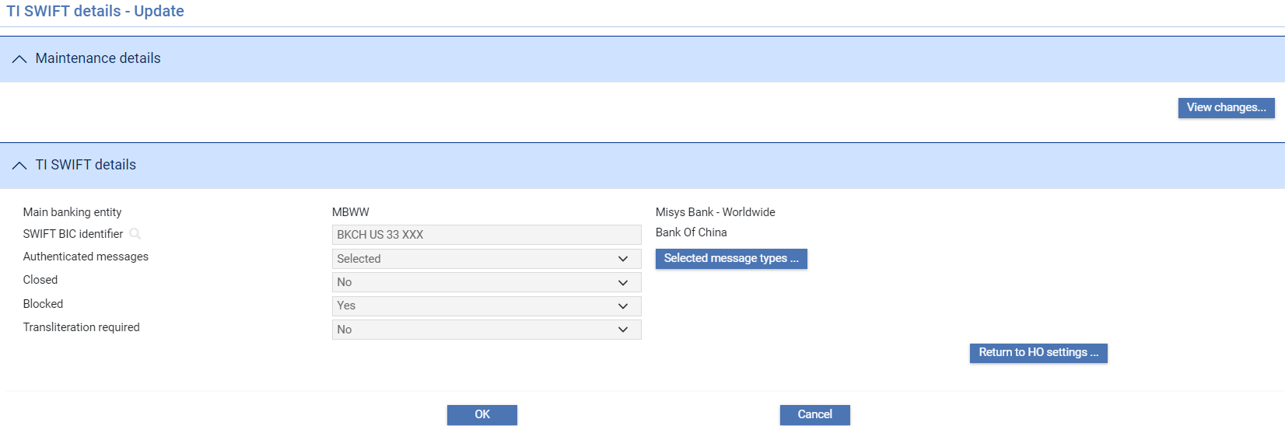

Similarly, from the Branch record, the Follow Head Office settings from the last time Include branches was ticked are visible.

Retaining these previous values ensures that there are no uncontrolled changes to any branch status during maintenance. This is intended for temporary use; it is recommended to ensure only branch statuses which have Include branches ticked in the associated Head Office record use the status Follow Head Office.

1. User Defined messages must be set up to enable the above statuses to control release of SWIFT messages within transaction event processing. Instructions for setting up errors and warnings to control SWIFT message release are provided in Appendix B.

## SWIFT BIC Plus IBAN Addresses

During transaction processing, when the input clerk uses the SWIFT address browser to list and select a SWIFT party, the system retrieves and displays the SWIFT party's name and the second, third and fourth lines of their SWIFT BIC address. The static data maintenance application includes facilities to allow you to access SWIFT BIC address details from the SWIFT BIC IBAN file.

1. If your bank has set the zone level system option SWIFTBICPlusIBANFeatures then SWIFT BICs will be validated against the SWIFT BICPlus IBAN file as they are entered into input fields in transaction processing. In addition IBANs are checked against the format expected for the country of the IBAN that is contained in the IBAN Structure file.

The window displayed when you select the SWIFT|SWIFT BIC menu option allows you to list existing SWIFT BIC addresses alphabetically by institution name.

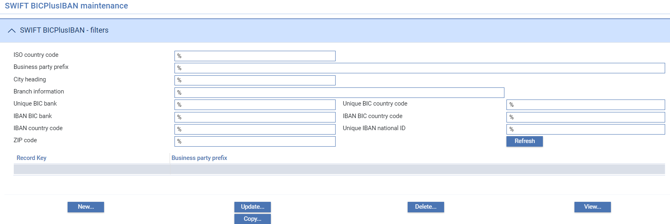

The following table explains what each of the columns in this window shows:

|  |  |
| --- | --- |
| Heading | What it Shows |
| Record Key | The unique IBAN record key for the address. |
| Institution Name | The institution’s trading name. |

To add or amend a SWIFT BIC IBAN click **New** or **Update**. The following window is displayed:

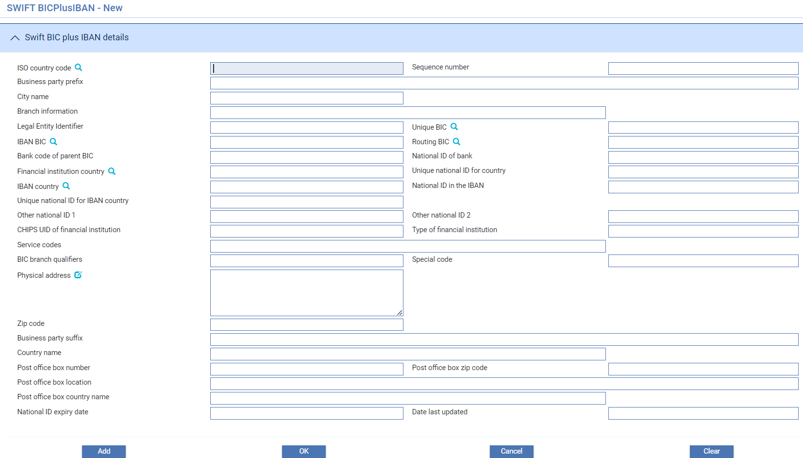

The following table explains what each of the fields in the window shows:

| Heading | What it Shows |
| --- | --- |
| ISO Country Code | ISO standard country code. |
| Sequence Number | A unique sequential number within country. Together with the ISO Country Code this forms the unique key (record key). |
| Institution Name | Institution name. |
| City Name | City name. |
| Branch Information | Branch information. |
| National ID BIC | The BIC related to the NATIONAL ID (the account servicing institution) if matched with a national code. BIC11 |
| Unique BIC | Unique BIC code within active records. BIC11 |
| IBAN BIC | The BIC issued together with the IBANs to the bank's clients. BIC11 |
| Routing BIC | If the IBAN BIC code is a non-connected BIC the routing BIC code is filled to provide an addressable code on the SWIFT network. BIC11 |
| Bank Code of Parent BIC | Bank code of the parent BIC.4 characters. |
| National ID of Bank | National ID of the bank. |
| Financial Institution Country | ISO country code of the Financial Institution. |
| Unique National ID for Country | Value is unique in the data file per Country Code. The value is unique within the active records. |
| IBAN Country | ISO country code of the IBAN that the bank issues. |
| National ID in the IBAN | The National ID as included in the IBAN. This ID is the country-specific identifier of the financial institution, used in domestic payments processing. |
| Unique National ID for IBAN Country | Value is unique in the data file per Country Code. This ID is the country-specific identifier of the financial institution, used in domestic payments processing. The value is unique within the active records. |
| Other National ID 1 | For some countries 2 types of national ID co-exist. |
| Other National ID 2 | For some countries 2 types of national ID co-exist. |
| CHIPS UID of Financial Institution | CHIPS Universal ID for the financial institution. |
| Type of Financial Institution | Type of financial institution (sub-type indicator) e.g. bank or a broker. |
| Service Codes | Value added services that the financial institution has subscribed to. For example: RTGSplus in Germany, BIREL in Italy. |
| BIC Branch Qualifiers | BIC branch qualifiers. For example: ADM = Administration, BKO = Back office. |
| Special Code | Specific information from the National record for the financial institution. |
| Physical Address | Address – Four parts x 35 long |
| Zip Code | ZIP code for physical address. |
| Location | Location. |
| Country Name | Country name. |
| Post Office Box Number | Post Office Box number. |
| Post Office Box Zip Code | Post Office Box ZIP code. |
| Post Office Box Location | Post Office Box location. |
| Post Office Box Country Name | Post Office Box country name. |
| National ID Expiry Date | The date on which the national ID has been removed by the national authority. |
| Date Last Updated | The date on which the record was last updated. |

1. A gateway message exists to enable automatic upload of the SWIFT BIC IBAN details either as a full upload or delta changes using the SWIFTRef file. Your bank must create an application to transform the data in the SWIFTRef file to the gateway message format for upload.

## IBAN Structure Codes

The **IBAN Structure selection** is displayed when you select the SWIFT|SWIFT IBAN Structure menu option. It allows you to list existing country IBAN structures.

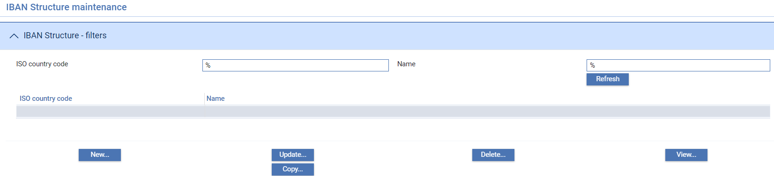

The following table explains what each of the columns in this window shows:

|  |  |
| --- | --- |
| Heading | What it Shows |
| ISO Country Code | The international standard country code associated with the IBAN structure. |
| Name | Country name |

To add or amend a structure code click **New** or **Update**. The following window is displayed:

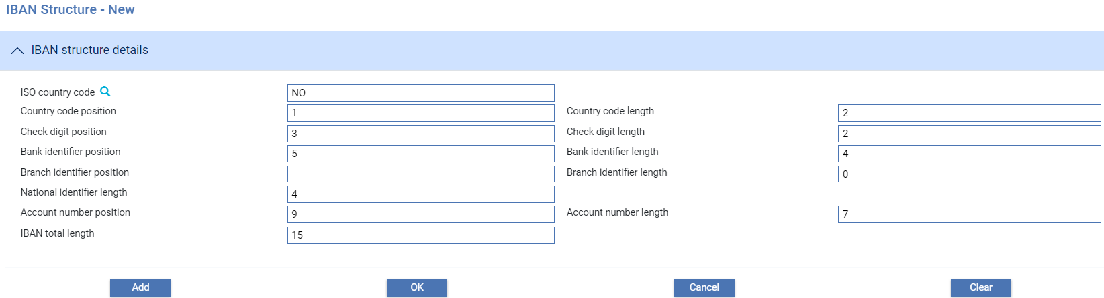

The following table explains what each of the fields in the window shows:

| Heading | What it Shows |
| --- | --- |
| ISO Country Code | The international standard country code associated with the IBAN structure. |
| Country Code Position | Start position of the country code in the IBAN. |
| Country Code Length | Number of characters of the country code in the IBAN. |
| Check Digit Position | Start position of check digit in the IBAN. |
| Check Digit Length | Number of check digit in the IBAN. |
| Bank Identifier Position | Start position of bank identifier in the IBAN. |
| Bank Identifier Length | Number of characters of bank identifier in the IBAN. |
| Branch Identifier Position | Start position of branch identifier in the IBAN (may be empty). |
| Branch Identifier Length | Number of characters of branch identifier in the IBAN (may be 0). |
| National Identifier Length | Number of significant characters of the National identifier that are used by SWIFT. |
| Account Number Position | Start position of the account number in the IBAN. |
| Account Number Length | Number of characters of the account number in the IBAN. |
| IBAN Total Length | The total number of characters of the IBAN. |

Click **OK** to save the information and return to the initial window in the sequence.

1. A gateway message exists to enable automatic upload of the SWIFT IBAN structure file. Your bank must create an application to transform the data in the SWIFTRef file to the gateway message format for upload.

## SWIFT Payment Rejection Codes

SWIFT payment rejection codes are available for use on SWIFT payment rejection messages to indicate the reasons why a clean payment request that has been received has been rejected. They are entered using the SWIFT|SWIFT Reject Codes menu option. The code is then mapped to the resulting SWIFT payment rejection message, such as an:

* MT200/202/205 Rejection
* MT103 Rejection
* MTn95/n99 Rejection

where n is 4, 7 or 9.

When you select this menu option the system displays a window that can be used to list all the rejection codes set up on your system.

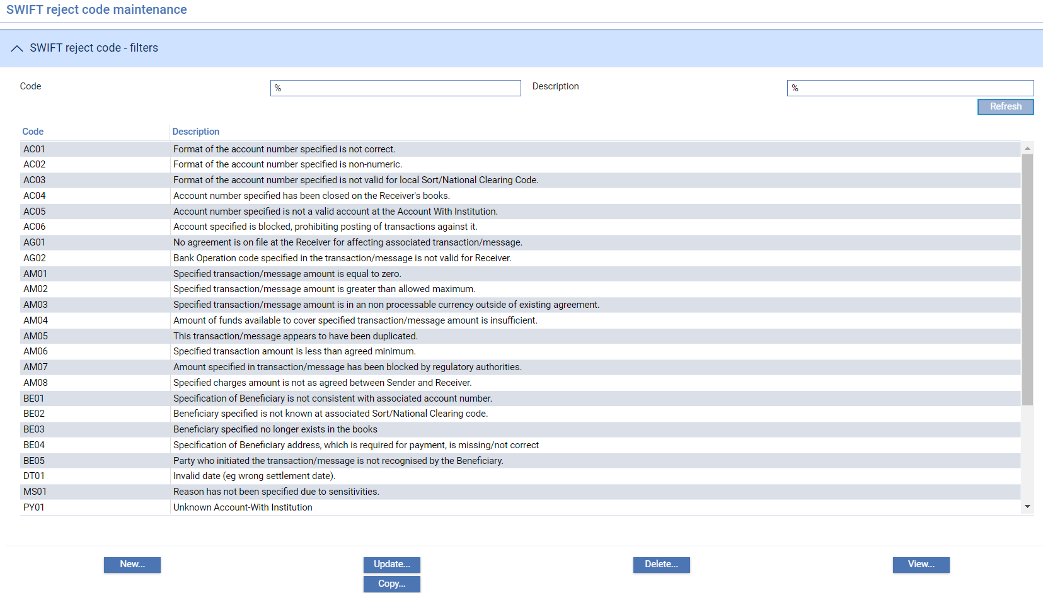

You can select them to view, amend, delete or copy in the usual way.

Click **New** to enter a new rejection code.

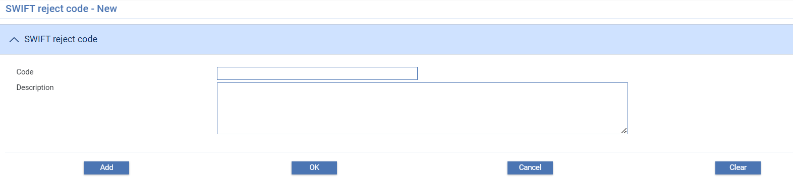

Enter a unique alphanumeric code and a text description to indicate the reason for the rejection when this code is used.

## SWIFT Clearing Codes

The system enables your bank to maintain your own list of national clearing system codes, for use in settlements. (This facility is only available if the ClearingSystemCodes system option is set to 'Yes'.)

This is done using the SWIFT|SWIFT Clearing Codes menu option.

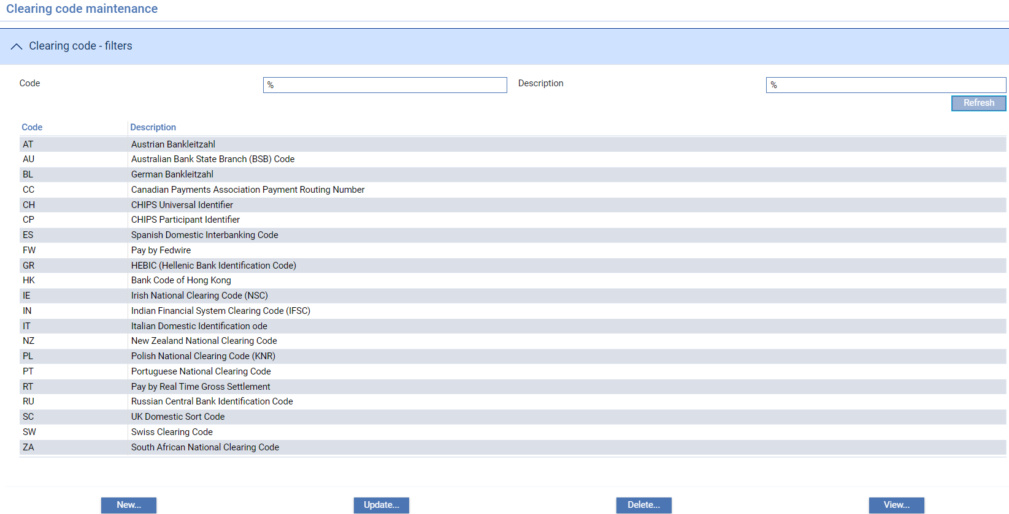

When you click **Refresh** this window lists all the clearing codes set up on your system and you can select them to view, amend, or delete in the usual way.

Click **New** to enter a new clearing code.

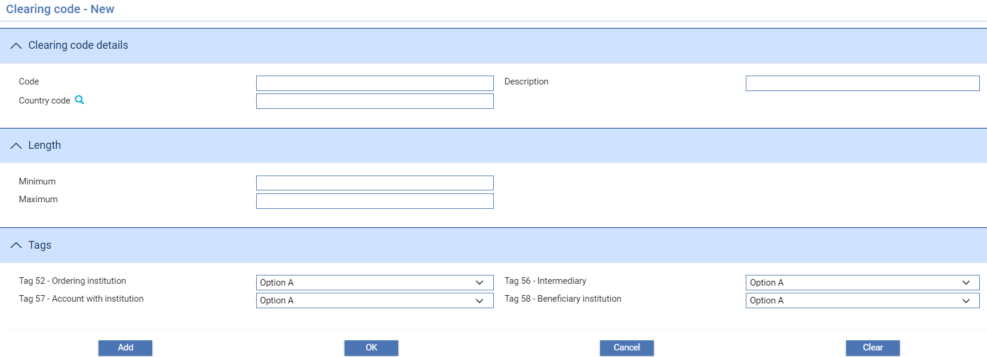

The following table explains what to enter into the fields in the window that appears:

|  | Field | What to Enter | | |
| --- | --- | --- | --- | --- |
|  | Code | An identifier for the clearing system code. | | |
|  | Description | A description of the clearing system code. | | |
|  | Country Code | The country in which the national clearing system operates. This is required to allow the system to retrieve the correct prefix for the national clearing system when generating SWIFT messages. | | |
|  | Length | The Minimum and Maximum fields define the range of lengths possible for the code, as follows:   * If Minimum is set to 0 and Maximum to any integer, the code may either be used blank or with an account number the length defined in Maximum * If Minimum and Maximum are the same, that value is the fixed length of any account number * If Minimum is greater than 0 but less than Maximum the account number may be of any length in the range.   For example: | | |
|  |  | Min  0  1  5 | Max  5  5  5 | Length permitted  Blank or 5 digits  Between 1 and 5 digits  5 digits exactly |
|  | Tags | For each of these fields, select one of the following options: | | |
|  |  | Option A | | Party Identifier and BIC |
|  |  | Option D | | Party Identifier and Name and Address |
|  |  | Either A or D | | Party Identifier and either BIC or Name and Address |
|  |  | Not valid | | The code may not be used in this tag |

# Customised Static Data Tables

This chapter explains how to enter data into customised static data tables.

## Overview

The system uses static data that is maintained using the facilities described in this guide. The system operates in one or more of the following ways:

* As a standalone system, in which case the system uses static data that is maintained using the facilities described in this guide
* As a system integrated with one or more back office systems where some static data is replicated from the external system. Static data is passed to the system and held in the database.
* As a system integrated with one or more back office systems using ‘services’ to retrieve some of the static data, such as customers, accounts and settlement instructions, from the back office database. A copy is used by the system and is then updated throughout business hours to keep it in line with the back office database

Some other types of static data are specific to trade finance, and so are stored on the database and maintained using Trade Innovation facilities, regardless of whether your system is integrated or standalone.

For some types of data, standard data sets are provided as part of the system release. They can be augmented and maintained using the static data application. These standard data sets provide a consistent set of static data that you can use while familiarising with the system. These can be deleted before your system goes live, but you may want to retain those standard data sets that conform to external standards for live operations.

Some other types of data are parameters that support global processing, such as branches and zones. Branches are organised into zones. Each zone has its own database of transactions, static data and users; and the branches within a zone share that database. Aliasing allows you to set up in each database a mapping between the key value held for a static item in that database and the corresponding key values held for the same item in other back office databases you might share data with.

When you use the static data application to make any changes to the system, before and after images of the affected data are journalled. You can display this information using the Full Journal Report.

The table in Appendix A lists all the static data types that the system uses.

The following sections in this chapter provide a brief description of the static data used by the system explaining what each is used for and how they interrelate, and providing some guidelines on the order in which static data should be set up.

## Entering Data into Customised Static Data Tables

The static data application allows you to enter, amend and delete information held in customised static data tables in the same way as for other types of static data.

When you select a customised static data table menu option, the system opens a browser window that allows you to list existing entries in that table.

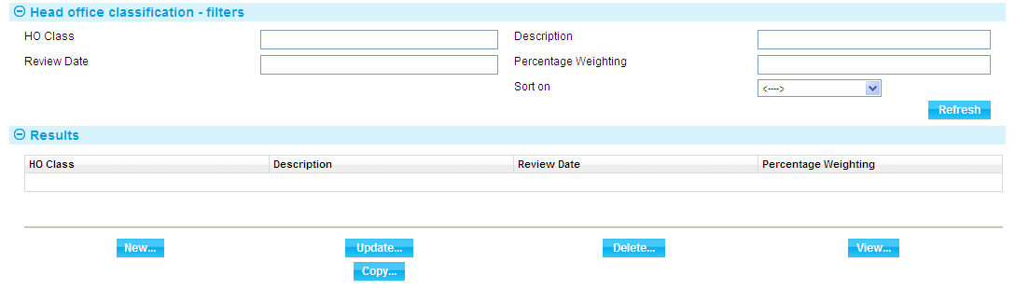

The buttons in this window work in the usual way. Filter fields may include browsers; and there may be sort fields present to allow you to alter the list sequence.

To set up a new entry, click **New**.

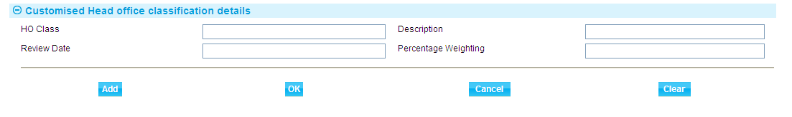

The system displays the fields held by records in that table. Enter the required data for the new entry and click **Add** to save it.

The system provides validation to ensure, for example, that the data entered into a field is of the correct type or length. Browser buttons may be present, allowing you to browse on and select other static data items, including items from other customised static data tables.

# Appendix A: Static Data Types

The following table lists all the static data types that the system uses. The first column indicates those for which a standard data set is provided with the system. The second column has a tick to indicate which static data types are typically provided from the back office(s) to which the Zone is linked:

|  |  |  |
| --- | --- | --- |
| Account Officers |  |  |
| Account Types | standard data set |  |
| Accounts |  |  |
| Address Types |  |  |
| Analysis Codes |  |  |
| Base Rate Codes |  |  |
| Base Rate Groups |  |  |
| Base Rates |  |  |
| Branches |  |  |
| Calendars |  |  |
| Charge Codes | standard data set |  |
| Charge Groups |  |  |
| Clearing Systems |  |  |
| Collateral Types |  |  |
| Correspondents |  |  |
| Countries | standard data set |  |
| Currencies | standard data set |  |
| Customer Addresses |  |  |
| Customer Groups |  |  |
| Customer Types | standard data set |  |
| Customers |  |  |
| Deal Types |  |  |
| Default Nostros |  |  |
| Differential Rates |  |  |
| Document Types | standard data set |  |
| Documents of Title |  |  |
| Entity Types |  |  |
| Foreign Exchange Rate Types |  |  |
| Foreign Exchange Rates |  |  |
| Goods Codes |  |  |
| Incoterms | standard data set |  |
| Instruction Groups |  |  |
| Languages |  |  |
| Nostros |  |  |
| Note Types | standard data set |  |
| Settlement Instructions |  |  |
| Spot Exchange Rates |  |  |
| Statistic Codes |  |  |
| SWIFT BIC Addresses |  | From SWIFT |
| SWIFT Clearing Codes | standard data set |  |
| SWIFT IBAN Structure |  | From SWIFT |
| SWIFT Reject Codes | standard data set |  |
| System Parameters | standard data set |  |
| TI Customer Details |  |  |
| Trade Finance Dictionary | standard data set |  |
| Transaction Codes | standard data set |  |
| Transfer Methods | standard data set |  |

# Appendix B: Control SWIFT message release under Authentication, Closed, Blocked and Transliteration statuses

## Transaction Event Fields

To support user defined messages to control the release of authenticated SWIFT messages (managed under the TI SWIFT Details maintenance function), the following party type event status fields are available:

|  |  |  |
| --- | --- | --- |
| Code | Description | Details |
| sakh | SWIFT full authentication key held | If sakh is Y then spak will be N and vice versa |
| spak | SWIFT partial authentication key held | If spak is Y then sakh will be N and vice versa |
| sakf | SWIFT authentication key fail | This is Y if the SWIFT message type document in release items is not in the authenticated messages ‘Selected’ list, or authenticated messages is ‘None’.  MT9nn messages are not included as they are outside of RMA. |
| sic | SWIFT address closed |  |
| sib | SWIFT address blocked |  |
| sts | SWIFT transliteration required |  |

To identify the SWIFT message types that fail authentication under Selected message type authentication, the following event field is available:

|  |  |  |
| --- | --- | --- |
| Code | Description | Details |
| SNAMP | SWIFT non authenticated message(s) present | This holds the RMA message types present in the transaction release items that are not authenticated. |

### Setting up User Defined Messages

**Authenticated messages Option A:**

A single user defined message to cover failing message types under both partial and no authentication.

Condition: Authentication of SWIFT key failed (sakf = Y)

Error ‘SWIFT Authentication for Message Type(s) not available for destination BIC – see SNAMP event field’

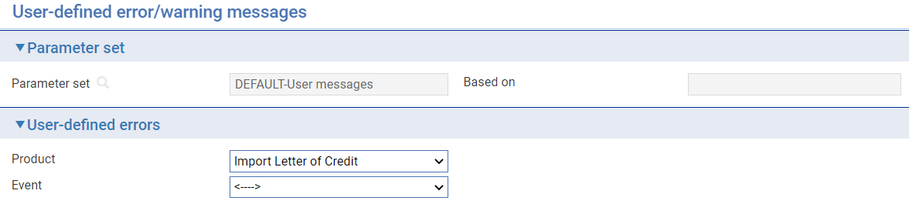

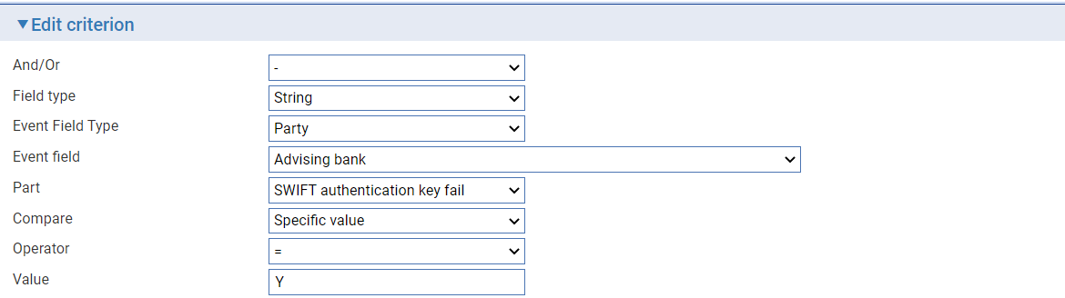

**Authenticated messages Option B:**

Separate user defined messages for no authentication failure and partial authentication failure.

Condition: Authentication of SWIFT key failed, but Partial Authentication key is held (sakf = Y and spak = Y)

Error ‘SWIFT Authentication for Message Type(s) not available for destination BIC – see SNAMP event field’

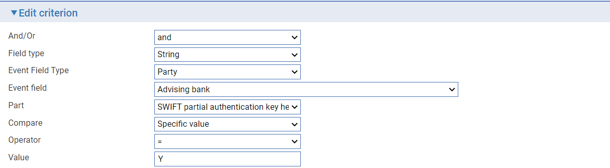

Condition: Authentication of SWIFT key failed and no key is held (sakf = Y and spak = N)

Error ‘SWIFT Authentication for RMA Messages not available for destination BIC’ (SNAMP will still show the failing message types; all RMA message types will fail under Authenticated messages - None).

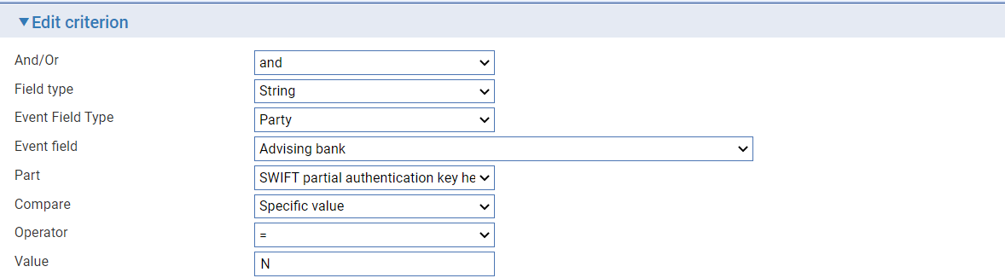

**Blocked, Closed and Transliteration required status validation:**

A user defined message can be set up for each of Blocked, Closed and Transliteration required.

Condition: SWIFT address is Closed (sic = Y)

Error ‘SWIFT Destination BIC is Closed’

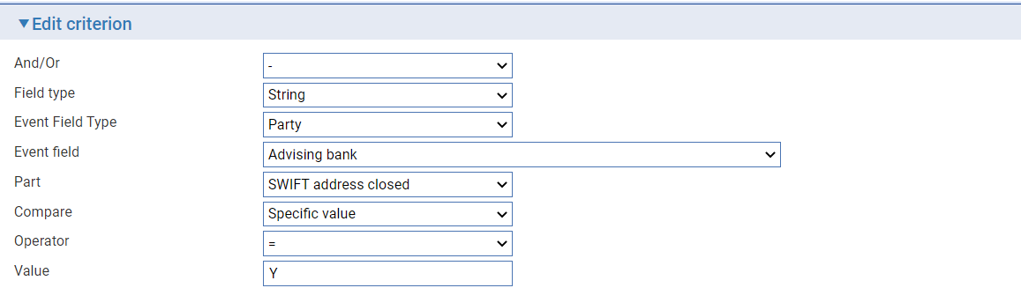

Condition: SWIFT address is blocked (sib = Y)

Error ‘SWIFT Destination BIC is Blocked’

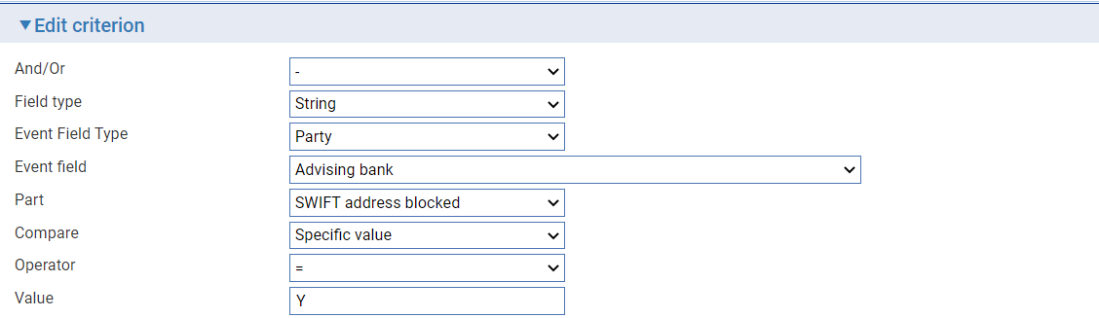

Condition: Transliteration is required (sts = Y)

Warning ‘SWIFT Destination BIC Transliteration is required’

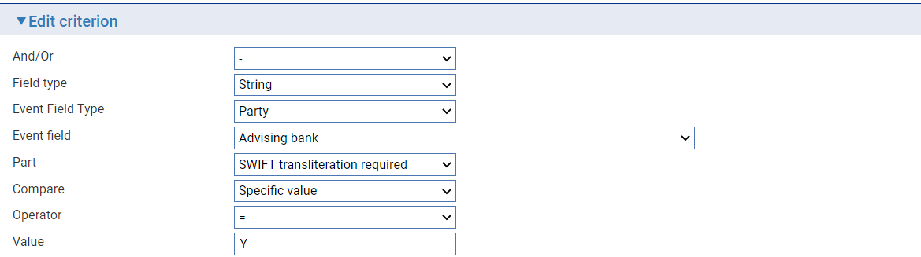

**Ensure ALL parties which receive SWIFT messages are included in the user defined messages.**

For example, where Reimbursing bank also receives an Import Letter of Credit MT740 message, the user defined messages should be expanded to include that party with ‘or’ clauses.

Where there is a single rule condition:

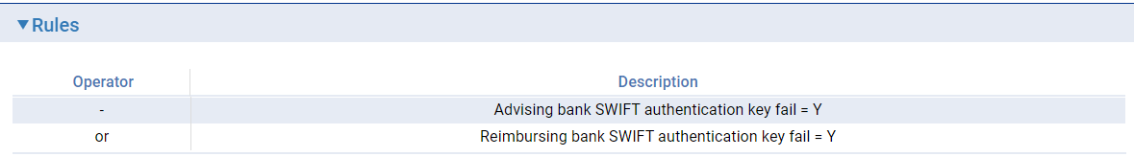

Where there is a multiple rule condition:

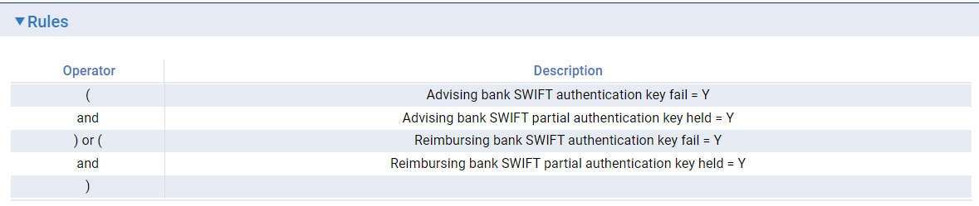

## Transaction Processing

Once the user defined messages are configured in System Tailoring, these control the release of SWIFT messages generated in the event (release items for the event). The configured errors and warnings will appear in the transaction after event validation when the rule conditions are met.

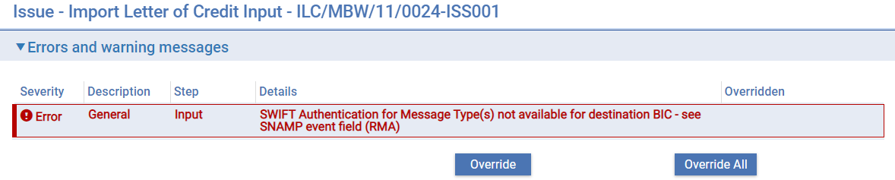

The event field statuses can be viewed within the transaction by selecting Event fields under the Other menu.

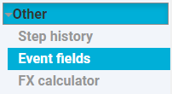

The status flags are accessible from the party record of the destination bank.

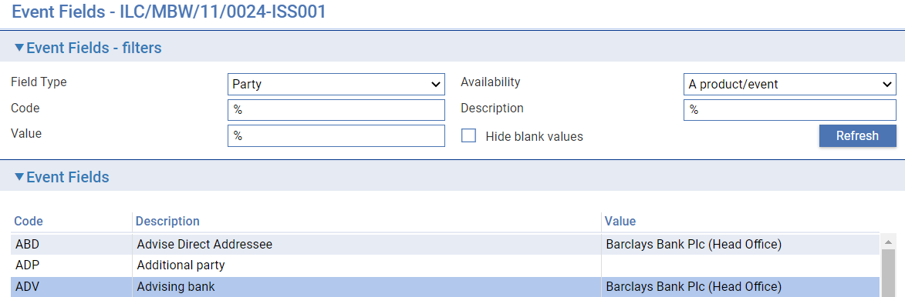

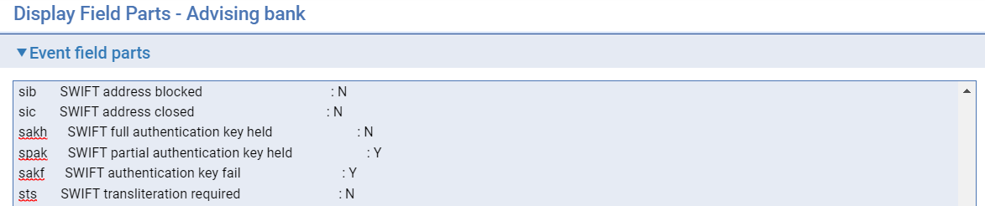

For troubleshooting, the actual SWIFT message types failing authentication are listed in the event field SNAMP.

